Ministry of Education and Science of Ukraine
Sumy National Agrarian University
Faculty of Economics and Management
Department of Public Management and Administration

Work program (syllabus) of the educational component

EC 3 - Business foreign language

(required)

Specialty | D3 Management
Educational program | Administrative management
Level of higher education | second (master's)

Sumy – 2026

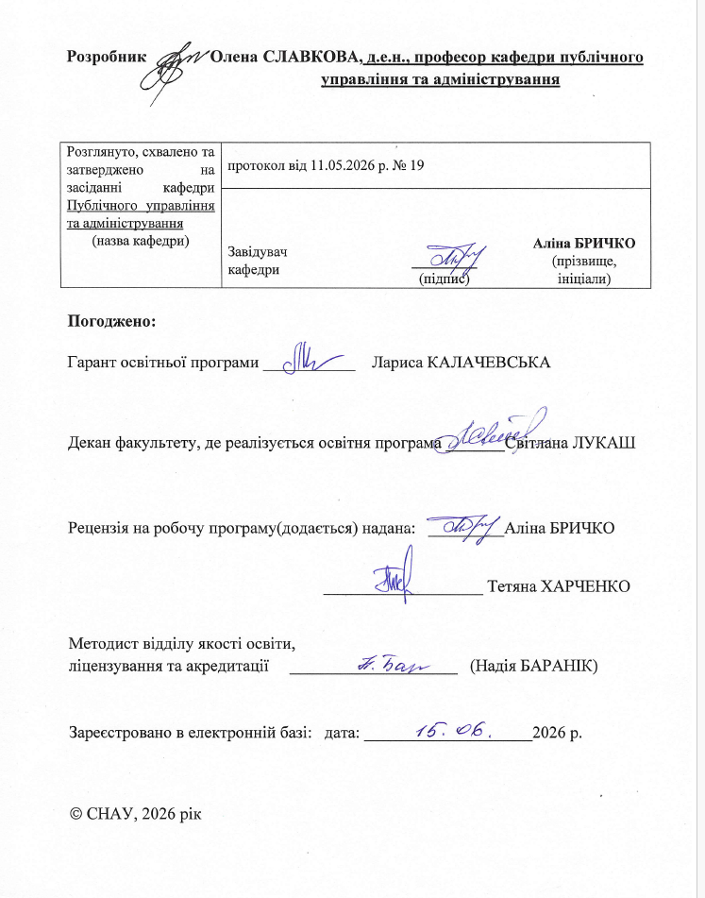
Information on reviewing the work program (syllabus):
Academic year in which changes are made | Number of the appendix to the work program with a description of the changes | Changes reviewed and approved
Academic year in which changes are made |  | Date and number of the minutes of the department meeting | Head of the Department | Educational program guarantor

1. GENERAL INFORMATION ABOUT THE EDUCATIONAL COMPONENT
 | Name OK | VK 4. Business foreign language
 | Faculty/department | Faculty of Economics and Management / Department of Public Management and Administration
 | Status OK | responsibilities
 | Program/Specialty (programs) that include OK for ( filled in for mandatory OK) | OP- Administrative Management  Specialty – D 3 “Management”
 | The OK can be offered for ( filled in for selective OKs) | For all university majors
 | NRC level | NQF of Ukraine – level 7, FQ-EHEA – second cycle, EQF-LLL – level 7
 | Semester and duration of study | 1 semester, 1-15 weeks
 | Number of ECTS credits | 5 credits (150 hours)
 | Total hours and their distribution | Contact work (classes) |  |  | Independent work
 | Total hours and their distribution | Lectures | Practical/seminar | Laboratory | Independent work
 | full-time Ph.D. | 30 | 30 | - | 90
 | correspondence course in physics | - | 16 |  | 134
 | Language of instruction | English
 | Teacher/Educational Component Coordinator | Slavkova O.P., Professor of the Department of Public Management and Administration (room No. 310, building of the Faculty of Economics and Management)
11.1 | Contact information | 0509354287, olena.slavkova.snau@gmail.com
 | General description of the educational component | Modern public administration is impossible without mastering the basics of systems thinking, understanding the methodology, methods of scientific research and information technologies in the field of management and administration, the ability to scientifically correctly process operational data and rationally use the information obtained in the process of making management decisions.
 | Purpose of the educational component | The goal is to teach the basics of business communication in oral and written form in typical situations: acquaintance, telephone conversation, job placement, business meeting, business trip, ordering tickets and hotel rooms, restaurant, shop, doctor's office, the ability to conduct business negotiations, discussions, drafting and signing contracts, commercial correspondence - letter, fax, telex, e-mail; request, order, complaints, etc. The basis of the training materials are texts in scientific and business style.
 | Prerequisites for studying OK, connection with other educational components of OP | 1. The educational component is based on the study of such disciplines as: foreign language.  2. The educational component is the basis for: writing a qualification paper
 | Academic Integrity Policy | When performing practical tasks and examination work, the student must adhere to the rules of academic integrity. In the event of a violation of academic integrity by a higher education applicant (cheating, plagiarism, fabrication), the work is assessed as unsatisfactory and must be performed again. In this case, the teacher reserves the right to change the topic of the task.
 | Link to the course in Moodle | I semester - https://cdn.snau.edu.ua/moodle/course/view.php?id=167
 | Keywords | Business English, professional communication, administrative management, business correspondence, commercial correspondence, employment, resume, interview, presentation, business negotiations, public administration, English for managers, written communication, oral communication, English grammar, business vocabulary, telephone conversations

2. LEARNING OUTCOMES BY EDUCATIONAL COMPONENT AND THEIR RELATIONSHIP WITH PROGRAM LEARNING OUTCOMES

Learning outcomes for OK:  After studying the educational component, the student is expected to be able to... | Program learning outcomes that the OC aims to achieve (indicate the number according to the numbering given in the OP) | How is RND assessed?
 | PRN 9. | How is RND assessed?
DRN 1. After studying the educational component, the student is expected to know the fundamental difference between members of a sentence and parts of speech; means of expressing the present, past and future tenses, modality, as well as spatial and temporal relations typical of stylistically neutral communication in a foreign language; means of expressing the affirmative and negative form. | x | Multiple choice tests
DRN 2. After studying the educational component, the student is expected to know the main business speech forms and clichés used in the field of business communication; the main speech forms and language formulas for expressing intentions, assessments, opinions, and relationships in the professional sphere; the structure and intonation of the main types of sentences. | x | Multiple choice tests
DRN 3. After studying the educational component, the student is expected to use basic speech forms and language formulas in his speech to express intentions, assessments, opinions, and relationships in the professional sphere; to master forms of professional speech, build reasoned statements, presentations, conduct business negotiations, telephone conversations, and organize meetings. | x | Multiple choice tests
DRL 4. After studying the educational component, the student is expected to demonstrate the ability to  use means of expression of affirmative and negative forms; use in oral and written speech the main business speech forms and clichés used in the business field of communications; use all the main types of reading: overview, detailed, search; use normative clichés necessary for written speech. | x | Multiple choice tests, individual assignment, essay
PRN 9. Communicate in a foreign language on professional topics, discuss public administration problems and research results.

3. CONTENT OF THE EDUCATIONAL COMPONENT (COURSE PROGRAM)
3.1 Full-time study

Topic.  List of issues to be addressed within the topic | Distribution within the overall time budget |  |  |  | Recommended reading
Topic.  List of issues to be addressed within the topic | Classroom work |  |  | Independent work | Recommended reading
 | Luke | P.z / semin.z | Lab. with.
Topic 1. The role of English in the modern world. | 2 | 2 |  | 5 | 1,5,9
Topic 2. Study, work, plans and ambitions. | 2 | 2 |  | 5 | 2,4,6
Topic 3. Employment. Questionnaire. Generating new ideas . | 2 | 2 |  | 5 | 5,8,9
Topic 4. Interview. Resume. | 2 | 2 |  | 10 | 2,5,10
Topic 5. Business correspondence. | 2 | 2 |  | 5 | 1,5,9
Topic 6. Reading. Text “Companies and their banks” | 2 | 2 |  | 10 | 1,5,9
Topic 7. Countries, cities, nationalities. | 2 | 2 |  | 5 | 2,5,10
Topic 8. States and politics. | 2 | 2 |  | 10 | 2,5,10
Topic 9. Business telephone conversation. Time management skills . Problem solving. | 4 | 4 |  | 10 | 2,5,10
Topic 10. Advertising. Presentation. Generating new ideas. | 2 | 2 |  | 5 | 1,5,9
Topic 11. Banks. Currency exchange. Case study. | 4 | 4 |  | 10 | 2,4,6
Topic 12. Business organizations, private sector. | 4 | 4 |  | 10 | 2,4,6
Total per semester | 30 | 30 |  | 90

3.2 Correspondence form of study

Topic.  List of issues to be addressed within the topic | Distribution within the overall time budget |  |  |  | Recommended reading
Topic.  List of issues to be addressed within the topic | Classroom work |  |  | Independent work | Recommended reading
 | Luke | P.z / semin.z | Lab. with.
Topic 1. The role of English in the modern world. |  | 2 |  | 10 | 1,5,9
Topic 2. Study, work, plans and ambitions. |  | 2 |  | 10 | 2,4,6
Topic 3. Employment. Questionnaire. Generating new ideas . |  | 2 |  | 10 | 5,8,9
Topic 4. Interview. Resume. |  | 2 |  | 10 | 2,5,10
Topic 5. Business correspondence. |  | 2 |  | 10 | 1,5,9
Topic 6. Reading. Text “Companies and their banks” |  | 2 |  | 10 | 1,5,9
Topic 7. Countries, cities, nationalities. |  | 2 |  | 10 | 2,5,10
Topic 8. States and politics. |  | 2 |  | 10 | 2,5,10
Topic 9. Business telephone conversation. Time management skills . Problem solving. |  | 2 |  | 10 | 2,5,10
Topic 10. Advertising. Presentation. Generating new ideas. |  | 2 |  | 10 | 1,5,9
Topic 11. Banks. Currency exchange. Case study. |  | 4 |  | 10 | 2,4,6
Topic 12. Business organizations, private sector. |  | 4 |  | 12 | 2,4,6
Total per semester |  | 16 |  | 134

4. TEACHING AND LEARNING METHODS
DRN | Teaching methods (work that will be carried out by the teacher during classroom lessons , consultations) | Teaching methods (what types of learning activities should the student perform independently )
DRN 1. | - conducting lectures and practical classes with multimedia presentations on each topic  - taking multiple choice tests | - Additional study of lecture material
DRN 2. | - conducting lectures and practical classes with multimedia presentations on each topic  - taking multiple choice tests | - Additional study of lecture material;  - preparation for presenting practical tasks;
DRN 3. | - conducting lectures and practical classes with multimedia presentations on each topic  - - taking multiple choice tests | - Additional study of lecture material;  - preparation for presenting practical tasks;
DRN 4. | -conducting lectures and practical classes with multimedia presentations on each topic  - taking multiple choice tests  - essay writing | - Additional study of lecture material;  - preparation for presenting practical tasks;

5. EVALUATION BY EDUCATIONAL COMPONENT
  - Summative assessment
    - To assess the expected learning outcomes, there are

No. | Summative assessment methods | Points / Weight in the overall score | Date of compilation
 | Essay | 20/20% | By week 13
 | IZ 1 (individual task) | 10/10% | By week 7
 | IZ 2 (individual task) | 15/15% | By week 13
 | Testing | 55/55% | During the semester

    - Evaluation criteria

Component | Unsatisfactorily | Satisfactorily | Good | Perfectly
Essay | <12 points | 12-14 | 15-18 | 19-20
Essay | Task requirements not met | Most requirements are met, but individual components are missing or insufficiently disclosed, there is no analysis of other approaches to the issue | All task requirements met | Fulfilled all the requirements of the task, demonstrated creativity, thoughtfulness, proposed their own solution to the problem
FROM 1 | <5 points | 5-6 | 7-8 | 9-10
FROM 1 | Task not completed | The implementation methodology is correct, but there are significant errors | The task is completed, but there are minor errors | The task is fully completed. There are no errors.
FROM 2 | <7 points | 7-9 | 10-12 | 13-15
FROM 2 | Task not completed | The implementation methodology is correct, but there are significant errors | The task is completed, but there are minor errors | The task is fully completed. There are no errors.

  - Formative assessment:
No. | Elements of formative assessment | Date
1 | Testing in (Kahoot) | At the end of each topic
2 | Filling out self-assessment information | Upon completion of the relevant topic
3 | Written feedback on the essay | Within 1 week after execution
4 | Verbal feedback from the teacher during the implementation of the IRP | During the execution of the IRD
5.3. The evaluation scale in force at the University :
Total points for all types of learning activities | National scale assessment
Total points for all types of learning activities | For exam, course project (work), practice, qualification work | for credit
90 – 100 | perfectly | enrolled
82-89 | good | enrolled
75-81 | good | enrolled
69-74 | satisfactorily | enrolled
60-68 | satisfactorily | enrolled
35-59 | unsatisfactory with the possibility of reassembly | not accepted with the possibility of retaking
0-34 | unsatisfactory with mandatory re-study of the discipline | not passed with mandatory re-study of the discipline

- LEARNING RESOURCES (LITERATURE)
Basic literature
1. Clandfield L., Robb Benne R. Business Partner. B2+ Student's Book. Harlow : Pearson Education Limited, 2020.
2. Dummett P., Hughes J., Puchta H. Keynote. Proficient Student's Book. Boston : National Geographic Learning, 2020.
3. Mascull B. Business Vocabulary in Use: Advanced. With Answers. 3rd ed. Cambridge : Cambridge University Press, 2022.
4. Rogers J. Market Leader. Intermediate Business English Course Book. 3rd ed. Harlow : Pearson Education Limited, 2023.

Supporting literature
5. Slavkova O., Figurna M. Methodical recommendations for practical classes of master's degree of specialty 073 "Management" Education Program "Administrative management", 281 "Pablic management and administration" Education Program "Pablic management and administration", Education Program 281 "Regional management" for part time student (protocol No. 7 dated 04.25.2024)
6. Slavkova O., Figurna M, English language Methodical guidelines of independent work of master's degree of specialty 073 "Management" Education Program "Administrative management", 281 "Pablic management and administration" Education Program "Pablic management and administration", Education Program 281 "Regional management" for part time student (protocol No. 7 from 04.25.2024)
7. Mark Foley, Diane Hall. Advanced Learners' Grammar. - UK, "Longman", 2005.
8. Jackie Newbrook. NewfirstCertificateGold. Course book - UK: "Longman", 2007.
9. Christine Johnson. Intelligent Business. Course book - UK: "Longman", "The Economist", 2007.

Links to information resources on the Internet, video lectures, other methodological support
10. Official website of the Maksimovich Scientific Library. – Access mode: http//www.lib- gw.univ.kiev.ua.
11. Official website of the National Agency of Ukraine for Civil Service. – Access mode: http: //guds.gov.ua/govservice/control/uk/index.
12. Official website of the National Library of Ukraine named after V.I. Vernadsky. – Access mode: http//www. nbuv.gov.ua.
13. Official website of the National Parliamentary Library of Ukraine. – Access mode: http://profy.nplu.org/lsite/fi.

