MINISTRY OF EDUCATION AND SCIENCE OF UKRAINE

Sumy National Agrarian University
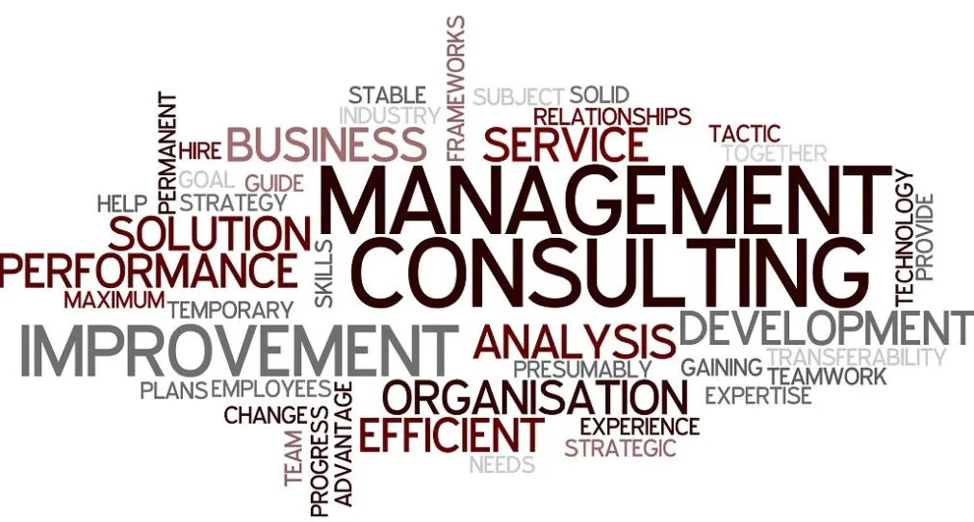

Management consulting

Course-book
for English-speaking students

Sumy 2022

MINISTRY OF EDUCATION AND SCIENCE OF UKRAINE
Sumy National Agrarian University
Economics and Management Department

Management consulting

Course-book
for English-speaking students
of master’s degree of speciality 073 “Management”, training program “Administrative management”

Sumy 2022
UDC 631.153 (072)
М 54

Compilers:

Author: H. Shtrobel, K. Shu, N. Bliaishtainer, L.I.Kalachevska, A.M. Brychko (practical classes)
Editor: Brychko A.M., PhD, Associate Public Management and Administration Chair

Authors
M 54 Scientific and methodological support of the educational process: Management consulting: Course-book for English-speaking students of master’s degree of speciality 073 “Management”, training program “Administrative management” / editor Brychko A.M. - Sumy, 2022. – 120 p.

Course-book aimed at assisting students during the study of “Management consulting” discipline. There are presented lectures, control questions, practical tasks, methodical recommendations for tasks’ solution etc.

Reviewers:

Koblyanska I.I., Ph.D., Associate Professor of Economic and entrepreneurship Chair, Sumy National Agrarian University,

Lukash S.M., PhD, Associate Professor of Public Management and Administrating Chair, Sumy National Agrarian University,

Responsible for issue: Slavkova O.P., Doctor of Economics, Head of Public Management and Administrating Chair of Sumy National Agrarian University

© Sumy National Agrarian University, 2022

TABLE OF CONTENTS
Name and contents
Introduction | 5
Theme 1. Nature and purpose of management consulting | 6
Practical class | 21
Theme 2. The consulting industry | 23
Practical class | 36
Theme 3. The consultant–client relationship | 37
Practical class | 52
Theme 4. Fundamentals of management in the consulting profession | 53
Practical class | 64
Theme 5. Enterprise planning: general economic principles and methods | 65
Practical class | 72
Theme 6. Characteristics of the enterprise | 73
Practical class | 76
Theme 7. Introduction to linear programming for farm business planning | 77
Practical class | 80
Theme 8. Introduction to linear programming for farm business planning using the optimization software XA and MS Excel | 81
Practical class | 99
Theme 9. Introduction to multi-period calculations of investment efficiency | 99
Practical class | 107
Tests for the knowledge control | 109
Individual work | 114
Glossary | 116
References | 118

Introduction

The main purpose of this lectures is to contribute to the upgrading of professional standards and practices in management consulting and to provide information and guidance to individuals and organizations wishing to start or improve consulting activities. Course book is an introduction to professional consulting, its nature, methods, organizational principles, behavioural rules, and training and development practices. It also suggests guidelines to consultants for operating in various areas of management. However, it is not intended to replace books and manuals that deal in depth and detail with management functions and techniques: for this the reader should refer to special sources.
In a nutshell, the course book is intended for:
– new entrants to the consulting profession;
– independent management consultants and consulting firms;
– consulting departments of productivity, management and small-business development institutes and centres;
– internal management consultants in business companies and governments;
– management teachers, trainers and researchers (who may be part-time consultants, and whose work is closely related to that of consultants);
– students of management and business administration;
– managers, business people and administrators who wish to use consultants more effectively, or to apply some consulting skills and approaches in their own work.
Finally, many principles and techniques described in the course book apply to consulting in general; hence consultants operating in areas other than management and business may also find it useful and inspiring.

Theme 1. Nature and purpose of management consulting

The aim of theme’s study is to learn the generic purposes and principal ways of consulting

Plan
- What is consulting?
- Why are consultants used? Five generic purposes
- How are consultants used? Ten principal ways
- The consulting process
- Evolving concepts and scope of management consulting

- What is consulting?
There are many definitions of consulting, and of its application to problems and challenges faced by management, i.e. of management consulting. Setting aside stylistic and semantic differences, two basic approaches to consulting emerge. The first approach takes a broad functional view of consulting. Fritz Steele defines consulting in this way: “… any form of providing help on the content, process, or structure of a task or series of tasks, where the consultant is not actually responsible for doing the task itself but is helping those who are.” Peter Block suggests that “You are consulting any time you are trying to change or improve a situation but have no direct control over the implementation… Most people in staff roles in organizations are really consultants even if they don’t officially call themselves consultants.” These and similar definitions emphasize that consultants are helpers, or enablers, and assume that such help can be provided by people in various positions. Thus, a manager can also act as a consultant if he or she gives advice and help to a fellow manager, or even to subordinates rather than directing and issuing orders to them.
The second approach views consulting as a special professional service and emphasizes a number of characteristics that such a service must possess. According to Larry Greiner and Robert Metzger, “management consulting is an advisory service contracted for and provided to organizations by specially trained and qualified persons who assist, in an objective and independent manner, the client organization to identify management problems, analyze such problems, recommend solutions to these problems, and help, when requested, in the implementation of solutions”. Similar more or less detailed definitions are used by other authors and by professional associations and institutes of management consultants. According to the International Council of Management Consulting Institutes (ICMCI), for example, “management consulting is the provision of independent advice and assistance about the process of management to clients with management responsibilities”.
We regard the two approaches as complementary rather than conflicting. Management consulting can be viewed either as a professional service, or as a method of providing practical advice and help. There is no doubt that management consulting has developed into a specific sector of professional activity and should be treated as such. At the same time, it is also a method of assisting organizations and executives to improve management and business practices, as well as individual and organizational performance. The method can be, and is, applied not only by full-time consultants, but also by many other technically competent persons whose main occupation may be teaching, training, research, systems development, project development and evaluation, technical assistance to developing countries, and so on. To be effective, these people need to master consulting tools and skills, and to observe the fundamental behavioural rules of professional consulting.
In our book, we have chosen to address the needs of both these target populations. Although it has been written primarily about and for professional management consultants, the needs of other people who intervene in a consulting capacity, even though they are not full-time consultants, are borne in mind.
We start by reviewing the basic characteristics of management consulting. The key question is: what principles and approaches allow consulting to be a professional service that provides added value to clients?

- Why are consultants used? Five generic purposes.
A manager may turn to a consultant if he or she perceives a need for help from an independent professional and feels that the consultant will be the right source of this help. But what sort of help are we talking about? What can be the purpose of using a consultant? Consulting purposes can be looked at from several angles and described in various ways. Let us look first at five broad, or generic, purposes pursued by clients in using consultants, irrespective of the field of intervention and the specific intervention method used (figure 1.1):
– achieving organizational purposes and objectives;
– solving management and business problems;
– identifying and seizing new opportunities; – enhancing learning;
– implementing changes.
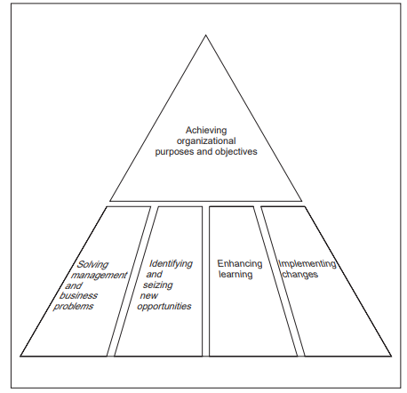
Figure 1.1 Generic consulting purposes.
Achieving organizational purposes and objectives
All consulting to management and business tends to pursue a general and overriding purpose of helping clients to achieve their business, social or other goals. These goals may be defined in various ways: sectoral leadership, competitive advantage, customer satisfaction, achieving total quality or productivity, corporate excellence, high performance, profitability, improved business results, effectiveness, growth, etc. Different concepts and terms reflect the thinking and the priorities of both clients and consultants, the current state of the art of management and consulting, and even fashion. Different purposes will be stressed in commercial enterprises, public services and social organizations. The time horizon of a consultancy will differ from case to case. Yet the common denominator remains the same: consulting has to add value to the client organization, and this value should be a tangible and measurable contribution to achieving the client’s principal purposes.
This global purpose of management consulting provides a rationale and a sense of direction for all consulting work. What would be the sense of organizational learning or costly and risky restructuring if the client organization could not get closer to its principal goals? What would be the use of successfully solving a few seemingly pressing management problems if “like the mythological hydra that grows two heads for every one cut off, the solutions we develop are often rapidly overwhelmed by a plethora of new problems”? The purpose of achieving the client organization’s goals assumes that the client has defined such goals. In some organizations this is not the case, and management operates without any perspective, goal or sense of mission. The consultant’s main contribution may well be in helping the client to develop a vision of the future, set ambitious but realistic goals, develop a strategy, focus on results, and start viewing current problems and opportunities in the light of longer-term and more fundamental organizational goals. Consultants must appreciate that client organizations may be pursuing different sorts of goals. At times, the objective of a consultancy may be to advise the client on how to maintain the status quo or even how to get out of business.
Solving management and business problems
Helping managers and other decision-makers with problem-solving is probably the most frequently mentioned purpose of consulting. The consultant’s task is described as professional assistance in identifying, diagnosing and solving problems concerning various areas and aspects of management and business. Within a business firm, a “problem” justifying the use of a consultant can result from any of the following (and readers can undoubtedly think of many other causes):
complaining clients high staff turnover
poor business results unrealistic self-image
unexpected loss lack of cash
natural disaster idle resources
loss of important market pressure of competition
lack of perspective failure to meet targets
obsolete control system lack of self-confidence
wrong investment choice excess of self-confidence
missed opportunity slowness of action
reluctance to change internal conflicts

The reader should be aware of the different uses of the term “problem” and of their practical implications. If “problem” is used to mean only mistake, failure, shortcoming or missed opportunity, the client’s and the consultant’s perspective will tend to be essentially backward-looking and narrow, and the focus will be on corrective action (with implied criticism and determination of responsibilities). The term “problem” can also be used as a more general concept to describe a situation where there is a difference or discrepancy between what is actually happening or will be happening and what should be happening. In this definition, a problem is described in relative terms, i.e. as a difference between two situations. In addition, someone has to be concerned about this difference and aim to overcome or reduce it. The problem must “belong” to someone – there must be a “problem owner”. Frequently the current situation of the client organization is compared with a situation that existed in the past. If there has been a deterioration such as falling sales or profits, the problem is defined as a need to restore the original condition. This explains why consultants are sometimes called “troubleshooters”, “company doctors” or “business healers”. Alternatively, the current situation may be compared with some standard (benchmark). The problem is then defined as the need to meet or surpass the standard, e.g. a competitor’s product quality, range of models offered or after sales service. In this sense, even a successful and forward-looking company that has been pursuing and achieving ambitious business objectives may have “problems” – a desire to further enhance its competitive advantage, to become a sector leader, not to miss a new marketing opportunity, to identify a new business partner, to explore an emerging technology, and so on. In this guide, the term “problem” will be used in this second way – as a generic term describing a client’s dissatisfaction with the difference between any comparable (but mainly between existing and desirable) situations in the organization. Thus, some of the problems will be related to past errors and shortcomings that need to be redressed; many others will concern perspectives, opportunities and strategies for improving the business in the future.
A correct definition of the problem to be resolved, and the purpose to be achieved by the consultancy, is critical. Experienced consultants warn against accepting the client’s perception of the problem at face value. If the problem has been wrongly defined or misjudged, the consultant will be caught in a trap. He or she will then work on the wrong problem, or the problem and potential benefits from its solution may not justify the consultant’s intervention and the costs incurred. To avoid this, most consultants insist on making their own independent assessment of the problem presented to them by the client, and on developing an agreed definition in discussion and collaboration with the client. The purpose of the consultant’s intervention provides a perspective for dealing with particular problems (see box 1.2).
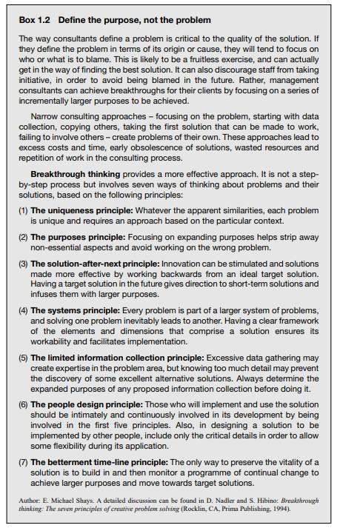

It could be argued that “the purpose is to solve the client’s problem”, but this provides little insight. It has been observed that “effective leaders and problem solvers always placed every problem into a larger context”. This implies getting answers to a number of questions about the purposes of the client organization and its key constituents, the focus and the significance of the proposed assignment, and the immediate and ultimate benefits to be obtained by the client if the current problem is resolved. In this way, it will be possible to select the “focus purpose”, avoiding purposes that are too narrow, as well as those that are too wide and distant to be tackled by the client at present. However, these wider and longer-term purposes ought to be kept in mind in order to place the client’s problem in a proper time perspective and seek solutions that will not block the path to the future. Consulting that is confined to corrective measures, aimed at restoring a past situation or attaining a standard already met by other organizations, may produce significant and urgently needed benefits. A crisis may be avoided, negative developments may be arrested and the client’s business may survive. Yet merely ensuring a return to a previously existing situation or catching up with competition gives the client no competitive advantage, and little additional competence or strength for coping with new situations and achieving superior performance in the future.
Identifying and seizing new opportunities
Most consultants feel that they can offer much more than simply helping organizations to get out of difficulties. This has been recognized by many business corporations and other organizations that are well managed, successful and ambitious. While they may at times call on a consultant to track back deviations that have taken place, and find and correct the reasons for them, they usually prefer to use consultants for identifying and taking new opportunities. They regard consulting firms as a source of valuable information and ideas that can be turned into a wide range of initiatives, innovations and improvements in any area or function of business: developing new markets and products; assessing and using state-of-the-art technologies; improving quality; becoming more useful to customers; developing and motivating staff; optimizing the use of financial resources; finding new business contacts (and contracts), and so on. Experience shows that even strong and important corporations have developed many ideas for action and have seized major business opportunities with the help of consultants. Consulting in e-commerce and e-business is a case in point: its purpose has not usually been to solve existing problems, but to help clients to see and take major new opportunities that can be exploited by adopting new approaches to doing business.
Enhancing learning
“The only work that is really worth doing as a consultant is that which educates – which teaches clients and their staff to manage better for themselves”, said Lyndon Urwick, one of the main contributors to the development of professional management consulting. In the modern concept of consulting this dimension is omnipresent. Many clients turn to consultants, not only to find a solution to one distinct problem, but also to acquire the consultant’s special technical knowledge (e.g. in environmental analysis, business restructuring or quality management) and the methods used in assessing organizations, identifying problems and opportunities, developing improvements and implementing changes (interviewing, diagnosis, communication, persuasion, feedback, evaluation and similar skills).
Consulting assignments become learning assignments. The purpose is to empower the client by bringing new competence into the organization and helping managers and staff to learn from their own and the consultant’s experience. It is often stressed that in this way organizations are helped to help themselves and become learning organizations. As already mentioned, this is a two-way exchange, since by helping clients to learn from experience a management consultant enhances his or her own knowledge and competence. The learning effect of consulting is probably the most important and durable one. The choice of the consulting methods and the degree of the client’s involvement can increase or reduce this effect. We shall, therefore, pay considerable attention to these questions in our guide.
Implementing changes
“Change agent” is another label frequently given to consultants. They are proud to be referred to in this way since this is a reflection of another general purpose of consulting: helping client organizations to understand change, live with change and make changes needed to survive and be successful in an environment where continuous change is the only constant. The importance of this consulting purpose has considerably increased in the current period owing to the complexity and pace of environmental changes, the need to keep informed about changes that may affect the organization and to think constantly of possible implications, the speed with which organizations have to adapt, and the increased demands on people’s flexibility and ability to cope with change.

- How are consultants used? Ten principal ways
In pursuing the generic purposes outlined in the previous section, consultants can intervene in many different ways. Both clients and consultants can choose among so many alternatives that trying to give an exhaustive and complete picture of these alternatives would be an impossible task. However, most of the consulting assistance to management will be given in one or more of the following ten ways:
● providing information;
● providing specialist resources;
● establishing business contacts and linkages;
● providing expert opinion;
● doing diagnostic work;
● developing action proposals;
● developing systems and methods;
● planning and managing organizational changes;
● training and developing management and staff;
● counselling and coaching.
Providing information
Better, more complete and more relevant information is often the main or only thing that a client needs to make the right decision. It may be information on markets, customers, sector trends, raw materials, suppliers, competitors, potential partners, sources of engineering expertise, government policies and regulations, or other. The consulting firm may have this information in its files, or know where and how to find it. Information gathering and analysis may be the only or the main objective of an assignment. Finally, any consulting assignment will have an information dimension and function. There is no consulting that does not involve working with and providing information. In providing information, a delicate question of confidentiality may be faced. Consultants have to distinguish between information that can be provided to a client because it is publicly available or has been gathered and developed specifically for that client, and information developed for previous clients or obtained from private sources, which may need to be treated as confidential
Providing specialist resources
A consultant can be used to supplement the client organization’s staff. Usually such consultants will be specialists in areas where the client is looking for short-term expertise, or wants to avoid recruiting a new employee. Some clients, mainly in the public sector, use consultants in this way to bypass restrictive regulations preventing them from recruiting new staff and/or to avoid keeping expensive specialists on the payroll. Other clients may have been forced to cut down their technical departments and find it convenient to recruit short-term specialists from consulting firms. A special case is “interim management”. Recently this way of using consultants has become more widespread and some client firms may “borrow” staff members of consulting firms to occupy a position in their management hierarchy on a temporary basis.
Establishing business contacts and linkages
Many clients turn to consultants in their search for new business contacts, agents, representatives, suppliers, subcontractors, joint-venture and merger partners, companies for acquisition, business and professional networks, sources of funding, additional investors and so forth. The consultant’s task may involve identifying one or more suitable candidates (people or organizations), presenting their names to the client, assessing their suitability, recommending a choice, defining and negotiating conditions of an alliance or business deal, and acting as intermediary in implementation. Often these contacts will be in sectors or countries not sufficiently known to the client.
Establishing business contacts and linkages
Many clients turn to consultants in their search for new business contacts, agents, representatives, suppliers, subcontractors, joint-venture and merger partners, companies for acquisition, business and professional networks, sources of funding, additional investors and so forth. The consultant’s task may involve identifying one or more suitable candidates (people or organizations), presenting their names to the client, assessing their suitability, recommending a choice, defining and negotiating conditions of an alliance or business deal, and acting as intermediary in implementation. Often these contacts will be in sectors or countries not sufficiently known to the client.
Doing diagnostic work
Diagnostic skills and instruments are among the consultant’s principal assets. Clients use consultants for a wide range of diagnostic tasks concerning the organization’s strengths and weaknesses, positive and negative trends, potential for improvement, barriers to change, competitive position, underutilized resources, technical or human problems requiring management’s attention and so on. Diagnostic work may concern the entire business or a part – a department, sector, function, process, product line, information system, organizational structure or other.
Developing action proposals
Effectively completed diagnostic work may be followed by the development of specific action proposals in an area that was diagnosed. The consultant may be asked to do the whole job, share the task with the client or act as an adviser to a client who has chosen to develop new proposals with his or her own resources. Action proposals may involve one or more alternatives. Also, the consultant may be asked to present alternatives with or without recommendations on the course of action to be taken by the client.
Developing systems and methods
A major portion of all consulting services concerns systems and methods in areas such as management information, business planning, operations scheduling and control, business process integration and management, inventory control, client order processing, sales, personnel records, compensation, and social benefits. Traditionally, many consulting firms have developed one or more of these areas as special lines of expertise. The systems may be custom-made or standard. The consultant may take full responsibility for choosing the most appropriate system, establishing its feasibility, adapting it to the client’s conditions and putting it into effect in collaboration with the client’s staff. Alternatively, clients may play a more active role in developing and adapting the system with the consultant’s support. Many organizations prefer to retain the consultant until the system has been “debugged”, becomes operational and achieves the promised performance. In today’s consulting, most of the systems provided are computerized, and their development, design and application require a combination of management and information technology consulting. A great amount of new systems development and installation is in the fields of e-commerce and e-business.
Planning and managing organizational changes
A fairly common case is that of a client who possesses the technical and managerial expertise to run the organization, but has difficulties and feels insecure when organizational changes are anticipated and cannot be avoided. Often these changes will put a lot of strain on people, since deeply rooted relationships, work habits and individual or group interests will be affected. In such situations, the special expertise sought from a consultant would be in change management – in identifying the need for change, developing a change strategy and plan, choosing and applying the right approaches to encourage change and overcome barriers to change, monitoring the change process, evaluating the progress made and results obtained, and adjusting the approach taken by management at all stages of the change cycle.
The consultant may provide expertise and advice both on specific methods and techniques that are being changed, and on how to deal with interpersonal relations, conflicts, motivation, team building, and other issues in the organizational and human behaviour field. The weight given to behavioural skills will be greater in assignments where change will put a lot of strain on people, resistance to change can be expected and management feels that its own change management skills are inadequate. In addition to behavioural skills, which are sometimes referred to as “soft” skills, the consultant may also provide help in the “hard” skills area: effective scheduling of change; sequencing; coordination; redefining structures; responsibilities and relationships; reallocating resources; adjusting recording and control systems; preventing gaps and disorder caused by poor monitoring of change operations; ensuring smooth transition from old to new work arrangements, costing the project and measuring the results, et.
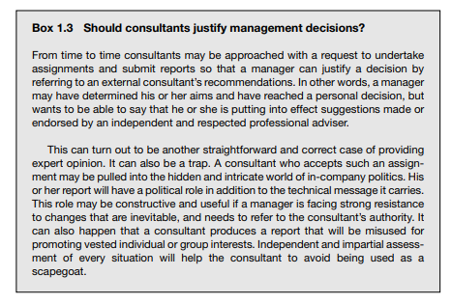

Training and developing management and staff
While learning is a general purpose inherent in all consulting, training and development of managers or staff may be a distinct client service provided separately or in conjunction with and in support of other services. The client and his or her staff will need to be trained in the new methods and techniques provided by the consultant, so that they become autonomous in using and improving them. There are many ways in which diagnosis, advice, systems development and training can be combined in consulting practice. Training can be an alternative to the interventions and ways of using consultants described above. Rather than asking a consultant to work on a specific diagnostic, problem-solving or change management assignment, the client may prefer the consultant to prepare and conduct a course or a workshop for managers and/or staff on the subject. For example, instead of requesting the consultant to identify specific productivity improvement measures and present a productivity improvement programme, he or she may be asked to organize a set of workshops on productivity diagnosis and improvement.
Counselling and coaching
Management consultants can render an excellent service to managers and entrepreneurs who need strictly personal feedback and relaxed friendly advice on their leadership style, behaviour, work habits, relations with colleagues, weaknesses that could be damaging to the business (such as the reluctance to make decisions or the failure to seek the advice of collaborators) and personal qualities that need to be well utilized. Personal counselling is necessarily a one to-one relationship based on trust and respect. It can be informal and should be fully confidential. Coaching, or executive coaching, pursues similar purposes. Despite its obvious potential, few consultants offer such a service to clients and few clients ask for it.

- The consulting process
During a typical consulting intervention, the consultant and the client undertake a set of activities required for achieving the desired purposes and changes. These activities are normally known as “the consulting process”. This process has a clear beginning (the relationship is established and work starts) and end (the consultant departs). Between these two points the process can be subdivided into several phases, which helps both the consultant and the client to be systematic and methodical, proceeding from phase to phase, and from operation to operation. Many different ways of subdividing the consulting process, or cycle, into major phases can be found in the literature. Various authors suggest models ranging from three to ten phases.11 We have chosen a simple five-phase model, comprising entry, diagnosis, action planning, implementation and termination. This model, shown in figure 1.2, will be used consistently in our book. Obviously a universal model cannot be applied blindly to all situations, but it provides a good framework for explaining what consultants actually do and for structuring and planning particular assignments and projects. When applying the model to a concrete situation it is possible to omit one or more phases or let some phases overlap, e.g. implementation may start before action planning is completed, or a detailed diagnosis may not be necessary or can be integrated with the development of proposals. It may be useful to work backwards from a later to an earlier stage. Thus evaluation can serve not only for a final assessment of the results of the assignment and of benefits drawn from change (termination phase) but also for deciding whether to move back and take a different approach. Every phase can be broken down into several subphases or parallel activities. The whole model has to be applied flexibly and with a great deal of imagination. The consulting process can be viewed as a variant of the change process, one in which change is planned, managed and implemented with a consultant’s help. The reader may have seen various models of planned organizational change and may be interested in comparing them with the model in figure 1.2.
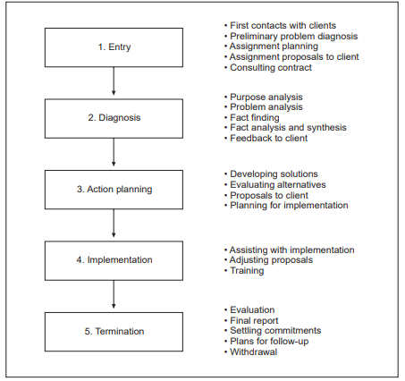
Figure 1.2 Phases of the consulting process
Entry
In the entry phase the consultant starts working with a client. This phase includes their first contacts, discussions on what the client would like to achieve or change in his or her organization and how the consultant might help, the clarification of their respective roles, the preparation of an assignment plan based on preliminary problem analysis, and the negotiation and agreement of a consulting contract. This is a preparatory and planning phase. It is often emphasized that this phase lays the foundations for everything that will follow, since the subsequent phases will be strongly influenced by the quality of conceptual work done, and by the kind of relationship that the consultant establishes with the client at the very beginning. In this initial phase, it can also happen that an assignment proposal is not prepared to the client’s satisfaction and no contract is agreed, or that several consultants are contacted and invited to present proposals but only one of them is selected for the assignment.
Diagnosis
The second phase is an in-depth diagnosis of the problem to be solved. During this phase the consultant and the client cooperate in identifying the sort of change required, defining in detail the purposes to be achieved by the assignment, and assessing the client’s performance, resources, needs and perspectives. Is the fundamental change problem technological, organizational, informational, psychological or other? If it has all these dimensions, which is the crucial one? What attitudes to change prevail in the organization? Is the need for change appreciated, or will it be necessary to persuade people that they will have to change? The results of the diagnostic phase are synthesized and conclusions drawn on how to orient work on action proposals so that the real problems are resolved and the desired purposes achieved. Some possible solutions may start emerging during this phase. Fact-finding and fact diagnosis often receive the least attention. Yet decisions on what data to look for, what data to omit, what aspects of the problem to examine in depth and what facts to skip predetermine the relevance and quality of the solutions that will be proposed. Also, by collecting data and talking to people the consultant is already influencing the client system, and people may already start changing as a result of the consultant’s presence in the organization. Conversely, fact-finding has to be kept within reasonable limits, determined by the nature and purpose of the consultancy
Action planning
The third phase aims at finding the solution to the problem. It includes work on one or several alternative solutions, the evaluation of alternatives, the elaboration of a plan for implementing changes and the presentation of proposals to the client for decision. The consultant can choose from a wide range of techniques, in particular if the client actively participates in this phase. Action planning requires imagination and creativity, as well as a rigorous and systematic approach in identifying and exploring feasible alternatives, eliminating proposals that could lead to trivial and unnecessary changes, and deciding what solution will be adopted. A significant dimension of action planning is developing strategy and tactics for implementing changes, in particular for dealing with the human problems that can be anticipated, and for overcoming resistance to, and gaining support for, change.
Implementation
Implementation, the fourth phase of the consulting process, provides an acid test for the relevance and feasibility of the proposals developed by the consultant in collaboration with the client. The changes proposed start turning into reality. Things begin happening, either as planned or differently. Unforeseen new problems and obstacles may arise and false assumptions or planning errors may be uncovered. Resistance to change may be quite different from what was assumed at the diagnostic and planning stages. The original design and action plan may need to be corrected. As it is not possible to foresee exactly and in detail every relationship, event or attitude, and the reality of implementation often differs from the plan, monitoring and managing implementation are very important. This is also why professional consultants prefer to be associated with the implementation of changes that they have helped to identify and plan. This is an issue over which there has been much misunderstanding. Many consulting assignments end when a report with action proposals is transmitted i.e. before implementation starts. Probably not more than 30 to 50 per cent of consulting assignments include implementation. If the client is fully capable of handling any phase of the change process alone, and is keen to do it, there is no reason why he or she should continue to use a consultant. The consultant may leave as early as after the diagnostic phase. Unfortunately, the decision to terminate an assignment after the diagnostic or action-planning phase often does not reflect the client’s assessment of his or her own capabilities and determination to implement the proposals without any further help from the consultant. Rather it mirrors a widespread conception – or misconception – of consulting according to which consultants do not have to achieve more than getting their reports and proposals accepted by the clients. Some clients choose it because they do not really understand that even an excellent report cannot provide a guarantee that a new scheme will actually work and the promised results will be attained. Other clients may be happy because what they really wanted was a report, not change.
Termination
The fifth and final phase in the consulting process includes several activities. The consultant’s performance during the assignment, the approach taken, the changes made and the results achieved have to be evaluated by both the client and the consulting firm. Final reports are presented and discussed. Mutual commitments are settled. If there is an interest in pursuing the collaborative relationship, an agreement on follow-up and future contacts may be negotiated. Once these activities are completed, the consulting assignment or project is terminated by mutual agreement and the consultant withdraws from the client organization.
A consulting assignment
In practice, the five stages of the consulting process are usually structured, organized and implemented through particular and separate consulting assignments (also called engagements, cases, consultancies, projects or client accounts). In a typical assignment, the consultant and the client agree on the scope of the job to be done:
– the purposes (objectives, results) to be achieved;
– the expertise to be provided by the consultant;
– the nature and sequence of tasks to be undertaken by the consultant;
– the client’s participation in the assignment;
– the resources required; – the timetable;
– the price to be paid;
– other conditions as appropriate
This agreement is confirmed in a consulting contract, which is written in most cases, but can be verbal. The contract will determine the phases of the consulting process that will be covered by the assignment, e.g. the assignment will be completed when an analytical report has been submitted to the client.
Alternatives to separate consulting assignments
An alternative to an assignment covering a distinct task or set of tasks and period of time is a retainer. Under a retainer contract, the client purchases in advance a certain amount of the consultant’s time. The nature and purpose of the work to be done are defined in general terms only and will be specified at the beginning of each period covered by the contract. Collaboration extends over a longer period of time, using a cost-effective format. For example, the client may use the consultant’s services for two days during the first week of every month to review jointly the general situation of the business, the problems and opportunities that have developed and the key decisions that will have to be taken. Or the agreement may define a more or less regular task for the consultant (e.g. assisting management in preparing board meetings) without specifying in advance the time to be spent. There are various types of retainer arrangement, but from a technical viewpoint two types tend to prevail:
● a generalist retainer, under which the consultant follows global results and trends of the client’s business, looking for opportunities for improvement in various areas and feeding the client with new information and ideas;
● a specialist retainer, providing the client with a permanent flow of technical information and suggestions in an area where the consulting firm is particularly competent and advanced (e.g. computer systems, quality management, international financial operations, identification of new markets).
Another alternative used in some technical assistance programmes is a framework contract.12 In this case the consultant is contracted for a certain kind of services over a period of time. Within this framework agreement, specific assignments or missions are requested by the client and agreed upon case by case according to established rules, such as fee rates or consultant profiles, applicable to the whole contract. The negotiation and contracting procedure is thus simplified and accelerated. There are various other modes of purchasing consultant services for longer periods without defining specific assignments and repeating each time all the phases of a consulting cycle as described above. Consultants may be permanent members of various committees or boards, special advisers to top managers, observers and advisers in management and board meetings, training faculty members and examiners, informal advisers acting as sources of new ideas and sounding-boards, or personal counsellors. Sophisticated clients tend increasingly to use these flexible and often more cost-effective formulas.
- Evolving concepts and scope of management consulting
Advice or results?
We have shown that consultants are advisers and remain in this position except when they are recruited by clients to become temporary members of staff. Advisers have no authority to make decisions about a client’s business and their influence has limits. The assignment may be too short and understaffed to produce tangible results, the client may be unwilling to follow the advice given, staff may not collaborate or their resistance and inertia may be too strong, or the consultant may be unavailable for follow-up and debugging. Even the soundest advice alone cannot provide absolute assurance that there will be tangible, measurable, and sustainable results. There is therefore a growing tendency to use consultants for more than providing advice. “Advice” tends to be defined more and more loosely and liberally, and consultants are increasingly viewed as assistants, helpers, service providers or even service brokers who work with clients on various issues for as long as necessary to make sure that tangible and measurable results are achieved. Also, consultant remuneration tends to be increasingly related to results, rather than to time spent on providing advice. Clients would be wise not to get bogged down in vaguely defined time-based assignments with unclear consultant responsibilities and uncertain results. In large and expensive projects, which are often focused on management systems and information technology, clients need to have safeguards against escalating costs, low reliability and failure to meet set parameters and promised performances. Consultants may be offered roles and positions likely to increase their impact on results or to give them more authority and responsibility for achieving certain results in client organizations. New ways of remunerating consultants have become widespread, including equity and stock options. In this way the consultant is clearly accepting to be dependent on the wider and longer-term business results and prosperity of the client, sometimes even beyond the scope of improvements that can be attributed to the consultant’s intervention.
Management consulting, business consulting, or any consulting?
Traditionally the scope of the services offered by management consultants was confined to functions, subjects and problems regarded as part of management, although the scope of “management” has never been fully and accurately defined. Management consultants were keen to stick to their business and maintain their identity, and most of them were not particularly seeking to broaden their services and explore new territory. Over recent decades this attitude has changed dramatically, and in several directions, both in management consulting and in other professional services. Management consultants have started to rethink and redefine their business, widening and enhancing their service offerings, merging or establishing alliances with other consultants and professional service firms, and abandoning self-imposed restrictions on the sort of work they are prepared to undertake. These changes have been triggered by a number of factors, including the growing complexity and sophistication of doing business in national and international environments, market deregulation and liberalization, new opportunities for innovative consulting, growing demand for integrated and “one-stop” professional services, competitive pressure coming from other professions and, above all, the advancement of information technologies and their rapid penetration into management and business processes. In using consulting and other professional services the clients are asking “what will add value to my business”, and the service providers must inevitably adopt the same perspective. In this new environment, some consultants have felt the need to stress that their field of activity is no longer management consulting (narrowly and rigidly defined), but business consulting (a wider concept and service portfolio) or consulting to management, consulting to business or organizational consulting (more open concepts permitting the service portfolio to be easily adjusted as opportunities and demands change).

Practical class

Student must know the principles and theoretic bases the generic purposes and principal ways of consulting and be able to identify and describe the consulting process, evolving concepts and scope of management consulting

Control questions:

- What is consulting?
- Why are consultants used?
- How are consultants used?

Questions for discussion:

- How do we measure the impacts of consultancy on organisational performance?
- How should we interpret the reported benefits of consultancy on organisational performance?

Case study: McKinsey and the Globalisation of Consultancy
What was Marvin Bower’s rationale for wanting to expand McKinsey internationally?
● U.S. based competitors had developed international businesses
● Clients needed to think globally and understand more than America
● Transform national firm into international firm
● Rapid growth of American multinational investment
● A worldwide shortage of U.S. dollars → encourage U.S. corporations to establish factories in EU → to buy American products
● Helps secure the firm’s survival and longevity
1. Enlarge client base (local + international client base)
2. Offer the prospects of lucrative new sources of income
3. Create opportunities for talented people
● Yearned for American management know-how
What were the market-based factors that underpinned McKinsey’s success in expanding globally?
● Europe was successful
● Making contract with local players (not market based factors)
● Shortage US dollar
● At first, one-firm approach → the same and consistent physical office space, dress-code and appearance and format of reports and other documents be uniform
1. To minimise the distractions and deviations the client is likely to take
2. Increase confident from clients and CEO.
3. Build identity
● Recruiting MBAs from Top Rank Business school (Harvard) → focus on young, relatively malleable individuals
● Consultants were rewards on the basis of their performance and were also motivated by promotion from consultant to principal and partner.
● Up or not policy for associates → whose performances were reviewed annually
● Expand large contacts with local elites in foreign countries in order to develop a domestic client base
Scholars have often described consultants as being transmitters of business techniques. Does the case study support this?
New ideas and concepts developed at Harvard Business School and other consultancies leading American business schools were regularly diffused to practitioners by McKinsey and other consultancies.
● McKinsey formalised its own contribution to management knowledge by launching the McKinsey Quarterly
● McKinsey Quarterly presents the firm’s innovative work on management theory to business leaders worldwide
For the consulting industry, what lessons can be drawn from the history of McKinsey & Company?
● One-firm: not only in term of attitude and philosophy but of legal entity
● Local network: McKinsey go to Europe and build that network
● Consulting is very good at helping client with their problems but not their own problems. But McKinsey took time to plan for their success
● Some American consultants sought to apply scientific management in Europe. Bedaux usually giving a minority share in local consultancies to close associates. The role of American consultancies was subsequently eroded by local spin-offs established by former employees
● The adoption of M-form to manage multiproduct firms
● CHANGE
● Premium on pleasing the client
● Quality of its work as the staff expand

Theme 2. The consulting industry

The aim of theme’s study is to learn the main types of consulting organization, generalist and specialist services

Plan
- Range of services provided
- Generalist and specialist services
- Main types of consulting organization
- Internal consultants
- Management consulting and other professions

- Range of services provided
The range of services provided by management consultants mirrors the development of management and business, and of the environmental and other challenges they face. Today’s management consultants may be asked to assist with any type of management or business problem in any sort and size of organization, virtually in any sector and part of the world. The same problem may be approached differently by different consultants, hence the service provided will be different. The consultants’ service portfolio is extremely wide and diversified, and is evolving fast. Service offerings are changing, partly under the pressure of clients’ changing needs, but also as a result of the consulting firms’ own research and innovation aiming to anticipate clients’ needs and offer new and better services to them. In consulting, service innovation and new ways of service integration are key differentiating factors. There have been many attempts to describe and classify consulting services. Information and publicity leaflets of consulting firms often give a listing and description of areas of expertise, but in the absence of standard terminology and service description, firms may use identical terms to mean different things. New terminology is often invented to underline uniqueness and novelty. Generally acceptable and easy-to-understand terms and classifications are yet to be developed.
Management functions, processes and systems
Traditionally, management consulting services were structured in accordance with the prevailing structures of management functions and processes. Services were offered in production organization and management, factory management, marketing and sales, distribution, personnel administration and management, training and development, office organization, financial management, general management and organization, and similar fields. This traditional structuring of service offerings has been very much preserved. Information technology, however, has transformed this area of consulting radically. Currently many consultants assist their clients in implementing IT systems, including assessing needs and feasibility; selecting, developing, adapting, introducing and debugging a system; training staff; and modifying procedures, documentation and work methods accordingly. The general trend has been away from separate systems for each area (production, personnel, etc.) to system coordination and integration, a dominant and promising approach at present.
Specific management problems and challenges
Many consulting services address distinct and separate business problems and challenges, usually cutting across several management functions and processes, reflecting new business opportunities and constraints that require a creative and innovative approach. In these cases the consultant may provide in-depth knowledge, experience and techniques to deal with a particular problem, and help to develop and apply an approach for dealing with the problem effectively in the client’ s particular context. Examples are: business expansion to a new territory, technology transfer, licensing agreements, investment project design, structuring and management, adaptation to new environmental legislation, cross-cultural management, starting an e-business or adding an e-business dimension to current business, and exploiting opportunities offered by deregulation and market liberalization.
Approaches to organizational change and performance improvement
Other consultants emphasize that their main strength and usefulness to clients lie not in a detailed knowledge of a specific technical area or system, but in their ability to share with the client their effective work method – for diagnosing and resolving organizational problems, devising action programmes for organizational change and performance improvement, introducing and improving knowledge management systems, and making sure that such programmes and systems are implemented. Their service is defined neither by the area of intervention (e.g. marketing) nor by the problem to be tackled (e.g. high production or distribution costs), but by the consulting approach or method used. Examples are organizational development, with its wide range of intervention techniques, action learning, team building, business diagnosis, various problem-identification and problem-solving methodologies, creative thinking and innovation techniques, benchmarking, and business process re-engineering. Some of these methods and approaches are highly structured and are applied as complete consulting and training packages, which are often proprietary and protected by copyright. Some are passing fads or new labels for old things. Others are true innovations and their impact on organizational effectiveness and the consulting industry itself can be significant and lasting. Consulting approaches to organizational change and performance improvement are increasingly offered in combination with special knowledge and skills in areas mentioned in the previous paragraphs.
Business strategy and transformation
At the top of the list of consulting services are those that address the very purpose and future of business. These services are in the areas of corporate strategy, strategic planning and decision-making, business alliances and partnerships, major business restructuring, privatization, mergers and acquisitions, total reorganizations, e-business strategies, divestment, and similar. These are “elite and prestige” consulting services as regards their image, required consultant expertise and style, and level of intervention in client organizations. Their impact on the whole organization can be significant and long-lasting. They are interdisciplinary, multifunctional and conceptual by definition, drawing on other groups of services and combining them as necessary. They are highly knowledge-intensive, require considerable experience and do not lend themselves easily to standardization an commoditization. Except in firms that specialize in this area, their volume in the service portfolio of consultant firms tends to be smaller than that of other service groups.
Human resource consulting services
A range of consulting services falls under the broad denomination “human resources”, “human resource management and development”, or “human capital”. Within this area, a number of different concepts and approaches have been practised by various firms over the years. The services include in particular:
● those related to employee benefits (social insurance, pensions, salaries);
● executive search and personnel recruitment services;
● personnel administration;
● human resource and human capital management and development, including training, and strategies and activities.
Sector-specific services
Some consultants have chosen a sectoral approach: they target all their work at one sector, or have established sectorally specialized divisions. The reasons may be both technical (the need for an intimate knowledge of sector technologies, economics, and business practices and culture) and commercial (many clients’ preference for consultants who know their sector). As some practitioners put it: “If you develop a reputation as a sugar-industry consultant, you get sugar-industry clients.” This can be quite useful in sectors that traditionally regard themselves as different from other sectors (e.g. the construction or mining industries) and are sceptical about the value of advice coming from outside the sector. In other cases, sectoral specialization may be the pragmatic choice of a consultant who knows one sector particularly well, or who happens to have a number of clients from the same sector. The shifts in the sectoral focus of consulting reflect the structural changes in the economy. Originally, most consultants worked mainly for industrial and commercial enterprises. Today, consulting for the service sectors tends to be very important; this includes specialized sectoral services in banking, insurance, utilities, telecommunications, transport, community development, central and local government administration, education, health care, voluntary associations, leisure and entertainment. Sectorally specialized services may encompass any of the areas described earlier, from strategy and company transformation issues to operations and efficiency, and may be provided in combination with services that are not sectorally specialized. Despite some obvious advantages, full sectoral specialization of services may lead to conflict of interest in serving clients who compete with each other within the same sector.

- Generalist and specialist services
In consulting, there is a long-standing debate about the pros and cons of generalists and specialists. Some contend that only an all-round generalist is a “real” management consultant; a specialist may be an industrial engineer, a financial analyst, an expert in compensation techniques or an industrial psychologist, but not a management consultant. Others object to this, considering that generalists lack the in-depth knowledge required fully to understand and resolve problems and provide added value in today’s business; therefore to be really useful a consultant must be a specialist. The history and the current profile of the profession indicate that both generalists and specialists have their place in management consulting. The issue is not generalists versus specialists, but how to combine generalist and specialist skills and perspectives to achieve a better total effect.
Specialist work viewed from a generalist perspective
Managing an organization is an interdisciplinary and multifunctional task, and measures taken in one specialist area will affect other areas. Therefore a management consultant should always aim to view specific (and often narrow) problems, requiring the intervention of a specialist, in a wider context. To be a good consultant, the specialist has to be able to look at the problem from the generalist point of view. He or she must be able to apply diagnostic and other methods common to all skilled consultants, and understand organizational relationships. This is one of the main objectives of the theoretical and practical training in a consulting firm.
Cooperation between generalists and specialists
It would be unrealistic to require every consultant to be both a specialist and a generalist, although a few talented and experienced individuals do achieve this. However, in most consulting firms there is some division of work between those who are primarily specialists (and keep up to date in a special area of knowledge and its applications) and those who are generalists (and deal with several areas of management, focusing on their interaction, coordination and integration). The so-called generalists prepare and coordinate global assignments requiring combined specialist and generalist interventions. They normally take care of preliminary organizational diagnoses, negotiations with clients, assignment planning and coordination, drawing of conclusions from specific observations made by specialists, presentation of final proposals to clients, and so on. Supervisory and managerial functions in consulting are often in the hands of the generalists. Some assignments are totally or primarily in the general management field and are undertaken by senior generalists. They concern issues such as corporate policy and strategy, leadership, organizational structure, mergers, turnarounds and the like. Most consulting for small businesses is done by generalists, capable of advising the client on the business in its totality. Clients expect the generalist to suggest the participation of a specialist consultant whenever such a need is identified, just as they expect the specialist to refrain from giving advice in areas beyond his or her competence.
The trend towards specialization
In today’s management consulting there is a pronounced trend towards specialization, reflecting the growing range and complexity of issues handled by consultants. This trend concerns first of all the service specialization of the consulting firms (of all sizes, including individual practitioners). Increasingly, clients are interested in working with firms that do not present themselves as universal experts in solving business problems, but possess the right specialist knowledge and expertise, e.g. in the industrial sector, functional area or special technique concerned. Many firms have been rethinking their profile to adapt to this trend. Furthermore, consulting firms have started to modify their internal staff structure, that is, the numbers and the respective roles of the specialists and generalists employed. As clients seek more input from specialists, firms may employ specialists part time, or borrow their services from another firm. However, many of these specialists, outstanding experts in their technical fields, urgently need to broaden their outlook and improve their understanding of the wider issues. As for all-round generalists, their role in dealing with interdisciplinary and multifunctional problems will remain important. But there are various perspectives and degrees of generalization. Clients are generally less and less interested in consultants who view themselves as universal problem-solvers and claim to be able to handle any situation thanks to their broad experience. Conversely, there is a growing demand for conceptualizers, coordinators and integrators with experience in certain sectors (health, transport) or with particular types of organizational and business problems and situations (mergers and acquisitions, programme coordination, business diagnosis, turnarounds, etc.).

- Main types of consulting organization
The wide range of providers of management consulting reflects the diversity of the clients and markets served, services offered, approaches taken and personalities involved. It also reflects the history of the sector and the growing competition for major clients and contracts. Recently the consulting sector has undergone considerable restructuring and it is still far from being stable. In the literature, firms tend to be grouped and classified by various criteria. In this section, we outline the profiles of the principal groups of actors who shape the current consulting market.
Large multifunctional consulting firms
The market is currently clearly dominated by large multifunctional and multiservice consulting firms, as a result of market growth and concentration over the past 20 years. All the firms in this group have grown thanks both to active business development supported by new staff recruitment and training, and to numerous acquisitions and mergers. A consulting firm employing several hundred professionals can be considered large. There are, however, at least 50 giants in the consulting world with over 1,000 consultants on their staff. In 2000, some 20 firms in this group earned over US$1 billion each. Most of the giants operate as multifunctional and transnational firms, with offices or affiliated companies in 20 or more countries. Their sheer size and influence permit them to deal with a wide range of clients and most complex management problems; they are sometimes referred to as “full-service consulting firms” able to provide “total service packages”. They prefer to serve large and multinational clients, and these clients often prefer to use their services. Many of them also possess certain specialist skills which make them different from each other, e.g. they may be known for sectoral expertise and services, or be particularly strong in management and IT systems, finance, human resources, business restructuring and e-business consulting. The management advisory services (MAS), first established as divisions of major accounting firms, have grown in recent decades into major multifunctional management consultancies. They loom large within this group and hold the leading position on the consulting market internationally. Today they are the world’s largest professional firms not only in accounting and audit, but also specifically in management consulting. They have drawn considerable benefits from their position as leading accounting firms in terms of expertise, image, contacts and assignment opportunities. Previously some of them used to emphasize that they were not keen to undertake just any type of assignment, but only those that “would be expected from a reputable professional accounting firm”, above all financial and general management assignments. This was followed by a period of fast expansion in a wide range of consulting and professional service fields, including human resources, organization development, production engineering, total quality management, management information and control systems, and even small business development.
Strategy and general management consultancies
While most large firms in the groups described above provide consulting in corporate strategy, company organization, business restructuring and other general mangement issues, some firms are particularly focused on this area and position themselves as advisers to management on key issues of strategy (the so-called “strategy houses”) and total business development. They have also added e-business strategy to their portfolio. Consultancies with distinct expertise in strategy and general business development include McKinsey, Boston Consulting Group, Bain, Booz-Allen & Hamilton, A.T. Kerney and Roland Berger. These firms typically declare considerably higher earnings per consultant thanks to the higher fees applied to strategy consulting than to now largely standardized and commoditized services in IT and similar systems (for example, in 2000 McKinsey earned US$470,000 per consultant and Bain US$380,000, while Andersen earned US$150,000 and IBM US$204,000)
Information technology and e-business consultancies
A few years ago, there was a separate emerging and dynamic group of firms providing information technology consulting. While pursuing their expansion, most firms in this group have recently undergone more restructuring and transformation than any other consultancies. At present, the listing of the largest IT consulting service providers includes the same names as the lists of multifunctional and integrated management and business consultancies. As information technologies and systems become better integrated, both among themselves and with management functions and processes, consulting services are following this trend. Firms refer to “integrated development models” and to the necessity to adjust IT consulting to the “increasing complexity of clients’ businesses”. It appears that the future will belong to service providers that can fully and cost-effectively integrate management and IT services, including e-business consulting services.
Employee benefits consultancies
A group of large international consultancies, mainly based in the United States and the United Kingdom, has traditionally specialized in the field of employee benefits, including actuarial services, pension schemes, social insurance and benefits, wage schemes and salary administration, and pension fund management. They also offer consulting in other personnel administration systems and activities. The leaders are Towers Perrin, Watson Wyatt, Mercer Consulting Group, Aon Consulting, and Hewitt Associates. The large multifunctional consultancies and some medium-sized firms are also active in these fields.
Medium-sized generalist and specialist firms
This group embraces a variety of organizations, ranging from a few to 50–100 consultants. Obviously a firm that is small by American standards can be large in a small developing country. Their prevailing technical profiles include: – general management, strategy and business development consulting for small and medium-sized businesses, often in a limited geographical area; – consulting in one or a few technical areas, such as personnel, maintenance, quality management, marketing, sales management, technology transfer or environmental auditing and management; – sectoral specialization, e.g. in urban transport, hospital management, textiles, printing industry, insurance. Entrepreneurial founders and managers of medium-sized firms have been able to find new niches and maintain their firms’ reputation with certain client groups despite the growing power and market share of the large firms. There has been a great deal of restructuring, too. Successful medium-sized firms are viewed as attractive acquisition targets by larger consultancies, especially if they possess specialist expertise sought by a larger service provider or if their acquisition permits entry to new markets. For a medium-sized firm, joining a larger consultancy will often be an attractive solution in a rapidly changing and increasingly competitive consulting market.
Sole practitioners and small partnerships
The existence of thousands of sole consulting practitioners and small partnerships of 2–5 consultants demonstrates that, despite market domination and aggressive marketing by large professional firms, there is plenty of interest in working with independent individuals or small teams and their networks. Small consultancies may be generalists, emphasizing their broad management experience, problem-solving and behavioural skills, or specialists working in a narrow area. Their strength is in a highly personalized and flexible approach, which is more difficult to achieve and apply consistently in a large consulting firm. The services of a senior individual practitioner can also be less expensive, because many of the overhead costs of a large organization are avoided. Before becoming independent consultants, many sole practitioners worked as business executives or employees of large consultancies. Some clients prefer to entrust a complete assignment to an experienced senior person, one who in a larger firm would probably work as a project leader, supervising the work of several more junior consultants through short visits. Sole practitioners are often connected with other colleagues in informal networks and so can collaborate to undertake large and complex assignments, or can recommend another person for work outside their own area of competence. Most of them consult for small enterprises, but even large companies sometimes turn to sole practitioners and small firms for small assignments, policy advice to senior management and special tasks.
Non-traditional suppliers of consulting services
A new group of suppliers of management consulting services has emerged in recent years. This group is rather heterogeneous but has one common characteristic: its original and main function is a service other than consulting, but consulting is viewed as a technically useful and financially profitable addition to its products and services. The group includes, among others:
● suppliers and vendors of computer and communication equipment;
● computer software houses;
● commercial and investment banks, brokers, insurance companies and other organizations in the finance sector;
● suppliers of equipment and turnkey projects in energy, transportation, drinking-water, irrigation and other utilities;
● economic, statistical and sectoral research institutes and information centres;
● other organizations that have turned their internal management service groups into external consulting services. A number of organizations, usually those with a strong mathematical, computer science, operations research or econometrics background, offer special consulting services in areas such as strategic studies, model building, forecasting of consumer demand, systems analysis and design, plant and office automation, and others. Some of them are also referred to as “think-tank” organizations. They may be independent, or associated with a computer firm, a technological university or a research institute. These consulting services tend to be research and/or technology based.
Consulting networks
During the past decade, consulting networks have become important service providers. They exist under various formulas and denominations: long-term partnerships based on formal cooperation agreements operate alongside ad hoc arrangements for single short-term assignments. The obvious advantages of such networks are flexibility, adaptability, potential to augment the marketing and implementation capacity of small service providers, and the opportunities they provide for sharing knowledge and experience. They allow experts who are available for a given project to come together, and permit consultancies to tap expertise outside their existing staff resources, including the expertise of individuals who are not full-time consultants. They also permit individual experts to remain independent while participating in projects that require teams of consultants. Thanks to their flexibility and ability to muster expertise in various combinations in line with changing client needs, the consulting networks and alliances are particularly suited to the information society and knowledge-based economy. They are therefore likely to become more widespread, and adopt various new formats, in the future.

- Internal consultants
An internal consulting unit is one that is established within an organization – a business corporation, a public utility, a government ministry or department – to provide consulting services to other units of the same organization. Definitions and delimitations are not very precise. These services are given many different names, but the term “management services” prevails. They can be found at different places in the organizational structure. Some of them are consulting services in the full sense of the term – they have a mandate to intervene in an advisory capacity at the request of a senior manager, or a unit manager within the organization. In other cases, consulting is only one of the functions, and the units concerned are also responsible for internal audit, accounting and information systems, records and reporting procedures, organizational circulars, staff development or other similar functions.
The current trend
Internal management consulting services have become common in large businesses; these units are staffed by specialists and generalists, some of whom may have had experience with external management consulting or accounting firms. The same trend can be observed in government administrations. Total numbers of internal consultants are not known, but most probably they are large. After some hesitation, professional bodies of consultants have started recognizing internal consultants. Already in 1976, the Institute of Management Consultants in the United Kingdom agreed that the term independent practice “shall include consultants engaged as in-house consultants who meet the required standards of knowledge, experience and competence and are free at all times to offer objective and independent advice”.
Why such an interest?
The rapid growth of internal consulting is a recognition of the power of the consulting approach. Internal units are one way of making consulting more easily accessible and available within an organization. Further reasons for retaining an internal consultant are quick availability, an intimate knowledge of the organization’s internal practices, management style, culture and politics (hence sensitivity and a more rapid orientation in any work situation), and confidentiality. Internal consulting is often thought to be more appropriate for problems that require a deep knowledge of the highly complex internal relations and constraints in large organizations. In governments, they may be given priority for reasons of national security and interest. The cost factor is not negligible. Because of reduced overheads, travel and other expenses, even a well-paid internal consultant will cost 30–50 per cent less than an external one if the company has enough work for him or her.
Independence and other problems
Independence and objectivity represent a problem in some cases, particularly if the management of the organization and the internal consultants fail to clarify the roles and mutual responsibilities of client and consultant within an organization, if consultants are used for anything that comes into an executive’s mind, and if they feel pressured to please top management or their direct client instead of giving an impartial view. An internal consulting service that has low status and no access to top management will not be able to deal with high-level and strategy-related problems, and its recommendations will lack credibility and authority.
Combining internal and external consulting
The use of internal consultants is not a passing fad, but nor will it replace the use of external consultants. The latter will continue to be preferred in situations where internal consultants cannot provide the required knowledge and expertise and meet the criteria of impartiality and confidentiality in dealing with particularly delicate internal issues. In a growing number of cases, assignments are entrusted to joint teams of external and internal consultants. This is a technically interesting arrangement: it can reduce costs; it helps external consultants to learn quickly about the client organization; it facilitates implementation; and it transfers knowledge to internal consultants. Many external consultants enjoy this way of working and regard internal consultants as technical partners, not competitors. They have learned not to underestimate or ignore any internal consultant in a client organization. In many situations it is tactically better if proposals are endorsed by an internal unit, or are presented by this unit, than if they represent only an outsider’s view. Internal consultants are more and more involved in defining terms of reference for external consultants, establishing short-lists for selecting consultants, making the selection, negotiating the terms of contracts, discussing recommendations, and monitoring implementation. Their use can improve the quality and reduce the costs of implementation quite considerably. An interesting way of enhancing the competence and credibility of internal consultants is to involve them in external consulting. Consulting is thus added to the product and service portfolio offered to customers and business partners. For example, management services units in several electricity corporations, railways and other public utilities have developed performance improvement, staff training and other programmes that are of interest to public utilities in other sectors or countries. In-company management services units in various sectors have done a great deal of work on project and systems design, technology transfer, consulting and training in developing countries.
The helping relationship within an organization
Besides the activities of internal consulting units, there are many other opportunities for making effective use of the helping relationship within organizations. Examples are advisory missions of managers and specialists to subsidiaries and plants within a corporation, temporary task forces and project groups, short-term detachments, personal coaching and counselling, ad hoc advice provided by staff departments, and so on. Some of these forms will be described in Chapters 3 and 4 in the discussion of consulting modes and organizational forms and interventions for managing and assisting change. They are often used in connection with a consulting project carried out by an external or internal consulting unit. Although this sort of helping activity is not normally referred to as consulting, it tends to produce better results if the individuals involved are familiar with the principles and methods of consulting.

- Management consulting and other professions
In previous sections, we have made several references to three trends: first, management consultants have been increasingly moving into new service areas, which may be emerging areas of management consulting, but also areas outside the management consulting field; second, other providers of professional and business services have tended to do more and more management consulting; and third, firms from different professions tend to work together more frequently than in the past. Professions no longer enjoy impenetrable borders and absolute protection against “intruders”. They are undergoing profound transformations, which are reshaping individual professions, shifting their borders and changing their status, relationships and methods of work.
Professional service infrastructure of the market economy
To function smoothly, the market economy needs a well-developed, reliable and effective infrastructure of professional services. Management consulting is one of them. The total infrastructure comprises many other services (figure 2.1), all of which serve the same private and public sector client base, including business firms, administrations, social organizations and individuals.

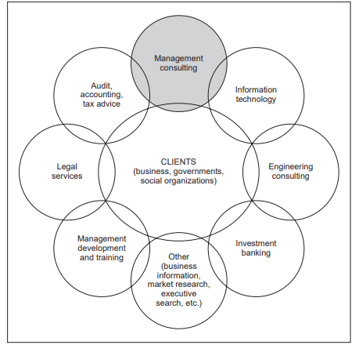
Figure 2.1 Professional service infrastructure

They also serve each other. The structural changes through which business and governments have passed in recent decades have had a major impact on professions providing services to them. The services of lawyers, accountants, investment bankers, management consultants and others are in great demand as the pace of structural changes accelerates and as these changes become radical and complex. Mergers and acquisitions, joint ventures, privatization, structural adjustment, trade liberalization, export development, new forms of cross-border trade and financial operations, major development projects, business alliances, and new laws and agreements regulating business nationally and internationally – all are green pastures for business- and management-related professions. Most of these business transactions and structural changes do not fall under the jurisdiction of one single profession. They involve legal, financial, accounting, organizational, managerial and other aspects, although one of these aspects may dominate in a given case. An international perspective and expertise, and a good knowledge of the perspective taken and services offered by other professions, are increasingly required from all professions. Management consulting has grown and evolved in this context. It has been changing in interaction with other professions, which has included both competition and cooperation. This interdependence is best documented by the spectacular growth of management consulting services of international accounting firms. Within less than 20 years, these firms have been able to become world leaders in consulting in addition to having strengthened their leadership position in accounting and audit.
Competition among professions
Tough competition is one of the main characteristics of the current state of the professions. There is competition both within and among professions. When a new market for professional services starts emerging, firms from several professions may claim that this market is primarily within their province. This has been the case, for example, with privatization, where accounting firms, investment bankers, management consultants and law firms have all been competing for a leadership position and a bigger market share. If the work to be done requires an interdisciplinary approach – which is more and more the case – a firm in one profession may decide to establish a new service line in an area that falls under another profession from a strictly technical point of view. Amanagement consultant might branch out into tax advice, or a computer firm decide to offer management consulting. The firm thus becomes multiprofessional or multidisciplinary. If there are legal or other barriers preventing a combination of certain service lines within one firm, a solution can usually be found by establishing a new sister or affiliated firm for the new service. In some grey areas competition is straightforward. For example, in many countries, company valuation is not a guarded domain of any profession. Management consultants may have advantages in the field: assessing the potential future earnings of a manufacturing company requires an ability to analyse demand and sectoral trends, the maturity level of the technology used, emerging technologies, raw materials, local and foreign competitors, quality and cost of labour, and the like. Still, accountants and investment bankers also offer valuation services, stressing the accounting and financial market aspects and implications. There are, too, independent experts in property, real estate and company valuation. Thus, several professions compete for the same clients.
Cooperation among professions
Cooperation among different professions is an equally important trend. Clients are not interested in interprofessional skirmishes and jealously guarded borders between professions. They resent corporatist attitudes that put the profession’s self-interest before the clients’interests. What they want is a coordinated and even integrated service in which no important aspect of the problem in hand is ignored or treated unprofessionally. If a consulting firm cannot deliver such a service with its own resources, collaboration with other professions can provide a solution. Management consultants collaborate closely with lawyers on many issues with legal aspects and implications. The initiative often comes from the legal side: legal counsel may feel the need for management or financial advice in dealing with a legal problem, and so turn to a management consulting firm, which may or may not already be on contract to a mutual client. However, the management consultant may also perceive the need for legal advice in a given situation, invite a lawyer to participate in a joint assignment, seek consultation with internal counsel or recommend that the client engage outside legal counsel. Another area with numerous links to consulting is audit. Statutory audits in the legal sense of the term, that is, checking and certifying accounting records and financial reports, are not consulting. However, they are only a step away. Auditors who express an opinion on the client organization’s financial records and reports or recommend an improvement – and this is increasingly required by many clients – act as consultants whether they call themselves consultants or not. Forensic audits (examining the health of an organization’s financial management, looking for potential past or future flaws and risks, and identifying responsibilities) are very close to management surveys and audits. Auditing often prepares the ground for important consulting projects and can help to promote consulting; this was well perceived by accounting firms when they decided to enter management consulting. Conversely, providing audits, IT and consulting services to the same clients can lead to problems of lack of independence and conflict of interests. Engineering consultants (consulting engineers) constitute a vast and diversified sector providing technical expertise in areas such as civil engineering, the construction industry, architecture, land and quantity surveying, town and country planning, project planning and supervision, mechanical engineering, chemical engineering, patent services, computer science and systems, and so on. The link between management consulting and consulting in engineering has traditionally been close and the boundaries are in many cases blurred. On the one hand, some engineering consultants also deal with organization and management questions, particularly in areas such as industrial or production engineering and control, quality management, maintenance, feasibility studies, patents and licences, plant design, and project design, implementation and supervision. On the other hand, production management consultants with an engineering background can deal with various production and productivity improvement problems that are of both a managerial and a technological nature. In many contexts the best results will be achieved if management and engineering experts work together on interdisciplinary projects. Several remarks on the relationships between management consulting and information technology consulting have already been made. Indeed, it is at this interface that the most spectacular and most rapid changes have occurred in recent years – and are likely to continue in the future. Computer software houses and hardware manufacturers first entered management consulting in the area of systems design, development and application, and then widened their interest to embrace general management and strategy consulting, and other areas. Management consultants’ strategies have been very similar: they have been adding more and more IT services to their portfolio. On both sides firms have come up with an expanding range of integrated management/systems/IT services, as well as highly specialized services. This has been achieved through numerous mergers and acquisitions, and also through authentic development of new service lines and new competencies.

Practical class

Student must know the main types of consulting organization, generalist and specialist services and be able to identify and describe professional service infrastructure.

Control questions:

- How you understand internal consultants?
- What do you know about main types of consulting organization?
- Explain management consulting in other professions.

Questions for discussion:

- How should consultancy services be prices? Give the examples.

Case Study: When Consultants & Clients Clash
1. What was Statler Group engaged to do?
- To merge both companies’ policies Did Royce Kellogg consider the project to be complex one? - No, he thinks that it is nothing to worry about → easy job
2. What was Royce Kellogg’s initial perception of Barlow and Roussos?
- They are inexperience → even Barlow has 6 years experience, she still has no experiences in merging companies.
- They cause more problems than they solve.
- Too young → don’t respect Did this perception change over time? - The perception about Barlow and Roussos doesn’t change at all
3. What concerns were staff conveying to Royce Kellogg after they had spoken to the consultants?
- Staff were concerned about whose policy would get adopted because it impacted their employment.
- Royce should have communicated to staff → the importance of the work
4. Is the business relationship between the Statler Group and Kellogg-Champion Securities a lost cause? How should the consultants - and the client - handle the status meeting?
- Senior partner from Statler needs to be involved but it has to be gentle introduction/ diplomatic → can’t assert, persuade
- They could wipe the slate clean and you are not changed for work done before and restart again. Mergers are time sensitive and should not be delayed lest the deals falls apart.
- Should not sent the junior consultants to meet directly 1:1 with clients.

Theme 3. The consultant–client relationship

The aim of theme’s study is to learn the client and the consultant systems, different roles of consultant–client relationship

Plan
- Defining expectations and roles
- The client and the consultant systems
- Critical dimensions of the consultant–client relationship
- Behavioural roles of the consultant
- Further refinement of the role concept
- Counselling and coaching as tools of consulting

The consulting process involves two partners – the consultant and the client. In theory it should be easy to put the consultant’s expertise to work on the client’s project, since it is fair to assume that both parties will do their best to achieve the same purpose. The reality is infinitely more complex. The consultant remains external to the organization, someone who is supposed to achieve a valid result in the client organization without being part of its administrative and human system. Even an internal consultant – an organization’s employee – is external from the viewpoint of organizational units where he or she is supposed to intervene. Quite independently of its technical relevance and quality, the consultant’s advice may or may not be understood and accepted by the client. The consultant can upset people and hurt their feelings in many different ways. Rejection can take many forms. The history of consulting contains thousands of excellent reports that have been buried in managers’ desks and never implemented, although they were formally accepted. Many consultants terminate their assignments with feelings of bitterness and frustration. They are absolutely sure that they have provided excellent advice, yet the clients do not follow it. This underlines the critical importance of creating and maintaining an effective consultant–client relationship. Building this relationship is not easy. To achieve success, both consultants and clients need to be aware of the human, cultural and other factors that will affect their relationship, and of the errors to be avoided when working together. They must be prepared to make a special effort to build and maintain a relationship of understanding, collaboration and trust that makes the effective.

- Defining expectations and roles
To begin with, the client and the consultant may look differently at both the expected outcome and the ways of carrying out the assignment. The client may have only a vague idea of how consultants work and may be slightly suspicious – possibly he or she has heard about consultants who try to complicate every issue, require more information than they really need, ask for more time in order to justify longer assignments, and charge exorbitant fees. The client may be approaching the consultant with mixed feelings (see box 3.1). But even if there is no a priori suspicion, and no fear on the client’s side, there is a risk of misunderstanding as regards objectives, end results, roles, relationships and other aspects of a consulting assignment.

Joint problem definition
First, the reason for which the consultant was brought in needs to be well defined. A manager who wants to call for a consultant’s help should not merely recognize a need for such help, but define the problem as he or she sees it, as precisely as possible. In many organizations, top management would not even consider using consultants unless presented with a clear description of the problem and the purpose of the consultancy. Before accepting the assignment, the consultant must be sure that he or she can subscribe to the client’s definition of the problem. Except in the most simple and clear cases, the consultant wants to be able to reach his or her own conclusion as to what the problem is and how difficult its solution might be. There are many reasons why the consultant’s definition of the problem might differ from the client’s. Frequently managers are too deeply immersed in a particular situation to be able to assess it objectively, or they may have created the problem themselves. They may perceive the symptoms but not the real issue. They may also prefer the consultant to “discover” certain significant aspects of the problem. Comparison of the client’s and the consultant’s definition of the problem lays down the basis of sound working relations and mutual trust for the duration of the assignment. It should be discussed. Both the consultant and the client should be prepared to make changes to their initial definition of the problem and to agree on a joint definition. But this first joint definition should not be considered as final. Once the assignment has started, detailed diagnostic work may uncover new problems and new opportunities, requiring a redefinition of the situation.
Results to be achieved
Secondly, the consultant and the client should clarify what the assignment should achieve and how this achievement will be measured. This may require an exchange of views on how each party regards consulting, how far the consultant should continue working on an agreed task (possibly exceeding the scope of that task), and what his or her responsibility to the client is there is often a misunderstanding about the consultant’s role in implementation. The consultant may be keen to participate in it, but the client may be used to receiving reports with action proposals, and to deciding on implementation only after the consultant has left. If possible, the consultant will often try to be involved in implementation. If cost is what worries the client, the consultant’s presence during implementation can be a light one.
The consultant’s and the client’s roles
Thirdly, it is important to determine how the assignment will be conducted by the two parties:
- What roles will be played by the consultant and what by the client? What will be their mutual commitments?
– Who will do what, when, and how?
– Does the client want to obtain a solution from the consultant, or does he prefer to develop his own solution with the consultant’s help?
– Is the client prepared to be intensely involved throughout the assignment?
– Are there specific areas that the consultant should cover without trying to involve the client? And vice versa?
These and similar questions will clarify the client’s and the consultant’s conception of management consulting and of the roles that the consultant can effectively play. The answers will define the strategy to be followed in order to make the assignment a success by both the client’s and the consultant’s standards. During the assignment, many unforeseen events may occur and new facts may be uncovered so that it becomes necessary to review the original definition of expectations and roles. Both the client and the consultant should be alert to this possibility and be flexible enough to adjust their contract and work arrangements. Staff in the client organization may find at some stage that they can easily produce information or action proposals that the consultant was originally supposed to work out, or that the consultant is more useful as a trainer than as a problem-solver. Insisting on keeping to the initial definition of roles, even when conditions change, may be counterproductive.

- The client and the consultant systems
When, how, and between which individuals will the consultant–client relationship be established? The client, in the widest sense of the term, is the organization that employs the services of a consulting firm. There we have an institutional relationship. A professional service firm works for a manufacturing enterprise, an Internet business, or similar. But the term client can also be used in a narrower sense to mean individuals or groups in the client organization who initiate the recruitment of the consultant, discuss the job with him or her, collaborate in the course of the assignment, receive reports and recommend to higher management whether or not to accept them, and so on. Often a number of managers, supervisors, and other staff members will be directly involved in the assignment at its various stages, or will be affected by the conclusions reached. The situation is similar on the consultant’s side. The consultant, in the wider sense of the term, is a service firm, i.e. a legal entity. But the firm employs individuals in various capacities – in management, administration, assignment marketing and planning, supervision, or assignment implementation – who are involved in various ways in negotiating, selling, preparing, managing and executing the assignment. These individuals enter into various relationships with client organizations, their internal units and individual employees.
In the delivery of professional advisory services the consultant–client relationship is always personalized. There will probably be a formal contract between the consulting firm and the organization using its services. However, the service is delivered through direct contact between people acting on behalf of the two organizations. This is fundamental. A productive relationship cannot be guaranteed by any legal contract between organizations; it will depend on the abilities and attitudes of the individuals directly involved, and on the “psychological contract” between them. In working with client organizations, management consultants may discover highly complex relations. They may face conflicting expectations, hopes and fears, respect and disrespect, confidence and distrust. Information may be readily offered or deliberately concealed or distorted. Consultants refer to the chemistry of “client systems”, taking a systems view of the organization and trying to map out the network of relationships in which they are going to operate. This may show that, for the consultant, the client system embraces only one part or aspect of the client organization. Within the client system, the consultant then needs to determine:
– who holds the real power for making decisions related to the assignment (at all stages);
– who has the main interest in the success or failure of the assignment;
– who should be kept informed;
– whose direct collaboration is essential.
Many consultants make the mistake of automatically considering and treating the most senior person as their main client. This can upset the people who know that they will have the main responsibility for implementing the conclusions reached, and that they – not the top manager – will be directly affected and will have to live with the results. On the other hand, it may also be a great mistake to leave out the high-level manager. He or she should be informed and asked for support at an early stage. During the assignment, the consultant continues to explore the client system and improve his or her understanding of the roles played by various people. He or she does this in order to confirm or modify the original assessment of roles, and also because assignments are dynamic processes and shifts in role can occur at any moment. For example, the appointment of a new manager can change the course of a consulting assignment dramatically. Some situations may be particularly intricate, e.g. if the consultant does not really understand who the main client is or whom he or she should try to satisfy first of all. This may happen, for example, if top management recruits the consultant, but leaves it solely to a functional department to handle the job, if a consulting assignment is recommended and sponsored by a bank as a precondition of a loan to its client, or if a ministry sends consultants to a public enterprise. In these and similar situations, the consultant needs to clarify whether he or she is supposed to act as an inspector, an auditor, an informant, or a real management consultant. He or she should find out who “owns” the problem and is keen to resolve it – this will be the main client.
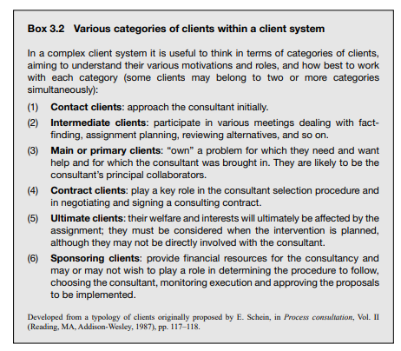

- Critical dimensions of the consultant–client relationship
Different situations and client expectations lead to different definitions of the consultant’s roles and methods of intervention. Nevertheless, even if situations, assignment strategies and consultant work methods exhibit considerable differences, all consultants and clients will try to establish and nurture relationships in which they can work together to achieve a common purpose. Three dimensions of these relationships are critical: collaboration, sharing of knowledge, and trust. These dimensions are essential in consulting and could be described as objectives to be pursued in order to make the relationship fully productive and satisfying to both sides.
Collaborative relationship
Without client–consultant collaboration, there is no effective consulting. Yet the need for active collaboration is not automatically perceived by every client and various misconceptions may have to be dispelled. Some clients imagine that by actively collaborating with the consultant they are doing the job themselves, paying the consultant a handsome fee for nothing. The consultant who insists on the client’s collaboration may be compared to “the guy who borrows your watch to tell you the time”. Often the readiness to collaborate is tested at the fact-finding stage. The client may feel that the consultant should not be given all the data he or she requests and may even instruct staff to withhold information. The client’s reluctance to give the consultant all the information on the state of the business cannot always be interpreted as unwillingness to establish a collaborative relationship. Accounting and financial information, for instance, may be regarded as strictly confidential by the client, and the consultant should only ask for such information if it is strictly necessary. The modern concept of consulting methodology assumes strong client collaboration for the following main reasons:
(1) There are many things that the consultant cannot do at all, or cannot do properly, if the client is reluctant to collaborate, for example, if the consultant is refused information or cannot exchange ideas with the right people.
(2) Often higher management is unaware of the competence that exists in the organization, and important strengths may be unknown to it. Through collaboration, consultants can help clients to discover and mobilize their own resources. Also, collaboration allows the consultant to refrain from undertaking tasks that the client is able and willing to do, thus saving the consultant’s time and reducing the cost of the assignment.
(3) Collaboration is essential if the client is to be fully associated with the definition of the problem and with the results of the assignment. Consultants often emphasize that their client must “own” the problem and its solution. The reason is that people often reject changes proposed or imposed from the outside. By collaborating on a solution the client is more likely to be committed to it and will not put all the responsibility on to the consultant. This commitment will be not only rational, but also emotional. We all know that we tend to have different attitudes towards projects into which we have put long hours of hard work and a lot of energy, and where we have seen solutions emerging from our thinking and debates with other people, and to solutions that we are asked to adopt without ever having been consulted on them.
(4) Most importantly, if there is no collaboration, there can be no transfer of knowledge or learning on either the client’s or the consultant’s side. Learning does not occur by defining terms of reference, and accepting or rejecting a final report, but by joint work at all stages of an assignment, from problem definition and diagnosis, to implementation and the assessment of results. In a consulting context, learning is embedded in collaboration.
Relationship of trust
Collaboration and knowledge-sharing generate trust. In The trusted advisor, 2 David Maister, Charles Green and Robert Galford explain why trust is the most important and critical issue in the consultant–client relationship. Unless the consultant becomes a trusted adviser, the breadth of business issues he or she will be asked to deal with and the depth of the personal relationships he or she will be able to develop with the client will remain limited. This breadth will increase as the personal relationship deepens from
(1) a service-offering-based relationship, through
(2) a needs-based, and
(3) a relationship-based, to
(4) a trust-based one.

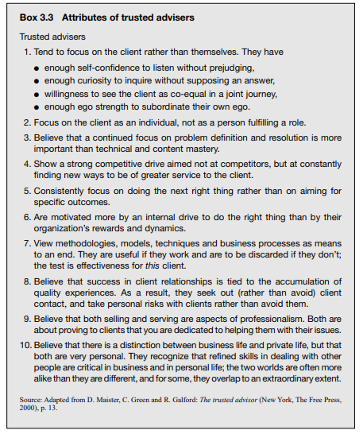

It would not be reasonable to claim and expect the client’s full trust at the very beginning of the relationship. Trust must be earned, and this means that the client must be convinced that the consultant merits trust and will not betray it. By trusting an adviser the client obviously takes a personal risk. Earning the full trust of managers and entrepreneurs is not easy, but it is worth the effort. Indeed, such a relationship can be very rewarding for the consultant.
Once he or she is a client’s trusted adviser, the relationship with the client becomes less formal and more open, at times even privileged. The consultant and the client can deal with issues, including delicate personal and confidential business issues, that would not even be mentioned in other circumstances. Less effort is needed to obtain new work and the client is likely to recommend the consultant without hesitation to business contacts. A consultant who demonstrates sincere interest, an understanding of the client’s problems and concerns, and flexibility can expect the same from the client. The trusted adviser’s status is an important part of the consultant’s intellectual capital, and it would be foolish to waste it. Some attributes of trusted advisers are listed in box 3.3.
The benefits to the client of a trust-based relationship with a consultant are obvious. In business and management, it is crucial to have colleagues and partners who can be trusted. The considerable risks involved in choosing and employing consultants are thus minimized. Trusted advisers can be involved in difficult and delicate issues and are likely to be easily accessible. Their advice is often available at short notice and will be provided informally if necessary. Conversely, clients know that their trusted advisers will not accept assignments for which they do not feel competent, and will not promise results that cannot be achieved.

- Behavioural roles of the consultant
This section examines the concept of the consultant’s behavioural roles (consulting modes), a topic that is very popular in the literature on consulting. It describes, in a condensed form, the most typical and frequent consulting behaviours, how consultants relate to clients, what inputs they make, and in what way and how intensively clients participate. The roles assumed depend on the situation, the client’s preferences and expectations, and the consultant’s profile. There is no shortage of descriptions and typologies of consulting roles. We have found it useful to make a distinction between basic roles, which include the resource and the process role, and a further refinement of the role concept, in which many more roles or sub-roles can be visualized in order to facilitate the understanding of the various intervention modes used in consulting.
Basic roles: the resource role and the process role
In the resource role (also referred to as the expert or content role), the consultant helps the client by providing technical expertise and doing something for and on behalf of the client: he or she supplies information, diagnoses the organization, undertakes a feasibility study, designs a new system, trains staff in a new technique, recommends organizational and other changes, comments on a new project envisaged by management, and the like. Management collaborates with the resource consultant, but this collaboration may be limited to providing information on request, discussing the progress made, accepting or declining proposals, and asking for further advice on implementation. Management does not expect the consultant to deal extensively with the social and behavioural aspects of the change process in the organization, even if the consultant is expected to be aware of these aspects. In the process role, the consultant as an agent of change attempts to help the organization solve its own problems by making it aware of organizational processes, of their likely consequences, and of intervention techniques for stimulating change. Instead of passing on technical knowledge and suggesting solutions, the process consultant is primarily concerned with passing on his or her approach, methods and values so that the client organization itself can diagnose and remedy its own problems. In various descriptions of process consulting, the organizational behaviour approach comes across loud and clear.
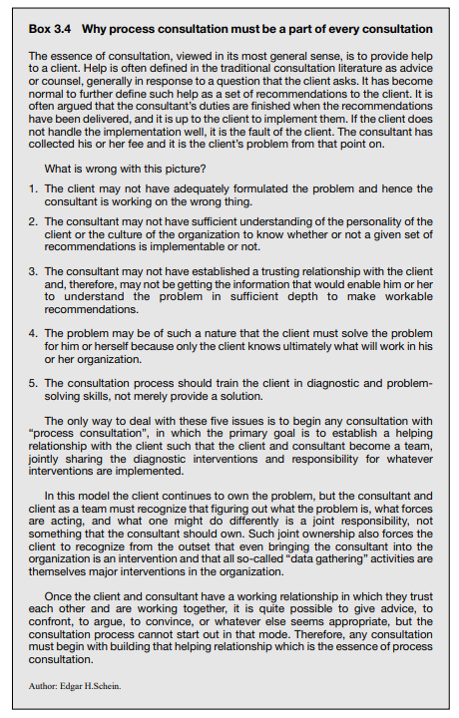

Expressed in simpler terms, while the resource consultant tries to suggest to the client what to change, the process consultant suggests mainly how to change and helps the client to go through the change process and deal with human and other issues as they are identified and understood. Edgar Schein describes process consultation as “the creation of a relationship with the client that permits the client to perceive, understand and act on the process events that occur in the client’s internal and external environment in order to improve the situation as defined by the client”. According to Schein, “at the core of this model is the philosophy that the clients must be helped to remain proactive, in the sense of retaining both the diagnostic and remedial initiative because only they own the problems identified, only they know the true complexity of their situation, and only they know what will work for them in the culture in which they live”. While any consulting involves some collaboration with the client, the process approach is a collaborative approach par excellence.
Choosing between the basic roles
Some years ago, “pure” resource or expert consulting was quite common. In today’s consulting practice, it tends to be used mainly in situations where the client clearly wants to acquire and apply, in one way or another, special technical expertise, and does not want the consultant to become involved in human problems and organizational change. In most situations, the resource and process roles are combined in a complementary and mutually supportive way. This is possible thanks to the increased competence of management consultants: today even technical specialists intervening in a relatively narrow area tend to have some training in the behavioural aspects of organizational change and of consulting, and are keen to help in implementation. On the other hand, the “pure” behavioural scientists, the traditional protagonists of process consulting, have recognized that their ability to help in organizational change would remain limited if they did not improve their understanding of technical, economic, financial and other problems and processes in client organizations. Thus, more and more consultants feel comfortable in both roles. Nevertheless, there are situations, or phases in assignments, where one or the other approach predominates and is more effective. A consultant may start an assignment in a resource role in order to become acquainted with key data on the client organization and demonstrate to the client that he fully understands what is going on as an expert in the technical field concerned. As time goes on, he may act more and more as a process consultant, involving the client in looking for solutions likely to make effective use of the client’s capabilities and to be internalized by the client. He may temporarily switch back to the role of resource consultant to provide missing technical knowledge so that the process of change does not stop. Conversely, other consultants emphasize that they would start every assignment in the process mode in order to ensure the client’s active involvement and develop a fair understanding of the organization’s human problems right at the beginning. “It is most necessary early in the encounter because it is the mode most likely to reveal what the client really wants and what kind of helper behaviour will, in fact, be helpful.”5 They would then switch to other roles or models when they feel that this is the right way to proceed. In choosing a role, the consultant must never forget that it constitutes a “communicating vessel” with the client’s role. Both the consultant and the client should feel competent and comfortable in their respective roles and believe that they have made the right choice. No one should try to use a role model that is alien to his or her nature and in which he or she will not be effective. The client may be unaware of the various consulting roles, or may be used to a different consulting style from previous projects. This should be discussed and clarified as early as possible in an assignment.
- Further refinement of the role concept
Reducing the various consulting processes to two basic roles or modes is a simplification that is conceptually useful, but that disregards a number of situational variables. For practical purposes it is instructive to visualize a greater number of consultative roles along a directive and non-directive continuum, as suggested by Gordon and Ronald Lippitt and illustrated in figure 3.1. By directive we mean behaviours where the consultant assumes a position of leadership, initiates activity or tells the client what to do. In the non-directive role he or she provides information for the client to use or not. Here again the situational roles are not mutually exclusive and can manifest themselves in many ways in a particular consultant–client relationship. The consultant may find it useful to play two or more compatible roles simultaneously or consecutively, switching from role to role as the relationship evolves. These roles are “spheres of influence” rather than a static continuum of isolated behaviour. Let us examine the different role choices in response to a client’s needs.
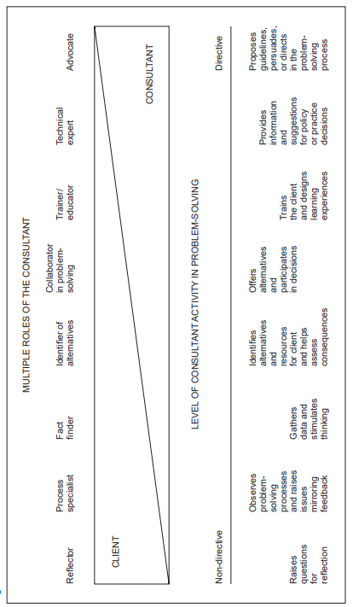
Figure 3.1 Illustration of the consultant’s role on a directive and non-directive continuum

Advocate
In an advocate role, the consultant endeavours to influence the client. There are two quite different types of advocacy:
● positional or “contact” advocacy tries to influence the client to choose particular goods or solutions or to accept particular values;
● methodological advocacy tries to influence the client to become active as problem-solver, and to use certain methods of problem-solving, but is careful not to promote any particular solution (which would be positional advocacy). In this role, the behaviour of the consultant is derived from a “believer” or “valuer” stance on content or a methodological matter.
Technical expert
One of the roles adopted by any consultant is that of technical specialist or expert. As mentioned above, the traditional role of a consultant is that of an expert who uses special knowledge, skill and professional experience to provide a service to the client. The client is mainly responsible for defining the objectives of the consultation. Thereafter the consultant assumes a directive role until the client is comfortable with the particular approach selected. Later in the relationship the consultant may act as a catalyst in helping to implement the recommendations made. The consultant may be a resource (content) specialist in the client’s problem, or a process specialist advising how to cope with a problem and how to implement change. This particular role makes use of the consultant’s substantive knowledge.
Trainer and educator
Innovative consultation frequently requires the consultant to carry out periodic or continuous training and education within the client system. In this aspect of the helping relationship, the consultant can suggest the most appropriate learning process, depending upon the situation and the need. The consultant may design learning experiences, or train or teach by imparting information and knowledge directly. This work requires the consultant to possess the skills of a trainer and developer of others’ potential.
Collaborator in problem-solving
The helping role assumed by the consultant uses a synergistic (cooperative) approach to complement and collaborate with the client in the perceptual, cognitive and action-taking processes needed to solve the problem. The consultant helps to maintain objectivity while stimulating conceptualization during the formulation of the problem. Additionally, he or she must help to isolate and define the dependent and independent variables that influenced the problem’s cause, and will ultimately influence its solution. He or she also assists in weighing alternatives, sorting out salient causal relationships that may affect them, and synthesizing and developing a course of action for an effective resolution. The consultant in this role is involved in decision-making as a peer.
Identifier of alternatives
There are direct costs associated with decision-making. While the value of a decision is dependent upon the attainment of a given set of objectives, in selecting an appropriate solution to a problem the consultant can normally identify several alternatives, along with their attendant risks. The alternatives, together with their economic and other identifiable implications, should be discovered jointly by the client and the consultant. In this helping relationship, the consultant establishes relevant criteria for assessing alternatives and develops cause–effect relationships for each, along with an appropriate set of strategies. In this role, however, the consultant is not a direct participant in decision-making, but a retriever of appropriate alternatives facing the decision-maker.
Fact-finder
Fact-finding is an integral part of any consulting assignment, both for developing a database and for resolving intricate client problems. The consultant’s role may even be confined to fact-finding. In this case he or she will assist the client system by choosing the sources of data, using a technique that will get the client more or less involved in gathering and examining data, and presenting data to the client in a way that will show where and why improvements are needed. In this role the consultant functions basically as a researcher.
Process specialist
The consultant focuses chiefly on the interpersonal and intergroup dynamics affecting the process of problem-solving and change. He or she works on developing joint client–consultant diagnostic skills for addressing specific and relevant problems in order to focus on how things are done rather than on what tasks are performed. Furthermore, the consultant helps the client to integrate interpersonal and group skills and events with task-oriented activities, and to observe the best match of relationships. In this role, an important function of the consultant is to provide feedback.
Reflector
When operating in the mode of a reflector, the consultant stimulates the client to prepare and make decisions by asking reflective questions which may help to clarify, modify or change a given situation. In doing so, the consultant may be an arbitrator, an integrator or an emphatic respondent who experiences jointly with the client those blocks that provided the structure and provoked the situation initially.

- Counselling and coaching as tools of consulting
Counselling
Counselling is a method whereby individuals are helped to discover, understand, face and resolve their own personal problems, which may be related to education, health, employment, competence, career, relations with colleagues, family relations and so on. Counselling is often thought of as an intervention that is very different from management and business consulting. Yet there is tremendous potential for using counselling as a tool of consulting, especially in helping individuals or groups to overcome personal difficulties and become more effective as managers and entrepreneurs. Counselling is necessarily a one-to-one relationship. In the case of small businesses, the person and the business may even be one and the same. A counsellor is consistently concerned in a very personal way with the problems and opportunities facing a particular individual. The counsellor’s aim should be to help his or her personal client rather than the organization, if their interests do not coincide, and it is perfectly possible for the person being counselled to decide to leave the organization or close down the business as the result of an effective counselling process. However, a more frequent and typical result of personal counselling is a client who feels empowered, more self-confident and more independent in pursuing personal objectives and reconciling personal and organizational objectives. It may be not too much of an exaggeration to suggest that the best evidence of an effective counselling relationship is when the client denies that the counsellor has had any role at all in the successful resolution of his or her difficulties. An effective counsellor is above all a good listener. All too often managers need most of all someone who will listen to them in an understanding way. They may be afraid of the people who are above them in the hierarchy, while those who are below them are afraid of them in their turn. In some organizations, honest admission of confusion and uncertainty is regarded as a sign of incompetence or weakness, and few managers are fortunate enough to have friends outside the organization who have the time or the ability to listen to them. A consultant who has been called in to what appears to be a traditional consulting assignment may find himself or herself in the position of having to be a counsellor to a lonely and distressed person. It is important not to regard time spent in this way as a distraction from the main business: it may well be the most important contribution that an outsider can make. Good listening in itself is not as simple as it might appear, but there is more to counselling than sympathetic listening. A counsellor is clearly more of a process facilitator than a specialist resource, whose task is to help the client to think through his or her personal situation, difficulties, priorities, and options, and the advantages and disadvantages of each, and then decide to act. Not only should the counsellor not propose solutions to the client, but he or she may not even participate too actively in the process of problem identification. The counsellor should rather help the client to identify his or her own problems, and the solutions to them, by asking questions, listening, and being supportive and encouraging. At the same time he or she must be scrupulously neutral in regard to what the client decides to do, since the objective is to develop the client’s ability to perform better in every way, and not merely to advise him or her what to do in a given situation. The fundamental task of the counsellor is to help clients to think things through, to organize their own approach to thinking about their work and perhaps their life in general. The counsellor must have a genuine desire to put himself or herself out of business by enabling the client to perform effectively without further counselling. Personal development of this sort obviously requires very different skills and, possibly, a different order of responsibility from those normally required of a consultant. A counsellor may need no particular management skills or experience, and such skills can even be a disadvantage, since he or she may be tempted to make technical suggestions to the client rather than letting the client come up with his or her own ideas. The client will be more likely to expect such suggestions and be diffident about putting forward ideas if he or she knows that the counsellor is an expert in the topic at hand. Because the task is so personal, and so all-embracing, it is easy for counselling sessions to evolve into unstructured conversation. Like any consultancy, counselling almost always involves a series of meetings, and it is important to ensure that the client has a sense of progress from one session to another. One way of doing this is to conclude each session by agreeing on certain tasks that the client, and perhaps the counsellor, will complete before the next session. It is important not to allow assignments of this kind to turn into instructions which take the decision-making away from the client. Finally, it is all too easy for the client to become dependent on his or her counsellor. This is exactly what must not happen, since the objective is to enable clients to be independent. A good counsellor must “move in” and establish a trusting relationship with the client, so that he or she draws out the client’s feelings and all the information that may be relevant, but the counsellor must also learn how to “move out” and leave the client at the end of the process. At the beginning it may seem difficult to create the necessary trust, but in the end breaking away is often even more difficult. An effective counsellor is able to do both.
Coaching
Some professional groups refer to “coaching”, by which they mean individualized and non-directive assistance to people to discover and realize their full potential, set and reach better goals, become more self-confident, and overcome various personal problems and barriers to performance and achievement. The basic philosophy of coaching is very close to counselling.
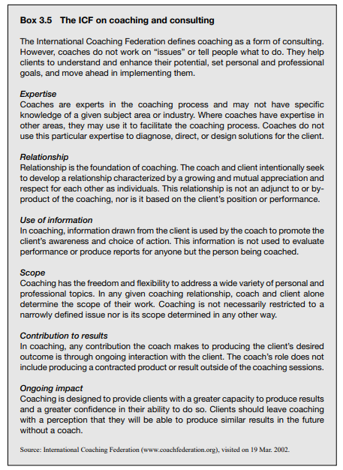
Box 3.5 contains the International Coaching Federation (ICF) definition of the relationship between coaching and consulting. Coaching can be practised in various ways by professional coaches, or by managers, supervisors, human resource specialists, consultants and others who have acquired coaching skills and are willing to act as coaches for their peers and junior colleagues.
Consultants may coach either their clients or their colleagues within the consulting firm. If a partner, team leader or practice leader acts as a coach, he or she will obviously relate the coaching to the work context and focus on helping colleagues to cope with various issues involved, such as stress, work organization, tackling new tasks, dealing with clients, learning, knowledge sharing and collaboration within the team, professional ethics, harmonizing personal life and professional goals, and others. In any event, the purpose and scope of coaching have to be agreed between the coach and colleagues or clients who wish to be coached.

Practical class

Student must know the client and the consultant systems, different roles of consultant–client relationship and be able to identify and describe the consultant’s role on a directive and non-directive continuum

Control questions:

- What are the main client and the consultant systems?
- What is the critical dimensions of the consultant–client relationship?
- Explain the behavioural roles of the consultant.

Questions for discussion:

- Counselling and coaching as tools of consulting
Explain the role of counselling and coaching in consulting. Give the examples.

Class Discussion Questions
● What costs and benefits may affect management consultants?
Costs
- They might lose up valuable people
- Take away element of creativity
Benefits
- Give them credibility
- Get an extra qualification behind your name
- Cut out the competitors cost of fragmented
● Who benefits from accreditation? Identity the stakeholders that benefit the most?
Client makes benefit from this, understanding what they gonna get from consultancy. clients don't know how to differentiate, what they can ask the consultants. however, you must balance the credibility.
● Would top-tier consulting houses like BCG, McKinsey and Bain be supportive of initiatives to certify practicing management consultants?
Beneficial than other consultancies

Theme 4. Fundamentals of management in the consulting profession

The aim of theme’s study is to learn the management challenge of the professions, achieving excellence professionally and in business

Plan
- The management challenge of the professions
- Managing a professional service
- Managing a professional business
- Achieving excellence professionally and in business

- The management challenge of the professions
As a relatively young profession, management consulting should be able to draw some lessons from the management experience accumulated by older and better-established professions, such as law or accounting. Unfortunately, management is a relatively new and underdeveloped field in all professions. Professional firms historically have been managed in one of two ways – badly or not at all. Management, as a distinct function and approach to running an organization, starts being practised systematically and consistently only when it becomes a recognized necessity. As long as professionals operate as individuals, independently or through loose groupings, sharing some physical facilities and administrative support, but each serving his or her own clients and ignoring the clients of colleagues, the management function looks superfluous, even undesirable. The key factor leading to the management of professions was the growing size and complexity of professional firms and of the tasks they tackled. The second factor was changes in the market and in competition. With the gradual disappearance of protective regulations and traditional attitudes inhibiting competition, professional firms started to be exposed to market pressures and opportunities like businesses in any other sector of the economy. Issues such as marketing, selling, product life-cycle, profitability, innovation and efficiency became important and had to be addressed. Conversely, certain factors have hampered the advent of modern management in the professions. First is the ambiguous attitude of many professionals to management. While they generally do not object to belonging to a wellestablished and financially strong firm, as individuals they cherish their freedom and dislike discipline. Many of them do not want to have anything to do with management or paperwork. This creates paradoxical if not inextricable situations. In Bruce Henderson’s words, “the basic paradox is the requirement to manage the unmanageable”.1 Another constraint has been the shortage of managers for professional service organizations. The best professionals can be the worst managers. Many professionals are prepared to devote some time to management, say by supervising a small team, if this does not take up more than a third or a half of their time. Few are prepared to give up all client work to become full-time managers of other professionals. Also, their colleagues must be willing to accept them as managers. Compromises therefore have to be adopted, mostly by combining management with direct work for clients, or rotating managerial roles. This, however, is more difficult in large firms, some of which have recruited full-time managers from outside – with mixed results. A third constraint has been the underdeveloped body of knowledge on the management of professions. Understandably, meaningful concepts and theories could not start developing as long as there was no practical ground, accumulated experience and demand. Significant contributions are few, and these date mainly from the past decade. In summary, the case for competent and effective management of professional service organizations seems to have been made. In addition to the competence, integrity and motivation of individual professionals, the management of professional teams and organizations is increasingly recognized as a key factor of service quality and business performance. Yet many professional firms have a long way to go to become well-managed organizations. In identifying the management requirements of consulting activities, we look first at consulting from two different perspectives. First, consulting is a professional service and some of its management requirements are determined by this characteristic.

- Managing a professional service
Understanding the nature of the service
It has been pointed out many times that professional services produce intangible outputs or products. In consulting, the product is the advice given to the client. Alternatively, if implementation is included, one could say that the final product is the change that occurs and the improvements achieved in the client organization thanks to the consultant’s intervention. Such a product is difficult to define, measure and evaluate. The client’s view of the product and its real value may be quite different from the consultant’s. In marketing his or her services, what the consultant is selling is essentially a promise – of help that will satisfy the client’s needs. To use Theodore Levitt’s words, clients cannot “see, touch, smell, taste or test” the product before deciding to purchase it. They have to look for surrogates in assessing whether the consultant is likely to deliver what has been promised. This explains the crucial role of self-assessment, self-discipline and an ethical approach in marketing and delivering the consulting service. Often the consultant will be the only person able to judge what services to offer in general, and what he or she can promise and actually deliver to a particular client. There are ways of reducing uncertainty by increasing product tangibility. The client can be given a manual describing in detail how the business will be diagnosed, what data will be examined, comparisons made, ratios produced and suggestions developed. Or the consultant may be offering a system or a procedure, which will be delivered as such, in its standard form, or with adaptations and supplements. As discussed in Chapters 1 and 2, service and product commodification has progressed in consulting. Any large consultancy has some tangible standard products to offer and some small firms have been completely built around one or two proprietary systems. Yet the basic issue remains the same. Every client organization is unique and there is no certainty that even an excellent standardized system will be effective in every client’s environment. Even the largest consultancies are not in the mass production and “ready-to wear” business but in “tailor-made” services and products. Determining what services to standardize is a key strategic decision. There are consultants who have spoilt their reputation by selling standard packages to clients who needed an individualized approach. On the other hand, a standard system or methodology applied flexibly and with imagination, and in combination with and in support of an individualized approach where appropriate, can increase the quality of the service and reduce the costs both to the consultant and to the client.
Managing the consultant–client interface
Building and managing a clientele is a crucial issue in managing professional consulting. If there is no client, there is no consulting. The consultant does not produce for stock, getting ready for prompt delivery once a client calls. The client is a direct participant in the production of the service. As a minimum, he or she helps the consultant to define the scope of the advice, provides needed information, and then receives the advice. In process consulting, it is the client who produces, while the consultant acts mainly as a catalyst. The link between the consultant and the client is a highly individualized one. On each side of the partnership there is one person or a small team. Whatever the size and complexity of the professional service firm, it sends individual professionals or relatively small teams to clients for specific assignments. Large consulting firms can handle larger and more complex projects (the largest projects including major inputs of IT may involve hundreds of consultants), and can support consultants on assignments with the collective know-how of the whole firm. Nevertheless, even a very large firm operates through individual client assignments and cannot think of selling services to unknown customers through networks of retailers. Clients, and the quality of relationships with clients, constitute the consultant’s “customer capital”. This capital has to be created, built up, maintained, improved, expanded and rejuvenated. Situational variables determine when a consultancy needs to focus on finding new clients, entering new markets, promoting repeat business with existing clients, offering clients new value and better quality, analysing and restructuring the clientele, etc.
Managing knowledge
To be able to transfer knowledge to clients, a consulting firms creates, develops and manages its own knowledge base. Knowledge management as such is nothing new and most professional firms have always used it to some extent: information systems, documentation, report libraries, client files, project debriefings, brain storming sessions, news sheets and similar services and activities have been used for years. What is new today is a more structured and conceptual approach, the use of powerful and flexible IT systems and the Internet, and increased emphasis on tacit knowledge and its sharing within the firm, with clients and through professional networks. The current practice of knowledge management addresses several critical issues. It defines the particular field and kind of knowledge that is unique to the consulting firm (ideally constituting the firm’s competitive edge), structures and encodes this knowledge, organizes formal databases, selects and applies appropriate technologies for recording, organizing, retrieving and exchanging knowledge, provides for easy online access by all staff, and establishes procedures for continuous updating and upgrading. Special attention is paid to ways and incentives for identifying and sharing tacit knowledge and to fostering a knowledge culture, or knowledge ecology, within the firm.
Managing professional workers
Professional consultants, including the beginners in the firm, are used to dealing directly with clients and spend more time with clients than with managers and other colleagues within their firm. The firm, on the other hand, must know that it can rely on the competence and integrity of its professional staff, including not only the senior partners but also the younger colleagues. In some established professions there is a well-defined path to the required level of competence and integrity, including university studies, attendance at a graduate school, and practical training and indoctrination over a number of years in a professional firm. Membership of a professional institution or special examinations may be required. The result of this process is a reasonably high degree of standardization of skills, permitting the definition of a range of jobs that even a relatively junior professional should normally be able to perform with no or limited supervision. Even the attitudes of professionals tend to become fairly standardized; thus it can be predicted how they will react and behave in typical situations in which they intervene. In management consulting the situation is more complex and less stable, for several reasons. It is a young profession, and consultants employed by any one firm usually have different educational and practical backgrounds. It is almost necessary for them to come from various schools and business environments, so that the firm can handle a variety of assignments and deal with management problems that require a multidisciplinary approach. The ten points in box 27.1 summarize the key issues of people management in consulting firms. People management is probably the most important but most delicate management function, because it involves highly skilled, independent, ambitious and often very individualistic people who may easily be irritated by insensitive or bureaucratic treatment. Within people management, the first and the last points in box 27.1 are crucial: (i) recruit only those people who possess a talent for consulting, and (ii) realize that superior performance in the often unstructured and difficult context of consulting can only be achieved and sustained by people with strong internal motivation, which must be enhanced, not weakened, by the consulting firm.
Managing the consulting firm’s culture
Despite their high level of knowledge and skill – or perhaps because of it – consultants as individuals are difficult to manage. Many of them are used to getting on with the job for the client and deciding what to do without waiting for instructions from their superiors. They tend to have their own concept of management in a professional firm: managers are responsible for creating favourable conditions for professional work (which includes finding new work and securing finance), but should not intervene in individual projects and assignments. Some professionals resent any control or interference in their work with clients, while others are prepared to accept it from people they respect.
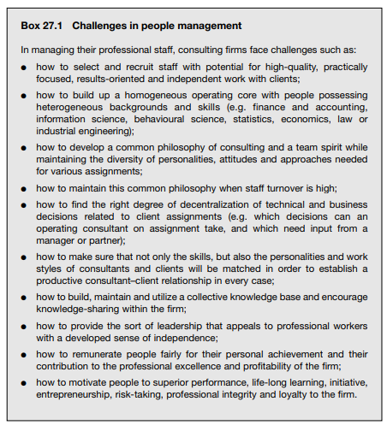

Some consultants are strong individualists and one may be tempted to ask why they actually stay with a firm. Some stay because they have chosen to work as technicians and do not want to be bothered with administrative and marketing problems. Others appreciate the advantages of teamwork and collaboration with professional colleagues. There is a third group for whom work in a professional firm is mainly a learning experience, and who do not feel committed to staying in consulting until retirement. The attitudes that prevail depend very much on the organizational culture and management style of a particular firm. Indeed, consulting firms tend to exhibit various organizational cultures. The firm may be nothing more than a collection of individuals housed under one roof, and physically not even under the same roof, since consultants spend most of their time with clients. The management of the firm may act as an employment agency, whose main objective is to find work, keep consultants occupied and provide common support services to the employees.
Providing leadership
The experience of the best consulting firms, small and large, has demonstrated the crucial role of leadership. Leadership is needed to build up a professional organization with a stimulating culture, whose individual members adhere to common values and work together as coherent teams in pursuing common professional and business goals. Leadership motivates individuals towards superior performance, service quality and loyalty to the firm. True enough, not every professional needs the same kind and amount of leadership and some consultants may even resent being exposed to it. However, without leadership, a professional firm is bound to operate as a mere collection of individuals, not as a firm, and almost certainly below its potential. It will end up by disintegrating sooner or later. Leadership in the professions is a rare commodity. It requires a combination of superior professional achievement with the personal qualities of a leader: a genuine interest in people, organizational talent, and an ability to set an example, maintain morale and provide feedback and encouragement. Professional workers resent leaders whom they cannot respect as more knowledgeable, experienced or productive professional colleagues and as persons with a genuine interest in leading and helping others. This makes the choice for management positions difficult. If possible, managers in consulting and other professions should also be natural leaders, and should be willing to assume both leadership roles and administrative responsibilities.
- Managing a professional business
Management consulting is a business, and has to be treated as such, in all cases where an independent service is provided to clients for a fee, and where the firm has to finance its existence and growth from its earnings. This applies to the vast majority of organizations that provide consulting services. Internal and subsidized consulting services constitute an exception and some principles of managing professional businesses may not apply to them. Still they can benefit greatly from being structured and managed as quasi-businesses.
Recognizing that consulting is a business
It is not always easy to call a spade a spade. For many years, professional firms resented being regarded as businesses, and even now some professionals feel uneasy about selling their services or discussing fees, which they regard as beneath their dignity. Consultants are often torn between being professional and commercial. Yet a professional service must find a buyer or client who is willing to purchase it and to pay an adequate price for it. There is a more or less developed and structured market for professional services, and competition among professionals is increasingly regarded not only as normal and acceptable, but as necessary and beneficial to the clients. The marketing of professional services has undergone spectacular changes over the past decades, and in many countries further changes are likely in the years to come. Like any other business, a professional consulting firm needs to be profitable. Its profits will depend on many variables, some of which are not under the firm’s control (e.g. general demand for professional services), while others are (e.g. the uniqueness and the quality of the services provided, its reputation and marketing skills, and the efficiency of operations). Profit planning, and deciding on the use of the profits, are important in every consulting firm that wants to be in a healthy financial position, motivate and compensate its people correctly and have sufficient resources for further development. Traditionally consulting businesses were highly labour-intensive and getting into consulting required relatively little initial capital. All a new entrant to the profession needed was his or her own talent and a small working capital to cover living and other expenses until fees could be collected on a regular basis. He or she could even borrow this money, and start working from home without renting expensive office space. Many sole practitioners were thus able to become consultants on their own, even if quite a few of them had to make personal sacrifices at the beginning of their consulting careers. Management consulting is now tending to become more capital-intensive. Consultants have to spend more on information and communication technologies, computer systems, Web sites, information and databases, licences, advertising, research, publications, and so on. Consulting firms need finance for growth through mergers, acquisitions and cooperation agreements with other firms, for international expansion, and for the development of new product and service lines, including proprietary and commoditized methodologies, systems and software. In the economics of consulting, a shift is taking place to longerterm considerations, including raising capital, the cost of capital, investment and return on investment, and to an increasing weight of other than direct staff costs in the firm’s cost structure and financial management. The cost of the firm’s human capital, i.e. those people “whose talent and experience create the product and services that are the reason customers come to it and not to a competitor”, has to be increasingly treated as an investment, despite the fact that human capital is not owned by the firm and has no financial value from an accounting point of view.
A business model for consulting firms
The basics of consulting firms’ economics are reflected in the profit model developed by David Maister and applied by the Association of Management Consulting Firms (AMCF) in its annual surveys. This profit model is a variant of the traditional DuPont formula for industrial companies, breaking down aggregate data into analytical ratios. “Return on equity” is replaced by “profit per partner” and the global formula is as follows:
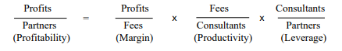
The understanding of the formula permits firm management to focus on particular factors that affect business performance, and to manage the relationships between these factors.
Leverage. Leverage (“an increased means for accomplishing some purpose”, according to Webster’s Dictionary) is one of the basic concepts underlying the structure and operation of professional firms. The general principle is simple: leverage is achieved by employing a number of (less experienced and lower-paid) junior professionals for each (more experienced and more highly paid) senior professional. In many instances, the senior professionals will be the firm’s coowners (partners), while the juniors will be the salaried employees. Leverage assumes a rational and efficient division of tasks: the seniors are mainly responsible for finding and managing work, while the juniors are mainly responsible for executing client assignments under the seniors’ guidance and supervision. In practice, the principle of leverage can be applied in different ways depending on the nature of the services provided, the clients’ needs and preferences, the career planning in the firm and other factors. Very demanding, state-of-the-art and highly responsible work does not permit the use of the same number of juniors per senior professional as more routine, repetitive, standardized and technically simpler services.
Productivity. Increasing productivity means earning more fees per consultant employed. The first way to achieve this is to increase working-time utilization – an important target in all professional firms, but one that is limited by legislation, human limitations, and the simple but important truth that unreasonably long working hours result in lower quality and falling efficiency. The second way is to charge higher fees per unit of time worked for clients. This cannot be an arbitrary decision if there is an accepted market rate and competition. Higher fees can be achieved by selling new, better and more sophisticated services thanks to innovation, programme development, training and self-education, and better utilization of know-how and experience within the firm.
Margin. The profit margin achieved by the consulting firm reflects above all the productivity and leverage levels. Higher consultant productivity and higher leverage generate higher margins. However, the margin can also be increased by reducing costs, such as general administration, purchase of information, and training and development costs. It is up to the firm’s management to judge what is feasible and beneficial in both the short and the long term. Saving on training and administrative costs will increase the margin, but may reduce consultant time utilization (as a result of poor administration) and fee levels (if training is neglected and the consultants’ competence will not increase).
Growth. As explained above, in the consulting business improvements in earnings per partner and profitability do not always require the firm to grow. There are even growth patterns that fail to increase profitability, or that reduce it, even though total profits are higher (box 27.2). On the other hand, the business may have to grow for other reasons (see also section 28.4): – to strengthen its position on the market and capture new markets; – to develop a more complete service portfolio and employ consulting staff able to undertake a wider range of complex assignments; – to provide for new work opportunities, career development and staff motivation.
Other criteria and tools. The profit model described in the previous paragraphs helps to understand, and manage, the basic relationships in firms built and operating as partnerships, where the ratio of staff to partners is crucial. If a consultancy is established as a company with shares held by people or institutions who are not partners, and even publicly traded, classical ratios for measuring profitability (see section 14.2) are applicable. Capital investment analysis (section 14.6) is becoming important in consultancies that invest heavily in research and in developing new, often commodified, products and services. These firms are also increasingly concerned with non-staff costs such as costs of equipment, software, licences, advertising and similar, and with comparing data on staff employed in direct and billable client work, and staff in research and development.
Entrepreneurship in consulting
Entrepreneurship lies at the very heart of business. In a consulting firm, the founder is the first entrepreneur. He or she is the person who has taken a chance and linked his or her personal future to the future of the new business. Although the first investment may have been modest in financial terms, it is always important in terms of human intellect and energy.
Aconsulting business needs entrepreneurial thinking and behaviour even when it becomes a large partnership or company employing a number of consultants. It must not turn into a bureaucracy or an academic institution. It probably needs an entrepreneurial spirit more than growing businesses in some other sectors, because of the rapidly changing needs of clients, growing competition, and the fact that consultants encounter new opportunities virtually every day. However, opportunities exist only for those who can see and are keen to take them. It is essential to clarify the entrepreneurial role of consultants, in addition to their specific technical and managerial roles. Consultants will think and behave as entrepreneurs if they know that such behaviour is wanted and valued by the firm. They should know what is regarded as entrepreneurship: Is it getting new clients? More business from existing clients? Selling more assignments that will be easy to execute? Looking for innovative work methods? Coming up with new ways of tackling old problems? Taking the initiative to develop new fields of consulting? Consultants need to know, too, who in the firm is supposed to think and act as an entrepreneur. Is this a guarded province of senior partners? Is every member of the firm, including the new recruits, expected to think and act as an entrepreneur?
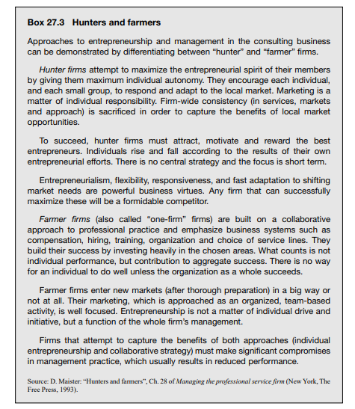

When consulting is not a business
Not all management consulting units are independent businesses. Internal consulting units within governments and business firms (section 2.5), and consulting services of various not-for-profit organizations, cannot be categorized as businesses. Some of these units provide consulting services free, or for a nominal price, instead of charging the full market rate. Their budgets may be subsidized by their parent body, technical assistance programmes or from other sources. Some of these units may be in competition with other consultants, but their independence tends to be limited in terms of recruiting, remunerating and terminating the appointments of staff, fixing consulting fees, expanding or scaling down activities, changing the service portfolio or finding new clients. Not all the principles involved in managing a professional business can be applied to such a unit. However, certain principles are applicable. The effectiveness of these units can be enhanced by treating them as “quasi-businesses”, providing them with relative autonomy in decision-making, encouraging them to sell services, and making sure that their business results have a bearing on staff remuneration and motivation, and on the future development of the unit. Internal consulting units may compete with external consultants for work to be done within the parent organization but, at the same time, may be authorized to market and sell their services to other companies.

- Achieving excellence professionally and in business
In real life, the professional and business sides of consulting are not separate. Professional decisions are business decisions and business decisions have professional implications. Key professional characteristics of the firm, such as staff competence and integrity, leadership, organizational culture, shared values, and good relations with important clients, have an economic value and are reflected in the value of the firm, fee levels, potential and real earnings, and so on. Managers of consulting firms have to address the two aspects irrespective of their personal background and preference for one or other side. The thrust of their work is sensitive, tactful and subtle balancing both of professional and business objectives and concerns, and of the interests of clients, individual consultants, partners and the whole firm. This balancing requires compromises, trade-offs, and anticipation, prevention and resolution of conflicts. In every firm, there are pressures that can destroy the delicate profession– business equilibrium. Individuals or teams may develop services in which they are personally interested, but for which there is no market, or which are no longer profitable. Some partners will resent leverage because they prefer to do everything themselves rather than relying on junior colleagues and developing these colleagues. The firm may press consultants to increase profitability by lowering quality. Operating consultants may be asked to become more productive by saving on data-gathering and analysis. Juniors may be assigned to jobs that are beyond their competence. A key task is the balancing of assignment and practice management. Assignments constitute the basic building-blocks in the management system of consulting organizations. Once an assignment has been identified and a contract signed, the organization appoints a consultant or an assignment team and furnishes them with needed resources. A self-contained management cell is thus created within the consulting firm. As assignments normally have a limited life-span, assignment teams cease to exist when the job is completed. Individual team members are regrouped to make up new assignment teams and new management cells, while other resources (e.g. equipment, finance) have been used up or are reallocated. Managing and coordinating assignments are crucial activities in any consulting firm. In large firms, dozens or hundreds of parallel and overlapping operating assignments may need to be managed simultaneously, while new assignments are in preparation. However, even the best assignment management cannot ensure the functioning and development of the firm as a whole. It can even create conflicts and imbalances by favouring one assignment over others, e.g. by taking resources from one assignment just because another client speaks with a stronger voice. Assignments can also conflict with the firm’s overall strategy. Future development can be jeopardized by favouring lucrative assignments from which the firm learns nothing new. Research and development may be neglected. Here again, a balanced approach is required, caring for global concerns and the needs of the firm in addition to managing specific client projects.
These global concerns and organizational needs include in particular:
● the firm’s professional and business culture;
● strategy for achieving high professional standards and service quality;
● strategy for achieving profitability and growth;
● the development of new capabilities and products;
● development and promotion of the market and client base;
● management, motivation and development of the principal resource – the professional staff;
● sound financial management and control.
The terms “balancing”, “trade-offs” and “compromise” used in the previous paragraphs truly define what mangers of consulting and other professional firms do for a large portion of their time, but they do not give the whole picture. First, the environment in which consultants operate, and their clients’ needs, are constantly changing. The consulting firm’s management must be flexible and dynamic enough to cope with and adjust to these changes. In other terms, in balancing the professional and business sides of the firm, it is not possible to return to an old equilibrium – a new one must be achieved, consistent with the changes that have taken place in the environment and in the firm itself. Coping with and managing change imply preventing discrepancies and conflicts between the professional and the business side. New markets are developed and new business models adopted, but professional standards are not sacrificed. New staff are recruited and trained but are not assigned to independent client work for which they are not competent. Secondly, and most importantly, every consulting firm sets its own standards of performance and achievement. An equilibrium between the professional and the commercial side of consulting can be achieved and sustained at various levels of excellence. There are firms with modest ambitions, where consulting is merely a source of income to managers and staff alike; these firms aim to achieve regular income from any, even uninspired and mediocre, service. The leaders in consulting behave differently. They have high standards and pursue ambitious though not unrealistic objectives both professionally and as businesses. They are keen to have excellent business results and earn more than competitors, but never to the detriment of professional performance and quality. They aim to be leaders in every respect. This is what makes these firms attractive to talented and dynamic individuals, and to sophisticated clients seeking professional services of the highest level they can afford. This is the thrust of consulting firm management.

Practical class

Student must know the management challenge of the professions, achieving excellence professionally and in business and be able to identify and describe to particular factors that affect business performance, and to manage the relationships between these factors.

Control questions:

- What are the main management challenge of the professions?
- What is the managing a professional service?
- Explain achieving excellence professionally and in business.

Questions for discussion:

- How might specialisation of roles within the consulting team influence the way in which it might add value for the client? Give the examples.

McKinsey Case Interview Examples

Client goal
Loravia is a fictional country located in Eastern Europe with a population of 20 million. The government of Loravia wants to achieve major improvements in both the quantity and quality of education for its children. Because McKinsey has great deal of global knowledge and expertise in the education sector, the Loravian Department of Education has asked McKinsey to provide advice on how they can achieve this transformation in its school system.

Description of situation
Loravia’s free-market economy is still developing, having emerged from many decades under communism. Recently, the government of Loravia put in place a new economic plan, with aspirations to transform its economy and “turbocharge” its development so that it is well positioned to compete with its European neighbors. The government of Loravia realizes that the education of its children is a critical factor in meeting its economic-development goals. It intends to transform its school system over the next 10 years so that it is able to support its economic aspirations.
Schooling in Loravia is completely public, and is provided by a network of government-run schools, which admit children from ages 5 through 18.
The first stage of this effort is to diagnose the current state of education in schools in Loravia to determine how best to meet the government’s future aspirations.

McKinsey study
McKinsey has been asked to support the Loravian Department of Education in diagnosing the condition of its current school system, and in identifying the most important areas for improvement.

Helpful hints
- Write down important information.
- Feel free to ask the interviewer for an explanation of any point that is not clear to you.

Question 1:
What are the issues you would want to investigate in diagnosing the condition of the current school system in Loravia?

Helpful hints
- Take time to organize your thoughts before answering. This tells the interviewer that you think about the problem in a logical way.
- Develop overall approach before diving into details.

Question 2:
One of the clients at the Loravian Department of Education mentions the example of neighbor country C, which outperforms all of Loravia's economic peers and neighbors in the international assessment. She believes that the more concentrated school structure in this country is a big reason for its better outcomes in the international assessment. She suggests that having larger, less fragmented schools allows for more effective selection and training of teachers, leading to improved education outcomes for the students. Finally, she shares that 15 percent of Loravia's population are currently attending school.
What would be the reduction in the total number of schools in Loravia if it were to reach the same average school size as neighbor country C?

Helpful hints
- Don't feel rushed into performing calculations. Take your time.
- Talk your interviewer through your steps so that you can demonstrate an organized approach.

Theme 5. Enterprise planning: general economic principles and methods

The aim of theme’s study is to learn the principles of marginal value, benefit-cost, disproportional costs, implementation of the farm planning

Plan
1 Introduction
  - The marginal value principle
  - The benefit-cost principle
  - Marginal value & benefit-cost principle and disproportional costs
  - Comparison basis for farm development measures
- Implementation of the farm planning
  - Farm data recording
  - Farm analysis
  - Quantification of additional farm enterprises
  - Compilation of all potential farm enterprises
  - Composition of business plans
  - Further special analyses
  - Evaluation of the business plans and selection of the "optimal plan"

1 Introduction
The basic task of the business management is to fit the business organization into the always changing off and intra-farm framework. The constantly repeated steps of planning, decision making, implementation and control make up the term "business planning" and should be examined more accurately. The aim of the business planning is to help the agricultural enterprises solve the problems of farm organization. Usually the objective of farm operation is assumed to be a possibly high achievable sustainable profit. The demand of sustainability should help make sure that besides the profitability the points of liquidity and stability (risks) are also taken into account in the planning.
The aims which do not comply with the maximization of the profit can be taken into consideration in the business planning as given limits of the planning possibilities (e.g. maximal work strain of family labour, readiness to risk, tradition, passion, minimal subsistance production, etc.).
A successful farm planning requires the consideration of economic principles which possess general validity. In the following chapter these principles should be briefly explained in terms of their meaning.

1.1 The marginal value principle
The marginal value principle stipulates the reasearch of the impact of marginal (very slight) changes of the farm organization on the farm success. Possible changes of the farm organization can be generally classified according to one of the three following "planning spheres" of the farm:
a) Optimal expenditure size
In the determination of the optimal expenditure size is based on the quantity and value relations between a product and a production factor necessary for its production. It is common in agricultural production that increasing production factor input (e.g. fertilizers) leads to increasing yields (e.g. cereals), but that the yield increases (marginal yields), which result from a constant amount of production factors, decrease (and eventually amount to zero or gain a negative value). This relation is called the law of decreasing yield increases. It goes without saying that an increase of expenditures under the assumption of certain product and factor prices is only profitable if the additional profit (marginal profit) caused by this increase covers the additional costs (marginal costs). The optimal input of a factor is achieved if the profit is maximal, that is: the marginal profit amounts to zero if input of a production factor for production of a product increases. (Marginal profit=Marginal output-Marginal costs)
b) Optimal expenditure composition
It is usually found in the production of a product as a result of coaction of a multiplicity of production factors which can be used to replace one another to a certain degree (e.g. production of 10 kg of milk by different combination of feedstuffs). If one factor (e.g. feedstuffs) is replaced by another, often the law of decreasing marginal rate of substitution, that is: that the additional input of one production factor as a result of reduction of another production factor causes the decrease of the amount of the last factor input which can be saved. The optimal expenditure structure in this case also depends on the factor prices. The optimal combination of the factors which can be substituted for production of a certain production quantity is achieved, if the total costs are the lowest, that is: if the additional costs resulting from the gradual replacement of two factors are just as high as those saved.
c) Optimal production direction
The described production technology relations can also be observed in the relations among the produced products.
The extension of one farm enterprise as a result of the reduction of another is efficient from the economic point of view, if the additional profit ("marginal revenue") of the extended farm enterprise covers the marginal costs by the replacement of the other farm enterprise. The (according to the available production factors) optimal combination of the possible farm enterprises of a farm is achieved, if the total gross margin (as well as the profit) are the highest, that is: if as a result of gradual substitution a farm enterprise by another one the marginal profit amounts to zero.

1.2 The benefit-cost principle
It was assumed in the explanation of the marginal value principle that each factor can be bought in unlimited amounts. However, this assumption does not apply for all production means. Many farm production factors cannot be changed (at least in a short period of time) (e.g. land, buildings, labour). Other production factors (e.g. raw forage) are marketable only to a limited degree and must be produced on the farm if necessary.
For the determination of the costs of the mentioned production factors, opportunity costs should be taken into consideration. They always appear if as a result of one or several scarce factors the extention of one farm branch can be done only if one or several other farm branches are limited at the same time.
Provided it is known what farm branches should be limited, it is easy to determine the opportunity costs. But from the economic point of view, it is always necessary to try to achieve only the lowest opportunity costs. Here the following question should be answered: what farm enterprises should be limited (to what degree) so that the extention of a farm branch would have the lowest costs possible (that is: the lowest possible shrinkage of the profit).
On a farm organized from all sides (larger number of fixed limited factors) this question can be answered only by means of the linear programming. In more simple planning calculations, the the minimal opportunity costs can be determined only approximately by means of several test calculations

1.3 Marginal value & benefit-cost principle and disproportional costs
The (combined) use of marginal value principle and opportunity costs principle provides basic decision help for the farm planning. The marginal value principle can be applied on areas which do not relate to the marginal changes of the farm organization but rather to answering of the question whether or not a farm branch should be completely given up in order to start another one and to increase the profit. Here an aspect not previously researched also plays a role: costs independent of the production scale are those which are not incurred - without production - and with (unlimited) steady scale of production ("fixed costs", "disproportional costs").

1.4 Comparison basis for farm development measures
Before a development measure can be evaluated, a decision about the situation which must be compared should be made. Since it concerns an evaluation of the impact of a specific measure (which usually can be observed gradually), the following can be used as reference systems:
- the condition before the implementation of the project (before-after comparison) or
- the situation without the implementation of the measure (with-without comparison).
Even though the future development of the farm without the implementation of a measure usually cannot be exactly determined but only extrapolated, a before-after comparison is not applicable. In this last method it was assumed that all changes which take place within the given period result from the implementation of the measure, in other words no changes in the initial situation would take place without its implementation. This can be assumed only in extremely rare cases. The problem of the determination of the development measure can be solved either by means of extrapolation of development trads or by means of the comparison of the observed development in similar situations.
t
Efficiency
- Efficiency with measures
- Efficiency without measures
+
= General efficiency with measures
t
Efficiency
- Efficiency with measures
- Efficiency without measures
+
= General efficiency with measures
Scheme 1 - Enterprise development with or without measures implementation

2. Implementation of the farm planning
2.1 Farm data recording
General information includes various conditions which are usually similar for farms of the same economic region as well as information specific for certain farms:
- legal and organizational information about the farm
- climate and soil conditions
- transportation and market conditions
- socio-economic conditions.
a) Availability of land (utilized land) Information about availability, quality, usability limits, rent conditions and possibilities, etc.
b) Availability of labour Determination of working capacity in a generally used measurement unit (working unit, h), possibly subdivided according to working time periods can be differentiated according to:
- family labour: distribution of tasks and working time requirements for non-agricultural activities
- permanent hired labour: qualification, salary
- seasonal hired labour: available time, qualification, salary
c) Assets and capital Systematization of assets and capital of a farm (e.g. by means of a simple balance) first of all in order to:
- determine the assets structure and the capital input,
- calculate the annual fixed costs incurred by assets,
- determine the interest payment and the net debt service burden of the existent farm and
- evaluate the potential assets which should be sold.
d) Other production restraints
For example, the following points serve as other production restraints: crop rotation restrictions, agreement conditions, legal/political preconditions, subsistence production, availability of borrowed capital, etc.

2.2 Farm analysis
By means of the illustration of the existent farm and as far as available by means of accounting information of the past years and the vertical and horizontal farm comparison, a situation analysis (economic and socio-economic farm analysis) together with the farmer should be made. The aims of this situation analysis are first of all:
• to generally reflect the existent situation,
• to conduct an economic and socio-economic problem analysis,
• to analyze the aims and e.g. to set up the aims hierarchies,
• to identify the points of improvement of the existent situation, that is: to show the major weak spots of the existent farm organization and to work out the development possibilities.

2.3 Quantification of additional farm enterprises
According to the principles already used in the quantification of the farm enterprises of the existing farm, it is necessary to quantify possible additional farm enterprises for planning purposes. This happens again in the calculation of gross margins including the determination of factor requirements and supplies. The necessity to quantify additional farm enterprises appears first of all for already existing farm branches for which the introduction of variants improved in terms of production technology should be verified. Besides, new farm enterprises, which were not operated before and which can be invested in, should also be quantified. In connection with planned investments in already existing farm enterprises it should be considered that the investments cause an impact on the coefficients (output, costs, factor requirements) described in gross margin calculations. If investment is made in (already existing) farm branch dairy cow breeding, it can influence milk output, animal losses, forage costs, energy costs, working time requirements, forage requirements, etc., so there are many farm enterprises which should be quantified for the farm branch dairy cow:
Farm enterprise 1: dairy cow on the existing farm
Farm enterprise 2: improved dairy cow in the existing stable without rebuilding
Farm enterprise 3: (improved) dairy cow in the existing stable with rebuilding
Farm enterprise 4: (improved) dairy cow in the existing stable with new building
Requirements for the program planning II (also for the simplified planning) of aggregation of forage production and livestock breeding bound to land include the consideration of additional costs for fixed assets, wages and rent payments through the investments. The summarization of gross margins and factor requirements allows a better evaluation of competitiveness of livestock production in comparison to production of marketable crops

2.4 Compilation of all potential farm enterprises
Planning work is made considerably easier if the data from the gross margin calculations, which is important for further planning, is displayed in form of tables. Next are shown the gross margins (with important output and costs positions) as well as factor requirements and supplies of factors important for the farm enterprises of the existing farm, possible improved farm enterprises (without/ with investment) and new farm enterprises (without/with investment). For the program planning II (also for simplified planning) is necessary the determination of competitiveness measures, that is: determination of gross margins in relation to factor input e.g. such as GM per ha, GM per h, GM per stable place, GM per 1000 € of current assets, etc. Depending on the usability of a factor, the farm enterprises can be classified according to rank orders which allow an appropriate evaluation of the competitive capacity.

2.5 Composition of business plans
There are different methods which can be used for composition of business plans. They differ in terms of complexity, planning realm, relation to the time period, etc. A detailed explanation is found in the module Introduction into the methodology of farm planning. The following rules for composition of business plans can be used more or less generally for all these methods, but they are based basically they are based on statistic farm planning.

2.6 Further special analyses
Besides the determination of the total gross margin within the framework of the actual planning calculation (combination of the farm enterprises) further analyses are necessary for the farm development decisions, depending on the planning situation:
Efficiency measures
Financing
Multi-period calculation
Consideration of risks and uncertainty

2.7 Evaluation of the business plans and selection of the "optimal plan"
The indicator considered to be important for the comparison of business plans is the total gross margin under consideration of all output and costs incurred by planning decisions. Besides the positions already contained by single gross margins of the farm enterprises, there are also all other changes (±) of the fixed and overhead costs of the farm caused by planning including the changes (±) of salaries, interest and rent payments. Though the economic exquisiteness of the business plans is sufficiently observed from the comparison of gross margins, it is mostly advantageous for the selection of the business plans to determine further coefficients for calculation of the profitability and liquidity. A comparison of the business plans according to the creteria of the profitability, stability and liquidity gives important clues about the economic advantages and disadvantages of the planned business organizations.
Further important aspects e.g. such as the following should be taken into account:
a) the desires of the family of the farm manager,
b) the evaluation of the risk by the farm manager (e.g. subjective borrowed capital debt limit),
c) the estimation of the future market conditions for products and production factors,
d) expected measures of the agrarian politics.
The decision about what business plan to select should be made by the farm manager himself. The better his knowledge of the farm, the more effective the decisions. It is important that the consultant and the farmer are educated in the farm business way of thinking

Practical class
Student must know the principles and theoretic bases of enterprise’s planning, the principles of marginal value assessment, and be able to apply the theoretic knowledge in practice

Control questions:

- Explain the marginal value principle.
- Explain the optimal costs’ level and optimal costs’ forming principles.
- Explain the optimal production direction principle.
- What are the prerequisites for the reaching of maximal profit?

Questions for discussion:

1. Explain the interrelation between marginal value principle and the opportunity costs principle.

Solve the tasks:

Task 1. There is presented the dependence of company total costs’ (TC) from output volume (Q) in table 1.1. Determine the variable costs (TVC), fixed costs (TFC), marginal costs (MC), average costs (AC), average variable costs (AVC), average fixed costs (AFC).

Table 1.1 – Initial data
Q, pieces | 0 | 1 | 5 | 10 | 15 | 20 | 25 | 30 | 35
TC, uah | 55 | 85 | 375 | 700 | 1500 | 1600 | 1770 | 1800 | 1950

Task 2. Company produces concentrative forage for livestock industry. An information about output, price and production costs is presented in the table below. Identify and calculate the total costs (TC), variable costs (TVC), fixed costs (TFC), marginal income.

Table 1.2 – Production and economic indicators for company.
Item | Value
Productivity | 1050 | t of forage
Average price | 17 | uah / c
Raw materials | 8.5 | uah / c
Fuels for production | 2 | uah / c
Salary of production workers | 5 | uah / c
Depreciation expenses | 67 000 | uah
Salary of top managers | 45 880 | uah
Buildings and equipment maintenance | 2 000 | uah

Methodical recommendations for the solution:

Total costs (TC) are calculated as follows:

, (1.1)

where TFC – time-fixed costs, uah; TVC – time-variable costs, uah.
Average costs (AC) are calculated as follows:

, (1.2)

where Q – volume of output, pieces.
Average fixed costs (AFC) and average variable costs (AVC) are calculated by the same principle as AC (see 1.2 formula).
Marginal costs (MC) are calculated as follows:

. (1.3)

It would be better to present results of task 2 solution in a table form.

Theme 6. Characteristics of the enterprise

The aim of theme’s study is to learn classification of data sources, factors of production and other production limitations, economic parameters for the current business

Plan
1 Data sources for business planning
2 Documenting a business
2.1 General information
2.2 Availability of factors of production and other production limitations
2.3 Specifying (quantifying) the production process in the current business
2.4 Determining economic parameters for the current business

1 Data sources for business planning
The sources of information available to the management team for planning, decision making or monitoring, or to advisers in their work, can be very different in nature. In general, the available data sources can be classified as follows:
Primary data: data captured by the business under real circumstances
Secondary data: data not captured by the business (e.g. received from accountant)
Business-specific data: related to a specific business
Standard data: average data, assumptions, estimated/typical data, etc.
The ideal basic dataset would be:
as much business-specific and primary data as possible,
as much secondary and standard data as necessary.
Standard data are consequently only to be used in areas where business-specific data cannot be determined, or would be costly to determine. Provided a set of books are available, important key figures are to be compared against or underpinned by accounting data.

2 Documenting a business
To be in a position to plan for an existing business or for a ‘typical’ business comparable to other farms in its category, the first step must be to capture the initial circumstances. In addition to
economic framework conditions such as natural circumstances, the markets for buying and selling, and particular socio-economic conditions, this primarily includes
the availability of factors of production (goods, services and rights, also classified as land, labour, stocking assets and capital),
knowledge of important limitations on or guidelines for production
quantification of the production processes carried out in the current business, as well as
establishing goals for current economic success.

2.1 General information
a) Legal and organisational information
Geographic and political situation, legal form (for companies: more detailed description of capital contributions), farming system, assessed value/economic value.
b) Climate and soil
Height above sea level, annual rainfall and individual key growth periods, Average annual temperature and individual key growth periods, Predominant soil type, terrain features, soil ratings.
c) Connectivity and market conditions
Internal connectivity: Land parcel location (consolidated, dispersed), number of pieces, average distance from field, average field size, track conditions
External connectivity: Distance from town, to the storage facility, to important commercial establishments, transport conditions.
Market conditions: Timely availability of means of production, sales opportunities for products (regional, national), prices for products and means of production (categorised by timing, if applicable).
d) Socio-economic conditions
Important socio-economic conditions must be described, especially for family businesses.
These could include:
Division of tasks among family members, staffing and financial
Social obligations, conduct when hiring external workers, securing the succession of the farm, etc.

2.2 Availability of factors of production and other production limitations
Data on available ground space should be classified according to type (arable, grassland, forest, orchard) and then by yield and cultivation potential as appropriate (e.g. land viable for wheat, different grades of grassland). For rented land, the type and duration of the contract should be noted in addition. For any community-owned land, the usage regulations should also be noted. For additional planning purposes, future rental opportunities are also to be determined.
The available labour capacity should be determined using universal units of measurement wherever possible. Normally, the hourly output (h) of the workers (LU) is stated (MHrs). Accordingly, 1 LU corresponds to one fully capable male or female person who is occupied within the business or household all year round.
To carry out a comprehensive business analysis and planning exercise, the assets and capital of a business must be captured, even in a simplified form. This is primarily to:
establish the asset structure and related financing,
determine the total capital, equity and borrowed capital invested,
calculate the annual fixed costs incurred by the assets,
demonstrate the interest and debt service burdens in the current business and
capture the asset items (e.g. livestock assets) that can potentially be expressed in terms of value (market value where possible).
The following are examples of other production limitations which may arise:
maximum amounts of various crops that can be cultivated due to crop rotation allowances, soil quality, etc.
contractual obligations (delivery rights, quotas, marketing contracts, environmental management agreements (KuLaP), etc.)
legal/political requirements (farming requirements, maximum stocking numbers, etc.)
subsistence production (strictly necessary production of certain goods regardless of their economic assessment)
availability of borrowed capital: upper limit on long-term credit for investments, short-term overdraft facility on current account

2.3 Specifying (quantifying) the production process in the current business
An illustration of the production processes carried out in the current business is best achieved by calculating the contribution margins, including determining the factor demands and factor supplies. The production methodology and economics are consolidated as part of the break-even analyses. This enables a clear illustration of which production-related assumptions are used as a basis for the individual coefficients. The following factor demands and supplies are especially important: Man-hour requirement (organised by time spans), capital requirement for livestock and current assets, basic ration requirements and supplies (organised by feeding periods, e.g. winter feeding). The requirement for livestock spaces should also be noted, as should storage space, machinery, straw, etc. Provided datasets are available for the applicable region, including example break-even analyses, these will usually help to quantify the business’s production processes. First, the current business processes are compiled on the basis of the most appropriate example calculation (comparable yield, comparable production methodology). Then as a second step, any price deviations or production-related coefficients are corrected (and documented).

2.4 Determining economic parameters for the current business
To determine the economic parameters for the current business, the operational totals for the most important individual production process coefficients must first be calculated (from the break-even analyses). The most important parameter for this is the overall profit margin. This is calculated from the sum of individual contribution margins multiplied by the scale of each production process in the current business (the total man-hour requirement, total capital requirement, etc. are all calculated in a similar way). Combining the processes in the current business establishes the following:
the level of desired output, the proportional special costs and the total profit margin,
how much of the available space will be used,
how many man hours (according to standardised data) will be applied,
how much investment (according to standardised/estimated data) is required,
to what extent self-sufficiency will be met and
to what extent the basic ration for existing animals meets requirements (balancing supply/demand).
etc.

Practical class

Student must know the principles and theoretic bases of enterprise’s planning, the principles of marginal value assessment and be able to identify and describe production process and their characteristics, as well as to calculate the appropriate values (costs and income).

Control questions:

- What are the main stages of planning process?
- What is the optimal production organization?
- Explain the use of the minimal opportunity costs criterion.

Questions for discussion:

- What is the way to ensure the optimal production organization?
- Explain the role of disproportional costs assessment in decision-making within the enterprise’s planning? Give the examples.

Task 1. You just started your software business after a year of saving $10,000 to contribute to your new company. The $10,000 is now your equity in the business, so you also need to increase your assets. How is the equation look like?
Task 2. Now that you have started your company, you need to purchase two computers and other equipment. So, you decide to purchase $2,000 worth of equipment on your company credit card. That $2,000 credit card purchase is both a liability (aka debt) and an asset. Both assets and liabilities increase by $2,000. How is the equation look like?
Task 3. Your business grew, and you now have customers. A customer decides to purchase your software for their own business’s computers. Your software is $10 per program download, and the customer needs the program for 50 computers, totaling $500. From this transaction, you gain both an asset and equity. How is the equation look like?

Methodical recommendations for the solution:

Assets = Liabilities + Equity

Liabilities = Assets – Equity

Equity = Assets – Liabilities

Theme 7. Introduction to linear programming for farm business planning

The aim of theme’s study is to learn meaning and concept of linear programming, approaches to solving a linear optimisation problem
Plan
1 Introduction
1.1 Meaning and concept of linear programming
1.2 Linear programming in the context of farm management
1.3 The mathematical structure of an LP mode
1.4 Turning a planning problem into an LP model
2 Approaches to solving a linear optimisation problem
2.1 Illustrating an optimisation problem
2.2 Graphical solution (two farm enterprises)
2.3 Solution using the simplex algorithm as a manual calculation method

1 Introduction
1.1 Meaning and concept of linear programming
Linear programming is a prominent “operations research” method. Its main area of application is in solving minimising and maximising problems (e.g. cost minimisation, profit maximisation). In agriculture, its main applications are in the static planning of production, investment and financing. It is also used in regional sector planning and in optimising subsectors such as low-cost feed ration formulation.
In relation to determining the optimum organisational structure of a farm business, this means specifically that within the scope of the available production capacities, the potential farm enterprises (e.g. crop or animal production) are combined to achieve the maximum total profit (or other objective). As such, the optimisation problem is represented by a linear system of equations, whose solution is determined through a sequence of systematic steps (iterations). During the course of this calculation process, the farm enterprises (activities) simultaneously compete for the available means of production (capacities). This ensures that the enterprises are each combined with one another at their optimum scale, thus achieving the best possible factor allocation and utilisation.
The large amount of calculation effort required — which are already caused by minor optimisation problems — can be dramatically reduced by using computers. In addition to statical linear programming, other methods such as non-linear or dynamic optimisation can also be used for the specified areas of application. However, both of these have only proven to be of minimal significance in practice up to now.

1.2 Linear programming in the context of farm management
The theoretical basis of linear programming is formed by marginal value theory. Linear programming allows the optimum farm organisation to be determined by simultaneously optimising all levels of farm planning.
a) Factor-product relationships: Optimum special intensity The optimum input quantity of a factor is achieved if the profit reaches a maximum, i.e. if the marginal profit is zero when a factor of production continues to be applied to produce a product. (Whereby: marginal profit = marginal revenue - marginal costs
b) Factor-factor relationships: Optimum expenditure combination The optimum combination of substitutable factors to create a specific quantity of a product is achieved if the total costs are at the lowest level, i.e. if the additional costs are equally as high as the saved costs when two factors are successively exchanged.
c) Product-product relationship: Optimum combination of farm enterprises The optimum combination (within the scope of the available factors of production) of potential enterprises on a farm is achieved if the total gross margin (and therefore the profit) is at its highest, i.e. if the marginal profit is zero when an enterprise is successively substituted by another.

1.3 The mathematical structure of an LP mode
a) Objective function The objective function is the function to be minimised or maximised and which contains all parameters influencing the goal. In farm planning these are generally the gross margins (costs or surpluses) of individual variables which are multiplied by and aggregated with their expansion factor. Solving a linear model requires a linear objective function.
Z = z1 × x1 + z2 × x2 + ... + zn × xn = Min!/Max!
Z = ∑ zi × xi = Min!/Max! (for each i = 1 to n)
Where: Z = Total objective function value
z = Objective function coefficient of the variables = (Monetary) contribution of one unit of a variable to objective function
Z x = Expansion of the variables
E.g.: Total GM = ∑ Enterprise GM × Enterprise expansion = Max! GM = gross margin
b) Constraints The production-technical and economic coefficients that have an influence on the relationships between the variables are known as constraints (also: limitations, restrictions).
c) Non-negativity condition The non-negativity condition excludes economically nonsensical, yet mathematically possible solutions. xi ≥ 0

1.4 Turning a planning problem into an LP model
The following elements are required to turn a planning problem into an LP model:
a) Objective function
b) Data
c) Variables

2 Approaches to solving a linear optimisation problem
2.1 Illustrating an optimisation problem
Starting point: A farmer can use 100 ha of arable land for cereals and/or forage. The available man hours per year are 3600 MHrs and there are 90 livestock spaces available. The gross margin for cereals is €600 per ha, €1500 for dairy cows and €400 per unit for fattening bulls (the variable forage crop costs are already accounted for in the livestock farm enterprises). The man-hour requirements are 10 MHrs per 1 ha of cereal, 45 MHrs per dairy cow and 14 MHrs per fattening bull unit. The livestock housing space requirement is 1.25 for dairy cows and 0.75 per unit for fattening bulls. The forage area requirement for a dairy cow is 0.5 ha, and one bull unit requires 0.2 ha. The farm organisation (expansion of the available enterprises) with the maximum total gross margin is to be determined.

2.2 Graphical solution (two farm enterprises)
In order to be able to solve the optimisation problem graphically (two-dimensionally), the problem situation must be reduced to two variables. Therefore, bull fattening is excluded for now. The operational capacities can therefore be used either by arable crops (for cereal production) or forage crops (for milk production). The scale of the cereal crop (ha) and dairy herd (no. animals) at which the maximum total gross margin is achieved must now be determined.
Alternatively, since this relates to linear substitution relationships, a combination of cows and cereals which lies either on or below each line between the specified extremes. The lines therefore represent the maximum limitations for keeping livestock. When combined, their effect is such that any combination of herd count and cereal acreage situated below or to the left of all of the capacity lines (= farm decision-making scope = feasable region) is possible for the farm.

2.3 Solution using the simplex algorithm as a manual calculation method
Corresponding to the illustrations under point 1.3, the example described can be represented as a system of inequations as follows. The available farm enterprises are represented as a variable P (production activity) with an expansion x.
Cereals: P1 Expansion in ha: x1
Dairy cow: P2 Expansion in units: x2
Fattening bull: P3 Expansion in units: x3
The planning objective is to maximise the total gross margin.
The land, labour and livestock housing production capacities limit the scale of production.

Practical class

Student must know the features of procedure of linear programming and be able to solving a linear optimisation problem.

Control questions:

- Name meaning and concept of linear programming.
- What are the features of linear programming?
- What information is used for linear programming?

Solve the tasks:

Task 1. Agriculture enterprise has 8 000 ha of land. It could be used for grain and feed crop production. Available production factors: work – 160 000 man-hours; farm capacity – 1 500 cattle-places. Reimbursement sum for different production processes: grain growing production – 1200 uah/ha; Dairy cows (DC) – 2650 uah/1 cow; bulls on fattening production – 1150 uah/1 bull. Variable costs of feed crop production process are 600 uah/ha. Work requirements: grain growing – 15 man-hours/ha; feed crop production – 13 man-hours/ha; dairy cows – 51 man-hours/cow; bulls on fattening – 18 man-hours/bull. Requirement of cattle-places for 1 cow is 1.3, for 1 bull it is 1.1. Requirement of energy from basic feed for each cow is 1500 kStU and for bull it is 2667 kStU. 1 ha of feed area provides 5000 kStU. Describe the production processes (simplified presentation). Express results in table form.

Theme 8. Introduction to linear programming for farm business planning using the optimization software XA and MS Excel

The aim of theme’s study is to learn basic structure of an LP matrix in XA/Excel, data input and output in XA/Excel, solution of optimisation problems in sub-ranges

Plan
1 Handling of the computer program XA in MS Excel
  - Basic structure of an LP matrix in XA/Excel
1.2 Data input in XA/Excel
1.3 Data output in XA/Excel
1.4 Arrangement of the input and output ranges in the Excel worksheet
1.5 Control commands (command line entries, LPCMD)
1.6 The XA Interface module
1.7 Optimisation
1.8 Parametrising in LP models with XA
1.9 Working with split matrices (Style III programming)
2 Special formulation approaches
2.1 Basic model
2.2 Breakdown of production processes
2.3 Land use
2.4 Labour management
2.5 Decreasing marginal productivity
2.6 Investment (increasing marginal productivity)
2.7 Financing
2.8 External regulations and directives
2.9 Other specific formulation approaches
3 Farm business planning with the aid of linear programming
4 Solution of optimisation problems in sub-ranges
4.1 Optimal feed ration
4.2 Optimal mechanisation
5 Multi-period model approach
5.1 Introduction
5.2 Multi-period land use planning
5.3 Production planning assuming price cycles
5.4 Optimal reinvestment time

- Handling of the computer program XA in MS Excel
1.1 Basic structure of an LP matrix in XA/Excel
The computer system XA (Sunset Software Technology, San Marino, USA) in connection with the program MS Excel can solve linear optimization problems according to the simplex algorithm. Excel serves as the user interface for data input and further processing of the results. XA has the ability to read the data necessary for optimization from the Excel worksheets and, after linear optimization has been performed, write the results to the designated areas of the Excel worksheet. For the user, the individual calculation steps (initial matrix, exchange steps, final matrix) of the optimization are not visible. XA presents only the results from the final matrix. Basically, the input of data for linear optimization in Excel is done in matrix form, i.e. in a combination of columns and rows. The data to be arranged in this matrix are the same as in the manual arithmetic procedure (simplex tableau):
• Activities: variable name (=identification), objective function coefficient, technical coefficients
• Constraints: constraint name (=identification), capacity In addition, minimum and maximum limits of extension can be defined for the activities (= variables = = procedures = processes).
The matrix can be built up in three different basic variants (called Styles at XA):
Style I: Arrangement of activities in columns and constraints in rows.
Style II: Arrangement of activities in rows and constraints in columns.
Style III: The arrangement is done in multiple tables on any number of worksheets.
All the following explanations and sample calculations refer to Matrix Style I . Style II will not be discussed further, as everything said for Style I can be directly applied to Style II. Style III places special demands on the matrix structure and is dealt with in a separate chapter.

1.2 Data input in XA/Excel
The structure of the matrix in Excel is very similar to the representation of an LP problem as a system of equations (or inequations):
Cereals Dairy cow Fattening bull
Total GM: 600 × x1 + 1500 × x2 + 400 × x3 = Max!
Land: 1,0 ha × x1 + 0,5 ha × x2 + 0,2 ha × x3 ≤ 100 ha
Stable: 0,0 Pl. × x1 + 1,3 Pl. × x2 + 0,8 Pl. × x3 ≤ 90 Pl.
Labour: 10 hrs × x1 + 45 hrs × x2 + 14 hrs × x3 ≤ 3600 hrs
The parameters contained in the (in)equations are sufficient to clearly define the LP problem. The parameters as well as the names of the activities and constraints are therefore transferred to an Excel worksheet (in an abstracted way). It is not necessary to convert the constraint inequations into equations by introducing slack variables, since XA does this internally.
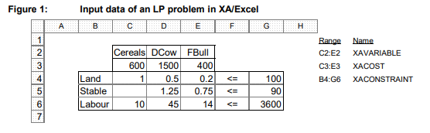

1.4 Arrangement of the input and output ranges in the Excel worksheet
To maintain clarity and flexibility (e.g. for stepwise enlarging the matrix), a structured arrangement of the input and output ranges required for XA in the Excel worksheet is of great importance. It is advisable to divide the different ranges into several worksheets of an Excel file. On each worksheet, the individual elements should then be grouped as clearly as possible. A sample for the design of the input and output ranges is shown in the following overview. It shows in parallel the implementation of the optimisation example already dealt with in XA/Excel and the range names used for this when the individual elements are divided into four worksheets:
Worksheet 1: Input ranges and output of the most important results such as activity level and Variable reduced cost of the activities (with total gross margin), utilisation and shadow prices of constraints.
Worksheet 2: Sensitivity ranges of variable objective coefficient of the basic variables with repetition of names, activity level, objective function coefficient and variable reduced cost of the activities. The upper and lower bounds of the variables can also be repeated.
Worksheet 3: Sensitivity range of variable reduced cost with repetition of names, activity level, objective function coefficient and variable reduced cost of activities. The upper and lower bounds of the variables can also be repeated.
Worksheet 4: Sensitivity range of constraint shadow prices with repetition of the name, capacity value (RHS), utilisation and shadow price of the constraints. The range for displaying the values of the RHS must be defined as two columns even if only one column was used for this purpose in the matrix!
The repetition of important input and output data on worksheets 2 to 4 serves to facilitate the identification and interpretation of the sensitivity ranges. In order to make this possible, the same range names must sometimes be specified repeatedly on the different worksheets. In Excel, this is possible by prefixing the name of the worksheet to the range name in the range definition (menu: Formulas > Define names) and separating it from the worksheet name with an exclamation mark. So, for example, the range for outputting the extent of the variable activity level on sheets 1, 2 and 3 must be defined as follows:
For sheet 1: Worksheet1!XAVA
For sheet 2: Worksheet2!XAVA
For sheet 3: Worksheet3!XAVA
The output ranges on tables 2 to 4 must necessarily be arranged in columns, as this is the only option for the sensitivity analysis tables. For the other output ranges (XAVA, XACA, etc.) it is no problem to define them in rows on one spreadsheet and in columns on another.

1.5 Control commands (command line entries, LPCMD)
Control commands make it possible to influence the optimisation process and the display of results in linear programming. They are entered as a command line in a specially named cell of the Excel worksheet: the LPCMD range (one cell, see data entry). Many control commands have a default setting in case they have not been specifically set. It is therefore usually sufficient to include only those commands in the LPCMD range that are to deviate from the standard setting. Concerning the syntax of the control commands, it generally applies that the individual commands can be abbreviated as far as they can still be clearly distinguished from other commands by XA.
To use several commands at the same time, they are entered one after the other (separated by a space) in the command line: Syntax: Maximize yes Set Casesensitive yes or shorter: Max y Set Case y Control commands retain their value in successive optimisations. For example, if a command is removed from the command line, the default setting does not automatically apply again. This is because once optimised, XA remains loaded in the computer's memory and stores the information once received until an explicit instruction is given or XA is removed from memory.

1.6 The XA Interface module
The XA interface module creates the connection of data input and output in Excel to XA. By default, the module is located in the workbook xaModul.xls. This workbook must therefore be opened in order to solve an LP matrix. When the module folder is opened, the XA menu appears on the screen with the following commands:
XA Solver Load XA solver and run optimisation
XA Revise Solver XA Revise Solver (optimisation aid in Style III - programming)
XA Unload Remove XA from memory
Clear ranges Deleting the contents of the data output ranges
If the matrix templates from the appendix to this script are used, the following menu commands can also be used. They are only active if a correspondingly prepared spreadsheet is selected.
Adjust ranges: Final matrix (On sheet with xaTableau)
Adjust parametric ranges: Variable (for variable-related parametrisation results)
Adjust parametric ranges: Constraints (for constraint-related parametrisation results)
How to handle the commands in practical use is explained in the following chapters. At this point, we would like to go into the setting options with which the user can influence the way the macros work. The following overview shows the first rows of the module sheet. They are used to adjust the XA macros.

1.7 Optimisation
After the input and output ranges required for XA have been defined in the Excel worksheet and the XA interface module (file xaModul.xls) is available, XA/Excel is ready for operation. The command Ctrl+Shift+X loads the XA Solver into the working memory, reads the input ranges of the LP matrix, performs the optimisation and writes the desired results into the predefined data output ranges of the Excel worksheet.
Excursus on keyboard shortcuts
On German keyboards, the Ctrl (Control) key is referred to as Strg (Steuerung) and the Shift key is the Umschalt key (temporarily switch to capital letters). The key combination Ctrl+Shift+X is executed by briefly pressing the X key once while simultaneously holding down the Ctrl and Shift keys.
Memory management
The XA Solver remains loaded in the working memory (RAM) after optimisation until it is removed from the memory with the command Ctrl+Shift+Q (or by closing the workbook). This has the advantage that XA saves the time for loading in successive optimisations and starts calculating faster. Furthermore, this behaviour is mandatory for using the XA Revise Solvers. A disadvantage of this feature, however, is that elements of the command line (LPCMD range) are also removed from memory (and thus switched off) only when XA is removed from memory and reloaded.
XA Message Window
As long as XA is loaded in the working memory, the so-called XA Message Window is also visible on the screen. It contains information about XA (version, capacity), the execution of the optimisation (e.g. number of variables and constraints), as well as (depending on the setting of the command line (LPCMD)) the repetition of the input data and display of the optimisation results. The window is especially important if problems occur during optimisation. For example, it contains information on input errors or, in the case of an unsolvable matrix formulation (infeasible solution, unbounded solution), it indicates the activity or constraint responsible for the unsolvability.
By means of a special LPCMD control command ("Output"), the content of the window can be written into an ASCII file or, with definition of the range name xaOutput, into a spreadsheet. After optimisation, the window can be reduced to an icon manually or with a control command ("Set Visible" in LPCMD). It is also possible to close the window completely; but XA remains loaded in the memory. By default, after an optimisation, the XA Message Window remains on the screen (as a window or symbol), but the Excel workbook with the matrix becomes the active window again. However, once the message window has been activated by mouse click, the Excel ribbon may have to be clicked again before Excel is ready to work again

1.8 Parametrising in LP models with XA
Parametric optimisation allows a further analysis of the sensitivity of the optimal solution with changed parameters. It comprises an optimisation procedure in which one or more parameters from the following categories are kept variable (parametrised):
• Objective function coefficients (gross margins of the procedures)
• Production capacities (RHS)
• production coefficients (exchange rates of the processes in the initial solution) The importance of parametrisation is primarily to be seen in checking the effects of changed assumptions with uncertain planning data on the optimisation result. It is often difficult to foresee the future development of product and input prices, or the determination of production capacities and technical coefficients (e.g. crop yields) are based on rough estimates. By parametrising such uncertain values, it is possible to determine how sensitive the optimal solution reacts to changes (ceteris paribus). Parametrisation can basically take place in two variants:
• Variation of a parameter along the limits of its sensitivity range (so-called corner-point parametrisation)
• Variation of a parameter in constant steps.
Corner-point parametrisation
The variation of a parameter within its sensitivity range usually affects the variable activity level. If the sensitivity range is exceeded, an exchange of a basic and non-basic variable takes place; as the parameter continues to vary, constant exchange rates then apply again until the next sensitivity limit is reached. The organisation at the respective next sensitivity limit is therefore always of interest, since there are always linear substitution ratios (and boundary values) between these corner points. In corner-point parametrisation, one therefore sets the value of the parameter to be examined equal to its (smallest) sensitivity limit and determines the optimal organisation with all relevant results. In the next step, the value of the variable parameter is set equal to the next sensitivity limit and the optimal solution is determined again. This continues until the sensitivity range approaches infinity or until possibly earlier if the results achieved are no longer of interest.

1.9 Working with split matrices (Style III programming)
Dividing the LP matrix into several tables can be useful if:
• the matrix of an LP problem becomes very large and with Style I or Style II programming the number of columns in Excel is no longer sufficient.
• Sub-ranges of the matrix have only a few linkage points to other sub-ranges. For example, it may be useful to present the field work and the livestock husbandry in separate tables. This makes the individual tables more compact, as each table only contains the rows that also contain entries (so, large "blank" areas in the matrix can be avoided).
• the structure of sub-ranges of the matrix is repeated several times. This is the case, for example, when separate rations are calculated for numerous animal groups during a farm optimisation. Formulating each ration in a single table makes it easier to copy the structure for further rations and again avoids a lot of large "blank" areas in the matrix.

2 Special formulation approaches
2.1 Basic model
In the following sections, specific formulation approaches to problems of agricultural farm business planning will be explained. In addition to technical production issues, aspects of investment and financing are also addressed. In addition to the isolated presentation of the formulation approaches in the text, there are also example matrices for XA for important questions. They are available as Excel files and are attached as printouts. Reference is made in the text to the example matrices. The model shown below serves as the basis for the individual special approaches

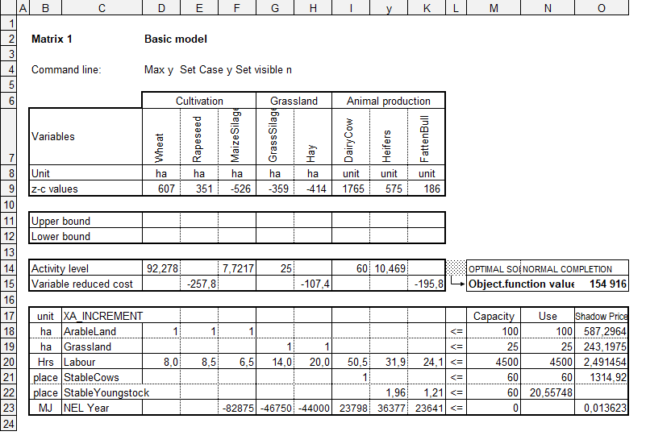
The farm on which the basic model is based has 50 ha of arable land, 10 ha of grassland, 4500 hrs labour , capacity, 60 stable places for dairy cows and 60 places that can alternatively be used for rearing heifers or fattening bulls. The basic model was deliberately structured in a simple way and limited to the most necessary items in order to be able to present the examples clearly.
The individual examples are therefore in no way suitable in themselves to do sufficient justice to the planning reality of a farm. Rather, it requires a combination of many of the approaches shown in order to take into account the diverse interactions between the individual activities of a farm with sufficient precision. With regard to such comprehensive and wholistic planning approaches, section Abschnitt 3 provides the necessary details.
The technical coefficients of the activities presented are compiled in gross margin calculations, which can also be found in the appendix. The objective function coefficients of the activities of the basic model correspond to the gross margins of the procedures. Any modifications to the matrix that become necessary in the examples are documented in the appropriate place.
The separation of animal husbandry and fodder production, as already included in the basic model, and the associated balancing of fodder energy is explained in the following section

2.2 Breakdown of production processes
A breakdown (disaggregation) of production processes always makes sense when there are alternatives for action and it is not clear from the outset how the farm organisation in this range is to be designed. In order to be able to decide in which way income and expenses are to be recorded, it is useful to subdivide the products and means of production of an agricultural farm as follows:
Products: Production resources:
Exclusively market-driven Exclusively for purchase
Exclusively farm related Exclusively self-generating
Optional market-determined Optional to be purchased
For exclusively market-driven products / means of production to be purchased, the gross monetary income of the product or the purchase price of the means of production is used to measure the output or the proportional variable costs. There are valuation difficulties for exclusively farm-specific products / means of production to be produced on-farm. They are to be taken into account in the LP model as internal physical output or demand. Optional market products / means of production to be purchased are also to be recorded as physical output or input for an accurate calculation. However, buying and selling activities are to be introduced for these goods. Income and expenses are therefore only included in the gross margin if their valuation is clear. In all other cases, they are included in the model as a physical output / requirement. In the following sections, this principle will be illustrated with practical examples (forage, purchase/supply, soil nutrients).

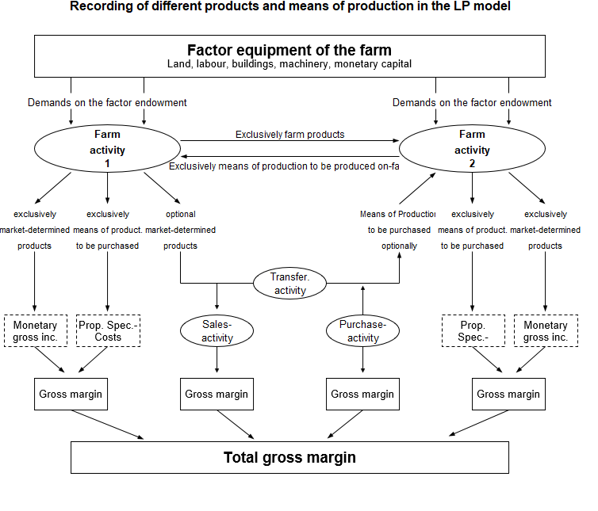
2.3 Land use
The availability of land is taken into account in the LP matrix by a constraints row. All farm enterprises that use land (usually a whole year) receive a 1 (1 ha claim) in this row. The farm land capacity is usually to the right of the arithmetic symbol (<=), but can also be made available via an activity. Possibilities of increasing and decreasing land capacity are to be taken into account through leasing activities (take or let land on lease). If leasing of land (take or let) is only possible to a limited extent, fixed upper bounds can be set. It often makes sense to divide the available land according to different qualities. This results in a separate constraint row for arable land, grassland, possibly also for vineyards, orchards, etc. If necessary, each category can be subdivided again according to different qualities (e.g. separate reporting of the land suitable for sugar beet, differentiation between meadow and pasture, etc.).
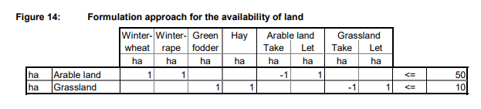
2.4 Labour management
The labour time requirements for the production processes is unevenly distributed over a year. In particular periods of time, there are working time peaks where bottlenecks in labour capacity prevent the implementation of a farm enterprise, although the overlall annual labour capacity is not fully utilised. For this reason, it is advisable to include rows for anticipated labour peaks in the LP model in addition to the constraint row for the total labour time requirement. It is advisable to choose the fieldwork periods suitable for a particular climatic region. For the crop production enterprises, the respective labour requirement in a time period can be easily determined (see gross margin calculations in the appendix). For the livestock enterprises, the determination of the relevant coefficients is mostly approximate based on the number of field work days of a period.
In the same way, the labour capacity in the time periods is also determined: Hrs in time period = hrs per year / 365 × field work days per time period.

2.5 Decreasing marginal productivity
With an increase in the proportion of cereals in the total arable land, the yield per hectare decreases disproportionately due to unfavourable crop rotation ratios. In order to be able to implement this non-linear relationship in the linear model, the grain yield function must be divided into several sub-ranges, each with a constant marginal productivity (linear approximation). In the example shown below, these are the five ranges 0-50%, 50-60%, 60-75%, 75-87.5% and 87.5-100% cereals proportion. The marginal gross margin, which remains constant within these ranges, decreases from 600 €/ha to 187.5 €/ha. The usable land is 100 ha
Discontinuously linearly decreasing marginal yields in cereal production (100 ha AL)
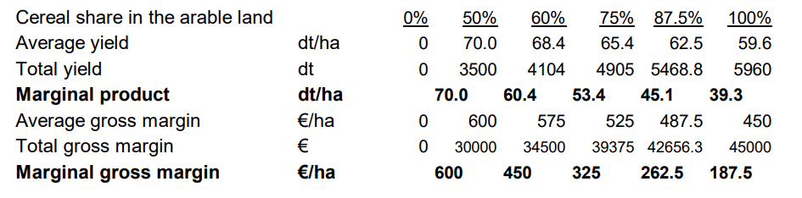
When determining the optimal cereals share, it is crucial that the objective function coefficient of the activities (share levels) is not the average gross margin achieved in each case, but the marginal gross margin applicable to the respective sub-range.
Formulation approach for crop rotation-related yield degressions
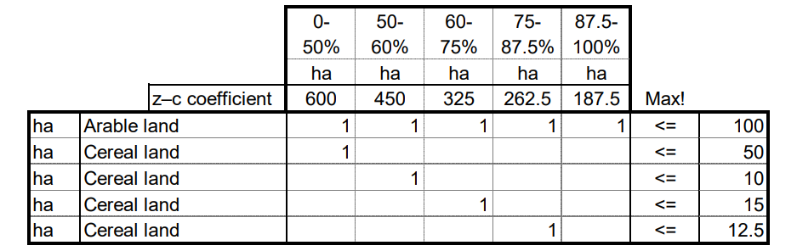

In the optimisation process, activities compete for available capacity. According to the order of their competitive strength, the activity 0-50% (max. 50 ha) is extended first (all other factors being equal), then 50-60% (max. 10 ha), and so on. If, for example, a cereals content of 67% of the arable land is determined as the optimum, this is realised by the following activities:
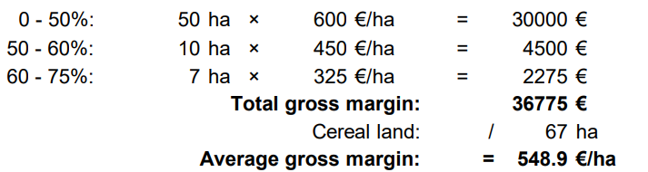

2.6 Investment (increasing marginal productivity)
Investments, especially in the livestock sector, are often an example of increasing marginal productivity, as an increase in stock here is usually associated with a significant reduction in labour time requirements and building costs per unit. The decreasing unit costs and factor demands inevitably increase the average gross margin per unit. Similar to the decreasing marginal productivity, due to the required linearity of the approach, a usually continuously degressive function must be converted into a discontinuous one (through approximation). An example from pig fattening may clarify the situation: A farmer is planning the construction of a fattening pig stable and has various offers of stable construction solutions. The annual costs (depreciation, maintenance, interest costs) were estimated as a sum at 10% of the initial investment for the construction of the stable.
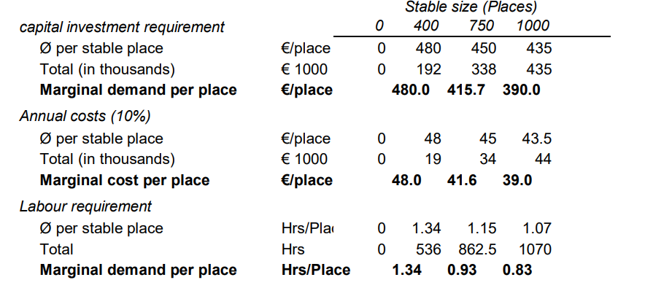

2.7 Financing
Investment financing planning concerns the determination of the most favourable sources of finance for an investment, taking into account the overall capital requirements of the farm (including current assets) as well as the securing of the farm's ability to service its debt. In an LP model, this goal is achieved by introducing financing activities in conjunction with constraints to ensure liquidity. Again, the construction of a fattening pig stable should serve as an example investment (400 to 1000 places, Zapf approach). Since the interest costs for capital is taken into account via the financing activities, now the objective function coefficient of the stable construction activities only includes depreciation and maintenance. Accordingly, the capital requirement (separated into current and fixed assets) is to be formulated as a demand. Of course, for all other activities, the interest costs for capital for the bound assets must not be included as a cost in the objective function coefficient and the capital requirement must be included as a demand in the model.
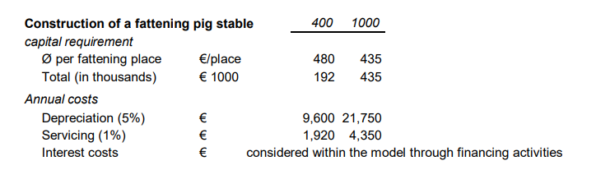

The investment will use capital for current and livestock assets (for pig fattening) and fixed assets (stable). Current assets are always 100% bound up, whereas fixed assets (as a general approximate simplification) are on average 60% bound up over time.
Equity capital ("EqCap", interest rate 6%) of up to € 150,000 can be used for financing. Current and livestock assets ("Curr&LstAss") can also be financed through a revolving loan ("RevLoan", = overdraw of the current bank account). Sources of funding for fixed assets are a subsidised loan ("SubsLoan", max. € 100,000) and a free bank loan ("BankLoan").
The different binding of the capital over time is taken into account in the LP matrix via the interest rates. Furthermore, one usually chooses 1000 € as the reference unit for the financing activities in order to avoid too large numbers. The objective function coefficients of the financing activities thus represent the interest costs in € per € 1000 capital requirement (interest expense for borrowed capital, opportunity costs for equity capital) The capital supply is accordingly 1000 € per unit (into the respective row for current or fixed assets).
To ensure sustainable or long-term debt service capability, the rows "SustainabDRC" and "LongtermDRC" are used (DRC = Debt Repayment Capacity). The debt repayment capacity is (simplified) generally calculated as follows:
Total gross margin from agricultural production incl. direct payments
– Fixed and general costs (excl. interest)
– Private withdrawals (+ incoming payments)
– Existing debt service (interest and principal repayment)
± Other out- or incoming payments (forest, diversification, ...)
= (Remaining) long-term debt repayment capacity
+ Depreciation for new investments in buildings and technologies
= (Remaining) sustainable debt repayment capacity

The model-internal consideration of the total gross margin is done by entering the objective function coefficient of all activities in the DRC rows, but with the opposite sign, since services mean a "delivery of debt service capability", but costs reduce the debt service capability (demand). Only the financing activities are an exception here. For them, the respective coefficient results from the annual debt service to be paid per € 1000 loan amount, assuming the conditions of an annuity loan (annual annuity, see the following overview). For a current account loan (revolving loan), only interest is to be estimated, no repayment. No debt service is required for equity capital. The existing fixed and overhead costs, private withdrawals and debt service on existing liabilities are also not available for new debt service payments. They are therefore entered as a fixed sum (with a negative sign!) in the capacity column (RHS). Sources of liquidity that are not part of the model via an activity, e.g. (parts of) direct payments and net income from forestry, diversification, etc., are also to be included in the amount of the capacity column: since they are deliveries of liquidit they reduce the negative amount of the fixed and overhead costs.
In the case of long-term debt service capability (in contrast to the sustainable one), depreciation for investment activities is also taken into account as a source of liquidity. Therefore, the coefficients of the investment variables include in the line 'SustainabDRC' only the maintenance costs, while in the line 'Long-term DRC' they also include the depreciation

2.8 External regulations and directives
Requirements in the farm organisation according to the directives of the EU agricultural reform often necessitate complex approaches in the implementation in an LP model. It is therefore usually sensible not to include schemes that are only very unlikely to be considered (such as the small producer scheme for larger farms) in the model from the outset. The example therefore requires individual adaptation of the described facts and, if necessary, expansion (e.g. cultural landscape programme, environmental protection requirements, etc.).
Direct payments (premiums, compensation payments, subsidies, ...)
Although direct payments based on the activity level of a production process can be included in the market output, they are more transparently presented as "physical (monetary) supply". The row "Trans Prem" and the activity "Premiums" are used to add direct payments to the total objective function value. The advantage of this approach is that the sum of the premiums received can be easily read off and the amount of the premium can be examined more closely (e.g. parametrise). When leasing land, it is important to consider whether the land is acquired with or without payment claims. In addition, if the payment demands are taken into account in the model, it should be noted that they can be allocated to both arable and grassland.
Milk quota (EU 1984 to 2015)
Farm milk production was limited by quota in the EU from 1984 to 2015. In the example, this upper bound is entered via the capacity column in the constraint row "Milk quota". Per dairy cow, an 8000 kg quota (annual milk yield per cow) is demanded. In addition to the presentation in the example, activities can be formulated to increase or decrease the quota via purchase/sale or lease.
Application limit for farm manure of animal origin
In Germany, the application of farm manure of animal origin is limited by law to a maximum of 170 kg of nitrogen per hectare. In the example shown, the line "Max N Manure" ensures that this limit is complied with.
Formulation approaches for (external) agricultural policy guidelines
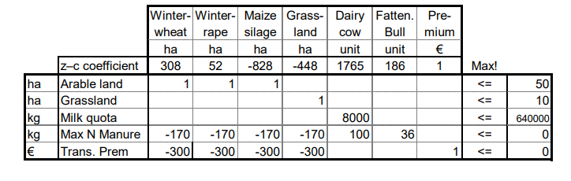
2.9 Other specific formulation approaches
To change coefficients that are in a fixed relationship to each other, the formulation of an index is suitable. In the following model, for example, an index for the prices of different cereals was formulated. By varying the index, the optimal farm organisation can now be determined for different scenarios. By parametrising the index, it is also easy to determine the effect of a gradual reduction in cereal prices by 2% each on the optimal farm organisation. The control command for this (LPCMD range) would then read:
Parametric PriceIndex 1 0.5 0.02
Formulation approach for coupling activities via indices
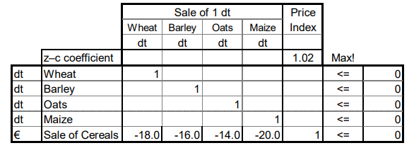

3 Farm business planning with the aid of linear programming
Linear programming offers farm business planning a method with which the one combination of farm enterprises can be found that has the highest total gross margin among all options (=optimum farm organisation), considering all relevant constraints. If formulated appropriately (through disaggregation of the activities), the opportunity costs of the factors demanded by the activities are taken into account internally in the model and are therefore (appropriately) minimised.
To implement the real conditions of a farm in an LP model, the formulation approaches explained in detail in section 2 can be used in appropriate combination. Depending on the situation and the planning focus, individual sub-ranges of the farm should be formulated in more detail (such as feeding, mechanisation, market crop production, etc.).
In general, the procedure for operational planning with LP corresponds to that of the simplified programme planning method. In the start-up phase, the production capacities and constraints are determined. Even with a highly disaggregated representation of the production processes in the model, it is advisable to quantify them first in the form of gross margin calculations (with special consideration of a wide range of factor demands). The gross margin calculations provide a compact overview of the economic efficiency of the processes and serve as data base for the model. The next step is to create various farm business plans using the LP model.
If formulated appropriately (taking into account all marginal output, marginal costs and marginal factor demands), the total objective function value can be used directly as the comparable gross margin and thus as the central selection criterion for the optimal plan. A particular advantage of the method is that once a model has been created for a farm, it is easy to determine its effect on the optimal farm organisation by changing individual coefficients. When drawing up farm business plans, a distinction is made between production models, investment models and financing models
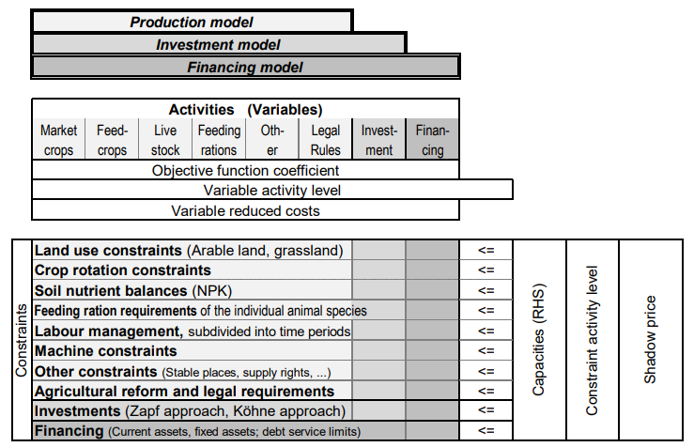
Schematic representation of the model structure for farm planning

4 Solution of optimisation problems in sub-ranges
4.1 Optimal feed ration
The aim of calculating an optimal feed ration is to determine
• which feedstuffs are included in the ration and to what extent (variables)
• while complying with all nutritional requirements (constraints)
• and minimising costs (objective function)
In the case of ration optimisation for fattening pigs, an isolated consideration is easily possible, since usually only marketable components are used, thus enabling a clear evaluation. When optimising the total ration (forage and concentrate) for ruminants, a proper evaluation of the components is often only possible to a limited extent. The optimal forage ration is often dependent on labour management aspects. Furthermore, feed production competes directly with cash crops for available land. Since all these factors are not taken into account in an isolated model, the corresponding opportunity costs must be expressed in the objective function coefficient, which can only ever be done approximately. It is largely convention to express the objective function coefficient (cost of feed) as a positive value and to minimise the objective function (Maximize No in the command line). The coefficients with the nutrient contents, although they represent a delivery, are also entered as positive values. Accordingly, maximum conditions are formulated with the arithmetic sign <= and minimum conditions with the arithmetic sign >=. The requirements for the ration refer either to the unit of weight of the feed (e.g. 1 kg, 1 dt, 1 t of feed) or to the requirement for one animal (per day). The reference to the unit of weight is best suited for feed mixtures, as the respective proportion of a component in the mixture can be read directly from the activity level of the variable. The reference to the daily requirement is often more suitable e.g. for ruminant rations, as the ration consists of forage and concentrate. The coefficients of the possible ration components (nutrient contents) usualy refer to fresh matter (e.g. 1 kg of fresh matter or any other chosen weight measure unit).
The requirements for a ration can be defined as fixed or variable maxima/minima:
• Fixed constraints are entered via the capacity column (RHS): e.g. energy requirement at least 13 MJ ME e.g. dry matter intake maximum 20 kg
• Variable constraints are bound to a specific other nutrient via transfer activities: e.g. Ca:P - Ratio 1 : 0.5 to 1 : 0.7 e.g. crude fibre content is at least 16% of dry matter
The formulation proposals presented in the examples (appendix) can also be implemented as part of a whole-farm matrix, so that feed can be provided via production activities (consideration of opportunity costs) or purchase activities. Furthermore, it makes sense to formulate a separate approach for each animal and performance group (fattening stages, lactation stages) or different feeding periods (summer, winter forage) in order to avoid balancing between the various animal groups.

4.2 Optimal mechanisation
As an example for determining the optimal mechanisation, the harvest of cereals was chosen, since the restriction to a single machine such as the combine harvester enables a largely isolated approach. In the example, a farmer is considering replacing his existing combine harvester with a new one to harvest his own 50 ha of cereals. The following data is available on the mechanisation alternatives available for selection:
Calculation data for mechanisation alternatives
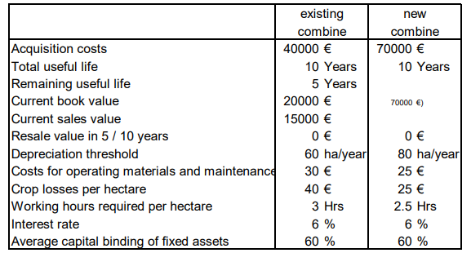

It is also possible to use one's own combine harvester in the machinery ring (125 €/ha) or to have one's own land harvested via the machinery ring (125 €/ha, 25 €/ha losses, 1 hrs/ha). A proposal for transferring the planning problem into an LP model is included in the appendix. By varying (parametrising) the land used for grain crops on the farm, it is possible to determine which mechanisation is most advantageous for which acreage. The resulting total and average costs are shown in the following figure. Note that the amounts (total objective function value) take into account the income from machinery ring activity and the labour costs.

5 Multi-period model approach
5.1 Introduction
The objective of formulating multi-period models is to determine not only the optimal production, investment and financing programme, but also their optimal temporal distribution over a longer planning period. However, the following specific problems arise here:
• The payment flows cannot be valued equally at the different points of time due to changes in purchasing power and occurring opportunity costs of the capital. Thus, payments require discounting (as it is done in multi-period investment calculations).
• It is necessary to choose a suitable planning horizon, as this can influence the planning result. Long-term models have the advantage that the final situation (model end-period), with its assumptions and evaluations, has less impact on the planning result. Furthermore, inter-periodic interactions can be taken more into account. Short-term models, on the other hand, offer greater planning certainty with regard to the assumptions made (prices, framework conditions and technical coefficients).
• Decisions require permanent review, even in the implementation phase. The models must therefore be constantly adjusted to the changing assumptions during the planning period.
• A cautious interpretation of the results is necessary to maintain flexibility in subsequent decisions required to adapt to changing conditions (e.g. changes in capital market conditions, influencing variables not recognised as relevant, etc.).
Of particular importance in multi-period optimisation are: dynamic-simultaneous models and dynamic-recursive models. Both planning approaches link several periods and their factor availabilities to time series, whereby the dynamic-simultaneous models permit optimisation across periods, whereas the dynamic-recursive models optimise individual periods on the basis of the preceding periods.

5.2 Multi-period land use planning
The problem of multi-period cropping planning can be particularly important in the case of an expected shift in the cost-benefit ratios between the different use alternatives or a major change in factor endowments. Here it is possible to allocate and value benefits and demands over time and to take into account their inter-periodic relationships. This method also offers advantages due to a more flexible crop rotation design and the appropriate farm optimisation when planning the cultivation of perennial crops. In the following planning approach, a farmer intends to expand pig fattening on the basis of self- produced cereals from 400 fattening places in period I to 900 fattening places in period III. The cereals yield is assumed to be 75 dt/ha; the feed requirement per fattening place is 4 dt of cereals.
The arable land is to increase from 30 ha in period I to 45 ha in period II and 60 ha in period III.
The gross margin of cereal cultivation is 600 €/ha for all planning period.
The gross margin per fattening place is 65 € in period I+II and 67.5 € in period III.
The crop rotation share of cereals (taking into account other cultivation methods) should not exceed 75% in total during the planning period. However, for reasons of space, the presentation of further procedures was omitted. The objective function coefficients of the individual activities are discounted via the activity net present value of the gross margins (NPV GM).
The interest rate used for calculating the discount factors is: 6.0%

5.3 Production planning assuming price cycles
An interesting example of the application of multi-period optimisation is production planning under the assumption of certain price trends. The main question here is the temporal distribution of production cycles and their allocation to assumed price cycles. A particular problem here is the overlapping of production processes.

Practical class

Student must know basic structure of an LP matrix in XA/Excel, data input and output in XA/Excel, solution of optimisation problems in sub-ranges and be able to identify and solve of optimisation problems in sub-ranges.

Control questions:

- What are the basic structure of an LP matrix in XA/Excel?
- What are the control commands?
- Explain the farm business planning with the aid of linear programming.

Questions for discussion:

- Explain the multi-period model approach? Give the examples.

Task 1. Please range production processes according to their relative advantages. Use the data given in table 13.2

Table 1 – Initial data
Production process | Production factor
 | Arable land |  |  | Labor
Unit of estimation | Requirement, ha | Income/ha,  uah | Rank | Requirement, man-hours | Income/man-hours,  uah | Rank
Winter wheat | 0 |  |  | 15 | 73.33
Sugar beet | 1 | 4200 |  | 50 | 80
1 ha of FCP + 2 DC | 1 | 3800 |  | 130 | 27.69
1 ha of FCP + 2 DC+E | 1 | 1850 |  | 0
1 ha of FCP + 3 BF | 1 | 1800 |  | 90 | 17.78
DC – dairy cow; FCP – feed crop production; BF – bulls on fattening.

Theme 9. Introduction to multi-period calculations of investment efficiency

The aim of theme’s study is to learn sense of profitability criteria in multiperiod investment calculations

Plan
1 Key principles
1.1 Static and multiperiod profitability calculations
1.2 Payment flows, periods and cash flow
1.3 Compounding interest and discounting
1.4 Present value
2 Profitability criteria in multiperiod investment calculations
2.1 Significance of decision-making criteria
2.2 Net Present Value (NPV)
2.3 Equivalent annuity
2.4 Internal rate of return
2.5 Payoff period
2.6 Benefit-Cost Ratio (BCR)
2.7 Net benefit-investment ratio (NBIR)
2.8 Comparing interpretations of the different profitability criteria
3 Sensitivity analyses

1 Key principles
  - Static and multiperiod profitability calculations
The main purpose of carrying out a profitability calculation is to answer the following questions:
• Is an investment profitable (absolute profitability)? (= will the invested capital be earned back, including any appropriate interest?)
• Which investment is the most profitable? (relative profitability of 2 or more alternatives)
• When should an investment be made (optimum replacement time)?
• What should the period of investment be (optimum duration of use)?
To answer these questions, the following points are important to remember:
• the payment amounts associated with the investment,
• the payment schedule and
• the interest rate, expressing the opportunity costs for the invested capital (also referred to as "adequate target rate", "required rate of return", "target rate of return")
The multiperiod profitability calculation method enables the economic effect of the scheduled distribution of payments to be captured with much higher precision than the static method. The multiperiod method is therefore particularly suitable for economically assessing investments with irregular payments over multiple periods (years). The method is ideal for business development plans and projects involving
• permanent crops, stock increases (herd development),
• technical changes implemented in stages or
• expected changes to technical and monetary factors over the course of time.

  - Payment flows, periods and cash flow
Any commercial procedures within the context of an investment are expressed in payment flows. The payment flow associated with an investment serves as the basis for assessing profitability and financing potential. Payments in a payment flow are classed as either cash inflow (inflow) or cash outflow (outflow). In simplified terms, cash outflow are all payments that are applicable to carrying out an investment project, and cash inflow are essentially income. Though any payments in kind and opportunity costs (e.g. for labour) are also to be regarded as cash inflow and payments as appropriate.
For multiperiod profitability calculations to differentiate between total and equity interest payments, receiving external funds is included as a cash receipt and the corresponding repayments and interest are included as cash outflow.
cash receipts (= inflow): Any liquid capital flowing in to the business from an investment and any other outputs with a monetary value resulting from an investment, such as natural produce. In multiperiod investment calculations to determine the efficiency of the total capital investment as well as that of the equity investment, the receipt of external capital is also to be considered as a cash receipt. By definition, receivable payments are not yet cash inflows.
Cash payments (= outflow) Any liquid capital flowing out of the business and any costs with a monetary value that are associated with an investment, such as increased labour input from family workers as a result of an investment. Cash payments for interest and amortisation are also to be considered in multiperiod investment calculations to determine the efficiency of the total capital investment as well as that of the equity investment. Depreciation payments are not taken into account, since the total acquisition costs during the acquisition period are included in the calculation.

  - Compounding interest and discounting
An investor will value payments received today at a higher value than payments that are only due in a year's time. The criteria for the higher valuation could be:
a) The interest amount that would be accrued throughout the year by investing/utilising the payment received today, or
b) The interest payments that could be saved by paying off existing debts one year sooner.
In both cases, a disadvantage occurs through the capital being available one year later, which can be valued on the basis of the foregone profits (interest earned or interest saved), i.e. the opportunity costs.
Discount factors indicate the cash value of future payments in the amount of €1 and need only be multiplied by the relevant payment amount. The higher the interest rate and the farther into the future a payment occurs, the smaller the factors and the greater the devaluation. Payments in T0 (period t0) are valued with a factor of 1 (no revaluation).
The purpose of future vlaue factors is to revalue past payments in today's terms, or to revalue current payments at a future point in time. In a similar way to discount factors , the future value factors are simply multiplied by the relevant payment amount. A past payment is valued higher than a current payment because interest earnings are taken into account for the past payment. A future value factor is the reciprocal value of a discount factor, therefore it is greater than 1.

  - Present value
When compounded or discounted payments from a cash flow are added together at a consistent point in time, it provides the present value of the series of payments. The present value can be calculated for any point in time (T0) within the payment period. The present value of a series of payments is calculated using the following formula:
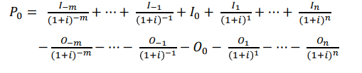
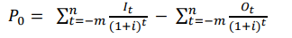
P = Present value
I = Cash inflow (receipts)
O = Cash outflow (payments)

2 Profitability criteria in multiperiod investment calculations
2.1 Significance of decision-making criteria
Business decisions are not only influenced by economic objectives such as maximising earnings or minimising costs, but also by a multitude of subjective motives and criteria, such as personal interests, expectations of the future, appetite for risk, etc. For this reason, economic decision-making criteria can never be the sole point of reference when evaluating alternative courses of action. Financial mathematics cannot replace a decision. It can, however, be extremely helpful in the decision-making process.
In general, the decision-making criteria for profitability calculations should fulfil the following requirements:
a) All payments and any other costs or outputs that occur as part of an investment must be included,
b) The amount and timing of cash receipts and payments should have a bearing on the decision, and
c) The rules for decision making must be logical and easily understandable. Building on the concepts already introduced, some of the most important methods for assessing the profitability of an investment are introduced and explained in more detail in the examples below.
In principle, all of the methods use the formula specified for determining the present value. It is simply solved using different parameters

2.2 Net Present Value (NPV)
Using the Net Present Value method, the T0 point in time is set as the relevant point in time, so that all other payments occur at either then T0 point in time (period t0) or later. As a result, all payments must be discounted at the T0 point in time, provided they did not fall due in period t0. The resulting present value is then the Net Present Value of series of payments.
Problem: What is the current value of a future series of irregular payments? (The future payments refer to the current point in time, i.e. they are discounted).

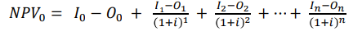
P = Present value
I = Cash inflow (receipts)
O = Cash outflow (payments)
The possible results of a Net Present Value calculation can be summarised into three case groups and interpreted accordingly:
a) If the Net Present Value of an investment is calculated as positive, this means that the invested capital → will be earned back completely via the investment, → interest will be earned on the invested capital in line with the used target interest rate and → a present value surplus will be earned in the amount of the "Net Present Value". The investment is therefore more economically favourable than an alternative use of the capital.
b) If the Net Present Value equates to zero, the capital will earn interest based on the suggested target interest rate r or, in other words, the invested capital will be earned back with interest at the interest rate. The investment is therefore economically comparable to an alternative use of the capital.
c) If the Net Present Value is negative, the investment should be ceased, since the capital can be utilised elsewhere and achieve more interest. A negative Net Present Value can even indicate potential capital losses in addition to the insufficient interest.

2.3 Equivalent annuity
Broadly, the equivalent annuity method serves to transform a payment that is due at a certain point in time T into n regular payments of the same value (= annuity). It therefore enables a series of irregular payments to be be transformed into a series of regular payments over n periods, whose Net Present Value is the same as the original series of payments. The equivalent annuity is also described as an average annuity.
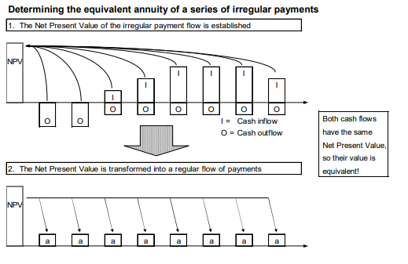
2.4 Internal rate of return
The return or effective yield from an investment is known as the internal rate of return. This interest rate is compared to the target interest rate (alternative interest return on capital). As is known from the Net Present Value method, a Net Present Value of zero means that the invested capital will be earned back with interest at the assumed target interest rate. Determining the internal interest entails finding the discount rate at which the Net Present Value of a series of payments equates to zero. This also then means, that the present value of cash inflow corresponds to the present value of cash outflow.
The established internal rate of return can be interpreted as follows:
a) If the internal rate of return is greater than the specified target interest rate r, then the investment is deemed positive (capital achieved more interest than alternative).
b) If the internal rate of return and r are the same, then the invested capital was earned back with appropriate interest, however no additional profits were earned.
c) If the internal rate of return is lower than r, then a loss of interest occurs, since the invested capital would have earned more interest elsewhere.
d) If the internal rate of return is lower than 0, then a loss of capital occurs, i.e. the invested capital can only be partially recuperated from the earnings resulting from the investment. No interest is earned on the capital. The internal rate of return does not depend on the volume of investment and is therefore suitable for comparing investments of irregular volumes.
This is a significant advantage compared to the Net Present Value method.

2.5 Payoff period
The payoff period is also determined based on discounting the series of payments. The discounted cash flow is cumulated from the T0 point onwards until the initial (negative) outflow surpluses (discounted) are balanced out equally by the received inflow surpluses (discounted). The payoff period is then used to determine how long the investment project would need to run in order to earn back the invested capital with an appropriate amount of interest. The point in time at which this is achieved is also known as the "break-even point".
Problem: How long does it take for an investment project to break even?
Solution:
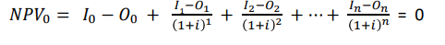
Investments with a high cash inflow at the beginning are best suited to this method, since the break-even point is achieved sooner. Furthermore, any potential differences in payments after the pay-off period do not have any effect on the relative performance of alternatives when using this method of calculation. For this reason, the pay-off method is not generally sufficient as a standalone basis for decision-making.

2.6 Benefit-Cost Ratio (BCR)
This method is also based on the Net Present Value method as above. It consists in determining separate Net Present Values for the cash inflow and outflow then dividing the Net Present Value of the cash inflow by the Net Present Value of the cash outflow. The resulting ratio is known as the benefit-cost ratio (BCR).
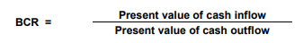
When calculating the BCR, it does not matter whether the cash flow contains only negative or only positive periods. If the benefit-cost ratio (BCR) is greater than 1, then interest is achieved above the target interest rate. In this case, the investment makes sense. Under no circumstances should any cash inflow or outflow be netted in advance when calculating the BCR, as this can lead to the result being distorted (netting out).

2.7 Net benefit-investment ratio (NBIR)
To determine the net benefit-investment ratio, the first step is to calculate the capital or present values of the positive proportion of cash flow. Then the present value of cash flow is calculated for the “negative” investment years. The quotient of both figures is the net benefit-investment ratio. Since the figures are completely “netted out” as part of the NBIR calculation, there is no danger of making mistakes from “netting out” otherwise.
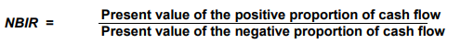
Net benefit increase is predominantly used in business planning to measure changes to the net surplus (net benefit) as a result of development measures after external financing. The net benefit increase (NBI) is thus determined on the basis of a comparison between cash flows after external financing with and without a project:
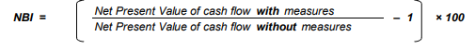
The net benefit increase indicates by what percentage the net surplus changes on average over the reference period if the farmer carries out the planned development measures. The cash flow progression illustrates how this surplus is distributed over time. The nature of the progression depends on the structure of the external financing.
The net benefit increase makes it possible for a farmer to estimate, for example, whether there is a sufficient incentive to participate in state initiatives to promote agricultural development based on the income uplift to be expected from a specific initiative. Furthermore, this parameter can be used to easily compare multiple alternative measures based on their effect on the farmer’s income. In both cases, however, attention should be paid to the distribution of the increased income over time.

2.8 Comparing interpretations of the different profitability criteria
Since the profitability criteria described here are all ultimately derived from one another, any contradictory interpretations are ruled out. The following overview illustrates the context of the explanatory power of each variable and summarises the most important interpretive approaches
Comparing interpretations of the different profitability criteria
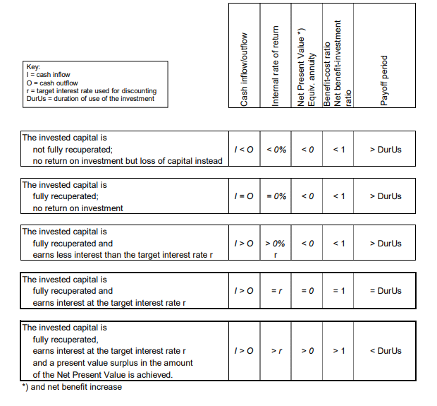
3 Sensitivity analyses
Sensitivity analyses are carried out to establish the effects of changes in data on profitability and financing calculation results. In general, they are used to monitor how any changes in unreliable data sets, such as yield, price and expenditure data, effect commercial success. These types of calculation are predominantly used to assess risk due to their ability to highlight any areas where critical variances may appear.
The clear representation of cash inflow and outflow in multiperiod investment calculations makes them a prime candidate for sensitivity analyses. This is especially true when the calculations have been programmed into a spreadsheet whereby the results are accurately updated in real time when individual data are changed.
The results of a sensitivity analysis can be plotted on a graph and illustrated as a “sensitivity rhombus” (see the above overview). Doing so requires the Net Present Values to be determined at different interest rates for the following six series of payments:
- average cash inflow (receipts)
- cash inflow reduced by 10%
- cash inflow increased by 10%
4) average cash outflow (payments)
5) cash outflow increased by 10%
6) cash outflow reduced by 10%
In the above graph it is evident that the left hand point of the rhombus represents the least favourable scenario (cash inflow – 10% and cash outflow + 10%), whereas the right hand point reflects the most favourable combination (cash inflow + 10% and cash outflow – 10%). If both intersections of the Net Present Value lines are projected onto the X axis, it is possible to see the internal rate of return achieved by each.
The interest rate at which both “average value curves” intersect would lead to a Net Present Value of 0 in this investment scenario. The interest rate at which both curves intersect thus indicates the internal rate of return of the investment in a standard scenario.

Practical class

Student must know the forms of investments and be able to analyze types of financing and choose the most preferable.

Control questions:
- Name the types of investments.
- Name the types of financing due to the financial assets’ origins.

Solve the tasks:
Task 1. Estimate the indices of efficiency of investments. Initial data is given in table 1.

Table 1– Initial data
Item | Size
Output, pieces | 100 000
Market price of product, uah | 200
Cost price, uah | 160
Investments, uah | 14 000 000
Fixed assets value, uah | 12 500 000

Task 2. Determine the optimal direction of enterprise development by cost reimbursement criterion. Initial data is given in table 2

Table 2 – Initial data
Indices | 1 direction | 2 direction | 3 direction
Investments, uah | 250 000 | 1 000 000 | 1 300 000
Cost price of annual output, uah | 1 100 000 | 1 080 000 | 900 000

Task 3. Determine the optimal direction of enterprise development. Initial data is given in table 3.

Table 3 – Initial data
Indices | 1 direction | 2 direction | 3 direction
Annual output, pieces | 110 000 | 115 000 | 125 000
Investments, uah | 200 000 | 500 000 | 700 000
Cost price of 1 piece, uah | 4.7 | 4.3 | 4.1

Tests for the knowledge control

- Which of the following options are within the scope of services provided by management consultants?
A. Management functions, processes and systems. Sector-specific services. Human resource consulting services.
B. Specific management problems and challenges. Business strategy and transformation.
C. Approaches to organizational change and performance improvement
D.All of above.

- What is the working model of generalists and specialists in most consulting firms?
A.Combining the skills and perspectives of generalists and specialists to solve problems in a broader context can achieve better results when encountering problems.
B.Generalists analyze multiple situations and propose corresponding solutions.
C.Experts analyze a situation and propose ways to solve the problem.

- What are the types of leading firms in the consulting market today?
- The market is currently clearly dominated by executive consultancies and strategy consultancies.
- The market is currently clearly dominated by large multifunctional and multiservice consulting firms.
- The current market is clearly dominated by digital consultancies and data analytics consultancies.

- Firms that provide consulting on corporate strategy, corporate organization, business restructuring and other general management issues and position themselves as management consultants on strategically critical issues and general business development.
- Strategy and general management consulting firm
- Information technology and e-commerce consulting firm
- Benefits Employee Consultancy

- Firms refer to “integrated development models” and to the necessity to adjust IT consulting to the “increasing complexity of clients’ businesses”.
- Strategy and general management consulting firm
- Medium-sized generalist and specialist firms
- Information technology and e-commerce consulting firm

- Firms traditionally specialized in the field of employee benefits, including actuarial services, pension schemes, social insurance and benefits, wage schemes and salary administration, and pension fund management.
- Medium-sized generalist and specialist firms
- Benefits Employee Consultancy
- Sole practitioners and small partnerships

7. This group embraces a variety of organizations, ranging from a few to 50–100 consultants. General management, strategy and business development consulting for small and medium-sized businesses, often in a limited geographical area; consulting in one or a few technical areas；sectoral specialization.
- Strategy and general management consulting firm
- Sole practitioners and small partnerships
- Medium-sized generalist and specialist firms

- The existence of thousands of sole consulting practitioners and small partnerships of 2–5 consultants demonstrates that, despite market domination and aggressive marketing by large professional firms, there is plenty of interest in working with independent individuals or small teams and their networks.
- Medium-sized generalist and specialist firms
- Sole practitioners and small partnerships
- Non-traditional suppliers of consulting services

9.What is an internal consultation?
- That is established within an organization – a business corporation, a public utility, a government ministry or department – to provide consulting services to other units of the same organization.
- It is an advisory service contracted for and provided to organizations by specially trained and qualified persons who assist, in an objective and independent manner, the client organization to identify management problems, analyze such problems, recommend solutions to these problems, and help, when requested, in the implementation of solutions.
- A new group of suppliers of management consulting services has emerged in recent years. This group is rather heterogeneous but has one common characteristic: its original and main function is a service other than consulting, but consulting is viewed as a technically useful and financially profitable addition to its products and services.

10.What are the trends in Management consulting and other professions?
A.Management consultants have been increasingly moving into new service areas.
B.Other providers of professional and business services have tended to do more and more management consulting.
C.Firms from different professions tend to work together more frequently than in the past.
D.All of above.
- What is the key factor leading to the management of professions?
- The growing size and complexity of professional firms.Changes in the market and in competition.
- The ambiguous attitude of many professionals to management.
- The shortage of managers for professional service organizations.
- The underdeveloped body of knowledge on the management of professions.

- What's the nature of the service?
- Building and managing a clientele.
- To be able to transfer knowledge to clients, a consulting firms creates, develops and manages its own knowledge base.
- Professional consultants, including the beginners in the firm.
- In consulting, the product is the advice given to the client.

- What's the Managing the consultant–client interface?
- Building and managing a clientele.
- Professional consultants, including the beginners in the firm.
- To be able to transfer knowledge to clients, a consulting firms creates, develops and manages its own knowledge base.
- In consulting, the product is the advice given to the client.

- What's the managing knowledge？
- Building and managing a clientele.
- Professional consultants, including the beginners in the firm.
- In consulting, the product is the advice given to the client.
- To be able to transfer knowledge to clients, a consulting firms creates, develops and manages its own knowledge base.

- What's the managing professional workers？
- Building and managing a clientele.
- Professional consultants, including the beginners in the firm.
- In consulting, the product is the advice given to the client.
- To be able to transfer knowledge to clients, a consulting firms creates, develops and manages its own knowledge base.

- How to improve the productivity of management consulting?
- To increase working-time utilization.
- Charge higher fees per unit of time worked for clients.
- All of above.

- What does productivity mean in management consulting?
- Increasing productivity means earning more fees per consultant employed.
- The profit margin achieved by the consulting firm reflects above all the productivity and leverage levels. Higher consultant productivity and higher leverage generate higher margins.
- In the consulting business improvements in earnings per partner and profitability do not always require the firm to grow. There are even growth patterns that fail to increase profitability, or that reduce it, even though total profits are higher.

- What does margin mean in management consulting?
- In the consulting business improvements in earnings per partner and profitability do not always require the firm to grow. There are even growth patterns that fail to increase profitability, or that reduce it, even though total profits are higher.
- Increasing productivity means earning more fees per consultant employed.
- The profit margin achieved by the consulting firm reflects above all the productivity and leverage levels. Higher consultant productivity and higher leverage generate higher margins.

- What does growth mean in management consulting?
- In the consulting business improvements in earnings per partner and profitability do not always require the firm to grow. There are even growth patterns that fail to increase profitability, or that reduce it, even though total profits are higher.
- Increasing productivity means earning more fees per consultant employed.
- The profit margin achieved by the consulting firm reflects above all the productivity and leverage levels. Higher consultant productivity and higher leverage generate higher margins

- How to achieve excellence professionally and in business?
- The environment in which consultants operate, and their clients’ needs, are constantly changing.
- Every consulting firm sets its own standards of performance and achievement.
- All of above.

- What is Management consulting?
- Management consulting can be viewed either as a professional service, or as a method of providing practical advice and help.
- Management consulting is a professional service, but not a way to provide practical advice and help.
- Management consulting is neither a professional service nor a way to provide practical advice and help.
- All options are right.

- What is the purpose of using the consultant?
- solving management and business problems;
- implementing changes;
- achieving organizational purposes and objectives;
- All options are right.

- Which of the following issues cannot be resolved using an advisor?
- unrealistic self-image;
- high staff turnover;
- Replace a better leadership;
- lack of perspective.

- What methods can the consultant provide when consulting the consultant?
- providing information;
- doing diagnostic work;
- planning and managing organizational changes;
- All options are right.

- Which of the following words is right?
- More complete and relevant information is not the main or only thing the customer needs to make the right decision;
- The consultant can only identify one suitable person in the assignment;
- Diagnostic skills and instruments are among the consultant’s principal assets;
- Developing systems and methods is not what consultants should do, which is the task of leadership.

Individual work

The aim of individual work is to study the issues, that are not included into the basic themes of discipline’s study plan and to control student’s ability to work independently and to use additional literature. Complex tasks for individual work includes theoretical question and practical task. Student must give answers for one theoretical question and solve the tasks. Feel free while choosing the theoretical questions to answer.

Theoretical questions for individual work
- Consulting in general and strategic management
- Consulting in information technology
- Consulting in financial management
- Consulting in marketing and distribution management
- Consulting in e-business
- Consulting in operations management
- Consulting in human resource management
- Consulting in knowledge management
- Consulting on productivity and performance improvement
- Consulting in total quality management
- Consulting in company transformation
- Consulting on the social role and responsibility of business
- Consulting in small-business management and development
- Consulting for the informal sector
- Consulting for the public sector

Task for individual work
Range production processes by their relative advantages. Make the conclusion. Choose the variant of initial data in accordance with number in students list.

Table 1 - Initial data (Variant 1)
Production process | Unit of estimation | Sum of reimbursement, uah | Requirement of factors
 |  |  | Land, ha | Cattle-places | Work, man-hours | Basic forage,  kStU
Grain | 1 ha | 1000 | 1 |  | 12
Feed | 1 ha | -500 | 1 |  | 14 | 5000
Dairy cow | 1 cow | 2850 |  | 1.1 | 54 | -2500
Bulls | 1 bull | 1050 |  | 1.3 | 17 | -1667
Capacity |  |  | 5000 | 3500 | 200000

Table 2 - Initial data (Variant 2)
Production process | Unit of estimation | Sum of reimbursement, uah | Requirement of factors
 |  |  | Land, ha | Cattle-places | Work, man-hours | Basic forage,  kStU
Grain | 1 ha | 2000 | 1 |  | 12
Feed | 1 ha | -600 | 1 |  | 14 | 5000
Dairy cow | 1 cow | 2750 |  | 1.3 | 53 | -2500
Bulls | 1 bull | 1050 |  | 1.1 | 17 | -1667
Capacity |  |  | 5000 | 3500 | 200000

Table 3 - Initial data (Variant 3)
Production process | Unit of estimation | Sum of reimbursement, uah | Requirement of factors
 |  |  | Land, ha | Cattle-places | Work, man-hours | Basic forage,  kStU
Grain | 1 ha | 1000 | 1 |  | 11
Feed | 1 ha | -500 | 1 |  | 14 | 5000
Dairy cow | 1 cow | 2750 |  | 1.2 | 53 | -2500
Bulls | 1 bull | 1150 |  | 1.3 | 17 | -1667
Capacity |  |  | 5000 | 3500 | 200000

Table 4 - Initial data (Variant 4)
Production process | Unit of estimation | Sum of reimbursement, uah | Requirement of factors
 |  |  | Land, ha | Cattle-places | Work, man-hours | Basic forage, kStU
Grain | 1 ha | 1000 | 1 |  | 12
Feed | 1 ha | -500 | 1 |  | 14 | 5000
Dairy cow | 1 cow | 2750 |  | 1.1 | 53 | -2500
Bulls | 1 bull | 1050 |  | 1.3 | 17 | -1667
Capacity |  |  | 5000 | 3500 | 200000

Table 5 - Initial data (Variant 5)
Production process | Unit of estimation | Sum of reimbursement, uah | Requirement of factors
 |  |  | Land, ha | Cattle-places | Work, man-hours | Basic forage, kStU
Grain | 1 ha | 1200 | 1 |  | 12
Feed | 1 ha | -500 | 2 |  | 14 | 5000
Dairy cow | 1 cow | 2850 |  | 1.2 | 53 | -2500
Bulls | 1 bull | 1050 |  | 1.2 | 17 | -1667
Capacity |  |  | 5000 | 3500 | 200000

Glossary

“Coaching” means individualized and non-directive assistance to people to discover and realize their full potential, set and reach better goals, become more self-confident, and overcome various personal problems and barriers to performance and achievement.

Cashflow – The movement of cash in and out of a business from day-to-day direct trading and other non-trading or indirect effects, such as capital expenditure, tax and dividend payments.
Cashflow statement – One of the three essential reporting and measurement systems for any company. The cashflow statement provides a third perspective alongside the Profit and Loss account and Balance Sheet. The Cashflow statement shows the movement and availability of cash through and to the business over a given period, certainly for a trading year, and often also monthly and cumulatively. The availability of cash in a company that is necessary to meet payments to suppliers, staff and other creditors is essential for any business to survive, and so the reliable forecasting and reporting of cash movement and availability is crucial.
Investment – The purchase of a security, such as a stock or bond. The use of money for the purpose of making more money, to gain income, increase capital, or both.

Marginal analysis – A basic technique used in the economics that analyzes small, incremental changes in key variables. The economic obsession with marginal changes exists for at least two reasons. One reason is that many economic decisions made in the real world are made "at the margin." A second reason for using marginal analysis can best be termed analytical sophistication.

Marginal cost and marginal product – Because variable cost is largely associated with the cost of employing a variable input in the short run, it's possible to identify a connection between the marginal cost curve and the marginal product curve. In particular, the quantity of output in which marginal cost is at a minimum, is the same quantity of output produced by the variable input when the marginal product of the variable input is at a maximum. In addition, over the range of production in which the variable input experiences increasing marginal returns and marginal product increases, the marginal cost curve declines. And over the range of production in which the variable input experiences decreasing marginal returns brought on by the law of diminishing marginal returns and marginal product increases, the marginal cost curve is rising.

Marginal cost – The change in total cost (or total variable cost) resulting from a change in the quantity of output produced by a firm in the short run. Marginal cost indicates how much total cost changes for a give change in the quantity of output. Because changes in total cost are matched by changes in total variable cost in the short run (remember total fixed cost is fixed), marginal cost is the change in either total cost or total variable cost. Marginal cost, usually abbreviated MC, is found by dividing the change in total cost (or total variable cost) by the change in output.
Marginal value – The incremental value that is achieved through additional output. Marginal value exists through a product modification that results in an increase in price or an increase in unit production. The value is calculated by subtracting additional input costs from the unit price of the additional output.
Management consulting is an independent professional advisory service assisting managers and organizations to achieve organizational purposes and objectives by solving management and business problems, identifying and seizing new opportunities, enhancing learning and implementing changes.
“Problem”– as a generic term describing a client’s dissatisfaction with the difference between any comparable (but mainly between existing and desirable) situations in the organization.
Productivity – The ratio of output (goods and services) produced per unit of input (productive resources) over some period of time.
Profit – As a generic term, this is the difference between revenue and cost. There are, however, three specific sorts of profit, each with a different meaning. Accounting profit is the difference between revenue and accounting expenses. Economic profit is the difference between revenue and the opportunity cost of production. Normal profit is the economic profit that could be earned by an entrepreneur in another business and is thus an opportunity cost deducted from revenue when calculating economic profit.
Profitability – The state or condition of yielding a financial profit or gain. It is often measured by price to earnings ratio.
Risk – There may be potential external events that will have a negative impact on your project if they occur. Risk refers to the combined likelihood the event will occur and the impact on the project if the event does occur. If the combined likelihood of the event happening and impact to the project are both high, you should identify the potential event as a risk and put a plan in place to manage it.
“The consulting process” has a clear beginning (the relationship is established and work starts) and end (the consultant departs).
The client, in the widest sense of the term, is the organization that employs the services of a consulting firm.

The consultant, in the wider sense of the term, is a service firm, i.e. a legal entity. But the firm employs individuals in various capacities – in management, administration, assignment marketing and planning, supervision, or assignment implementation – who are involved in various ways in negotiating, selling, preparing, managing and executing the assignment.

References
- Dr. Harl Neil E., Achenbach Jr. Robert P. (2016). Farm Estate and Business Planning. Agricultural Law Press; 19th edition. 510 p. ISBN-13: 978-0967785691
- Stephenson G. (2019). Whole Farm Management: From Start-Up to Sustainability. Storey Publishing, LLC. 312 p. ISBN-13: 978-1635860740
- "Management Consulting". Educational and methodical complex for conducting lectures, practical classes and independent study of the discipline Management-consulting for 5th year full-time students majoring in 073 Management specialization Administrative management of educational and qualification level "Master". Approved on September 27, 2016 by an international working group in the field of agricultural management and rural development headed by the University of Applied Sciences Weinstefan-Trisdorf (Germany) according to the charter of MRGAR and the cooperation agreement of 04.11.2008 (available to students in printed form of 136 pp. at the Department of Public Administration.
- F. Steele: Consulting for organizational change (Amherst, MA, University of Massachusetts Press, 1975), p. 3.
- P. Block: Flawless consulting: A guide to getting your expertise used (San Francisco, CA, Jossey-Bass/Pfeiffer, 2nd ed., 2000), pp. xvi and 2.
- L. E. Greiner and R. O. Metzger: Consulting to management (Englewood Cliffs, NJ, Prentice-Hall, 1983), p. 7.
- See www.icmci.org., visited on 19 March 2002.
- P. Drucker: “Why management consultants”, in Perspectives (Boston, MA, The Boston Consulting Group), No. 243, 1981.
- See G. M. Bellman: Getting things done when you are not in charge (San Francisco, CA, Berrett-Koehler, 1992).
- P. Stroh: “Purposeful consulting”, in Organizational Dynamics (New York, American Management Association), Autumn 1987, pp. 49–67.
- G. Nadler and S. Hibino: Breakthrough thinking: The seven principles of creative problem solving (Rocklin, CA, Prima Publishing, 1994), p. 128. See also Stroh, op. cit.
- Nadler and Hibino, op. cit. p. 149.
- Frequently referred to is the Kolb–Frohman model, which includes the following seven phases: scouting, entry, diagnosis, planning, action, evaluation, termination. See D. A. Kolb and A. L. Frohman: “An organization development approach to consulting”, in Sloan Management Review, Vol. 12, No. 1, Fall 1970.
- For example, framework contracts with consultants are used by the European Union in technical assistance programmes.
- For a fine account of the history of management consulting see H. J. Klein: Other people’s business: A primer on management consultants (New York, Mason-Charter, 1977); and P. Tisdall: Agents of change: The development and practice of management consultancy (London, Heinemann, 1982).
- Wolf W. B.: Management and consulting: An introduction to James O. McKinsey (Ithaca, New York, Cornell University, 1978).
- Management Consultancy, Nov. 2000, p. 9.
- E-business consulting: After the shakeout (research report by Kennedy Information, 2001), and M. Porter: “Strategy and the Internet” in Harvard Business Review, Mar. 2001, pp. 63–78.
- R. Dawson: Developing knowledge-based client relationships: The future of professional services (Boston, MA, Butterworth-Heinemann, 2000), pp. 208–209. Thought-provoking reading for consultants.
- D. Maister, C. Green and R. Galford: The trusted advisor (New York, The Free Press, 2000). Essential reading for consultants! See also I. H. Buchen: “The trusted advisor revealed”, in Consulting to Management, June 2001, pp. 35–37.
- E. Schein: Process consultation revisited: Building the helping relationship (Reading, MA, Addison-Wesley, 1999), p. 20.
- An online management and leadership consultancy programme PracticeCoach® (www.practicecoach.com.ai/content/what.html), visited on 19 Mar. 2002.
- Cited in H. J. Hagerdorn: “The anatomy of ideas behind a successful consulting firm”, in Journal of Management Consulting (Milwaukee, WI), Vol. 1, No. 1, 1982, pp. 49–59.
- T. Levitt: “Marketing intangible products and product intangibles”, in Harvard Business Review (Boston, MA), May–June 1981, p. 96.
- T. A. Stewart: Intellectual capital: The new wealth of organizations (New York, Doubleday, 1997), p. 91.
- This section is based on D. Maister: “Profitability: Health and hygiene”, in Managing the professional service firm (New York, The Free Press, 1993), pp. 31–39.

Management consulting

Course-book for english-speaking students

Editing and publishing department of Sumy national agrarian university,

Sumy, H. Kondratiev str., 160.

Signed for print: June 2022 year. Format А5: Garniture Times New Roman

Edition: 100 copies Order _________ Cond. Pr. Papers._5.4_____

